|  |
| --- |
|  |
| **ERP APPLICATION –QUICK CARDS**  **HOW-TO DOCUMENTS FOR THE FINANCE MODULE** |
| |  |  |  | | --- | --- | --- | | DEPARTMENT OF INFORMATION COMMUNICATION AND TECHNOLOGY | 9/10/18 | AFRICAN REINSURANCE CORP. | |

# **TABLE OF CONTENTS**

TABLE OF CONTENTS 1

INTRODUCTION 3

FINANCE 4

GENERAL LEDGER 4

A. How to open a GL PERIOD 4

B. How to Open Encumbrance 5

C. Clearing and create accounting for bank 6

D. Budget Loading Manual 11

E. How to run a GL analysis with GLWand (on ERP) 21

ACCOUNTS RECEIVABLE 26

A. How to Open Accounts Receivable Period 26

**b.** **Write**-**Back**/ **Allocation** **of** **Receipts** 28

**c.** **Claims** **Settlement** 28

D. Defining receivables Activities 12

ACCOUNTS PAYABLE 14

A. How to Open Accounts Payable Period 14

B. Auto Prepayment Application 14

C. Un-applying prepayments 15

D. Creating a bank, branch and account 17

E. Voiding Payments and Cancelling invoices 33

F. Treatment of Cash Calls and Payments in Foreign Currencies 38

G. Creating Suppliers 41

CASH MANAGEMENT 52

A. Clearing Bank Statements Manually 52

IEXPENSE 54

A. IExpense Reimbursements – Proxy Application 54

B. Applying for reimbursement in a currency other than USD or local currency 56

C. Submit requests to payables module immediately 59

TREASURY 62

A. How to roll over with full interest Accrued 62

B. How to close a deal on Maturity 68

C. How to handle interest on deposit on Maturity 73

FIXED ASSET 76

A. How to Create Physical Location Inventory 76

B. Bar Code Settings 91

C. FA MASS ADDITION PROCESS 96

JOURNALS 109

A. Auto Reversing Journals 109

B. How to delete a journal 110

# **INTRODUCTION**

This a quick reference manual to show users how to carry out specific tasks on the ERP application. You will require a valid login to the ERP application and must have a responsibility for the specific module to complete the tasks.

This manual is based on the Finance module of the application is to be discussed. For easy reference, use the Table of Contents to navigate.

If you require any help, please contact as a first line of support, your respective ICT officers. If the issue is still unresolved, log on to the Sysaid application where you can log a request. The ICT department at the Headquarters office will respond.

If this is urgent or you have not received a reply within 2 hours, please contact Toyin Arowolo of the ICTD department at [Arowolo.oluwatoyin@africa-re.com](mailto:Arowolo.oluwatoyin@africa-re.com) or Toe, Lazard on [lazard.toe@africa-re.com](mailto:lazard.toe@africa-re.com).

# **FINANCE**

## **GENERAL LEDGER**

### How to open a GL PERIOD

**Responsibility:** ARCGLAdvancedUser <<office name>>

**Navigation**: ARC GL Advanced User >> Open/Close

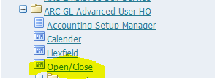

**Select** highlighted form: **Open**/**Close**

When the form opens (see below), **select** your **ledger**, **Status**: Any and **Period** you want to Open or close e.g. Sep-16

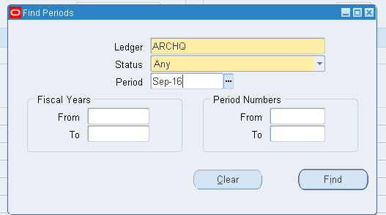

**Click** on Find.

This opens up another form:

**Click** on Status and **select** desirable change i.e. Open or Closed

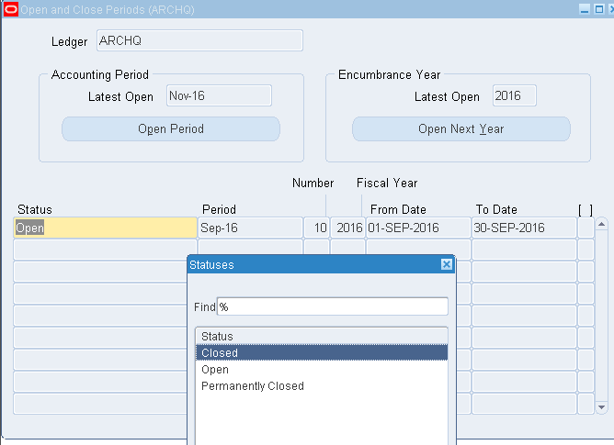

**Save** record.

## **How to Open Encumbrance**

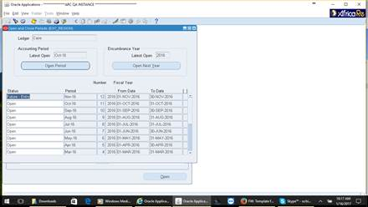

## **Clearing and create accounting for bank**

**Responsibility:** Cash Management

**Navigation:** Bank Account transfers

1. **Select** Bank Account Transfers

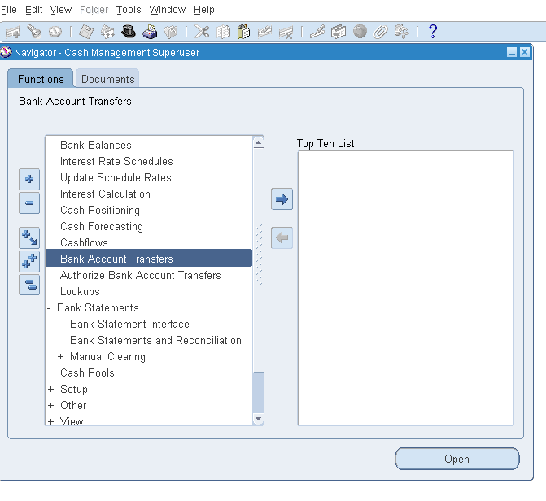

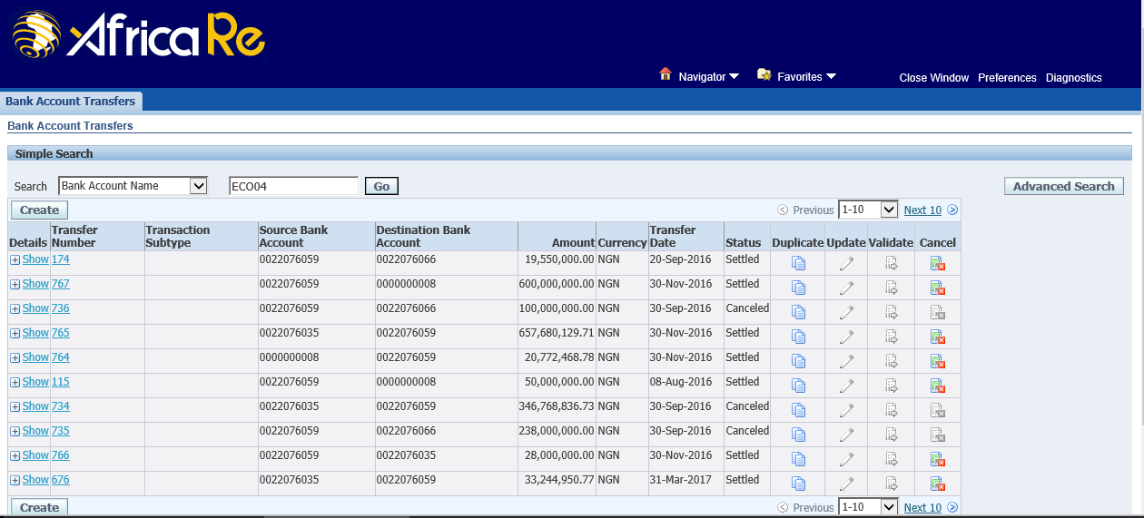

Once transfers have been completed,

1. **NAVIGATE**: Cash Management >> Authorize Bank Account Transfers

**Select** all previous transfers and **click** the ‘**Authorize Transfers’** button.

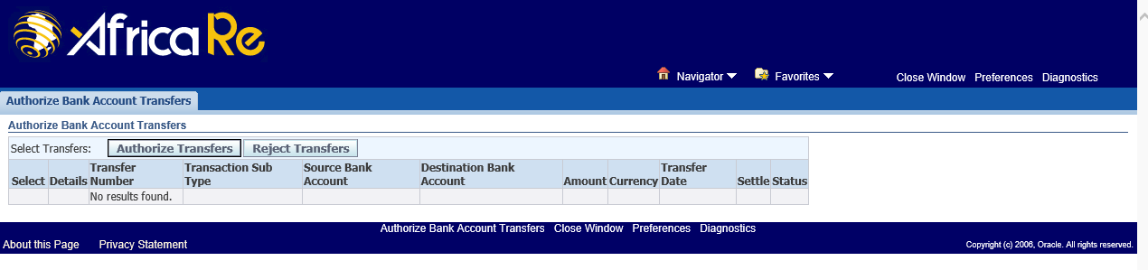

1. **NAVIGATE**: Cash Management >> Bank Statement: Manual Clearing: Clear Transactions

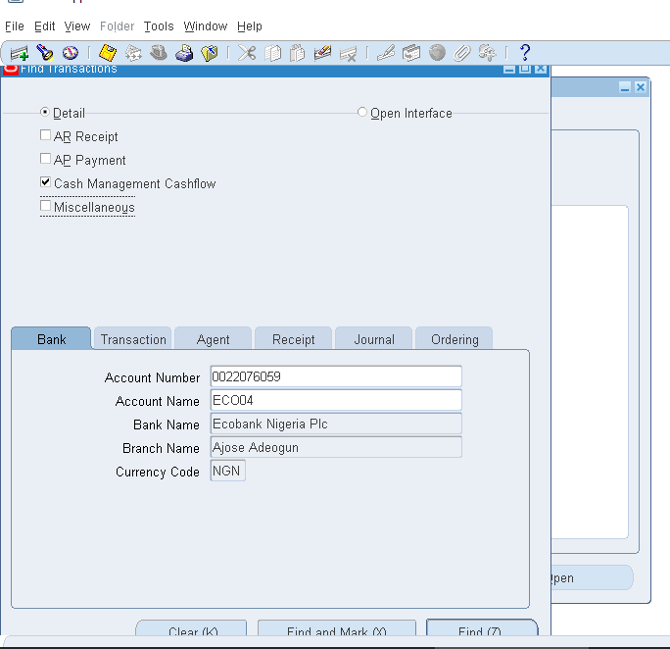

1. **Click** Find and Mark (X)

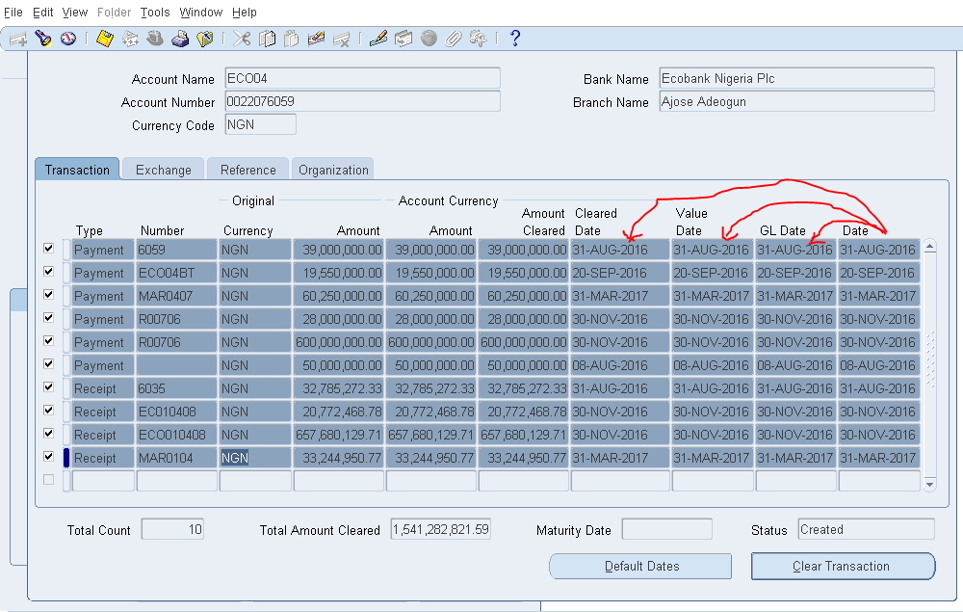

1. **Update** Cleared Date, Value Date and GL Date With Date Column Value
2. Then **Click** on ClearTransaction
3. **Navigate:** View => Request

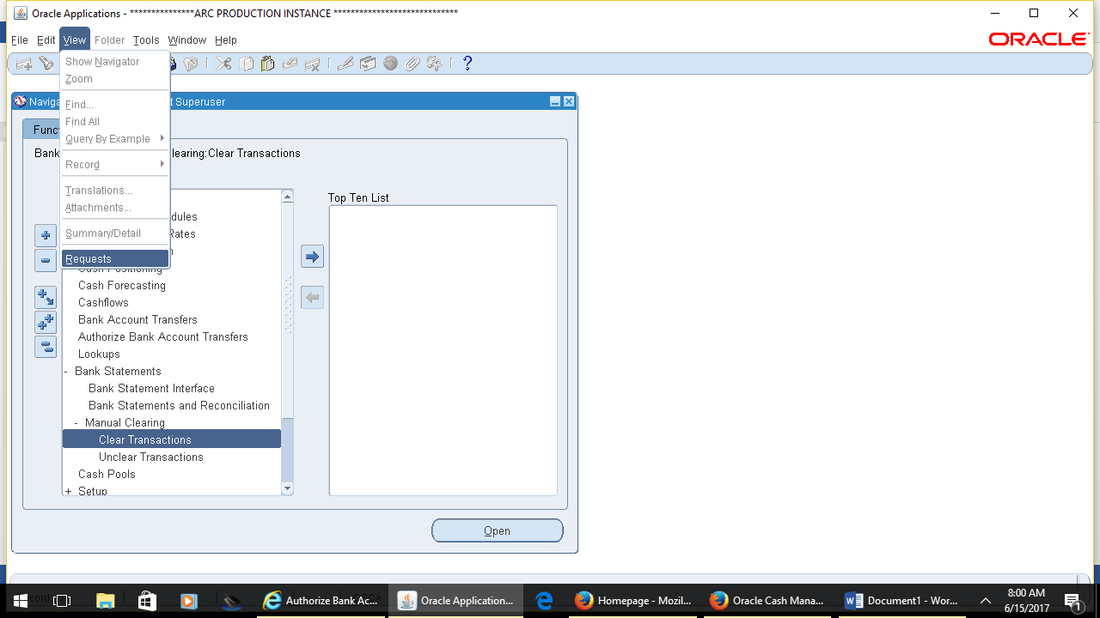

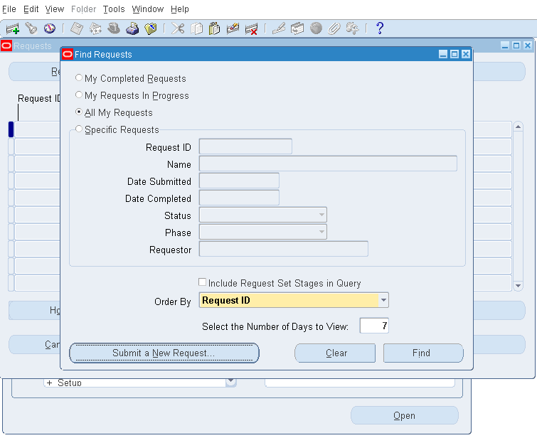

1. **Submit** a New Request

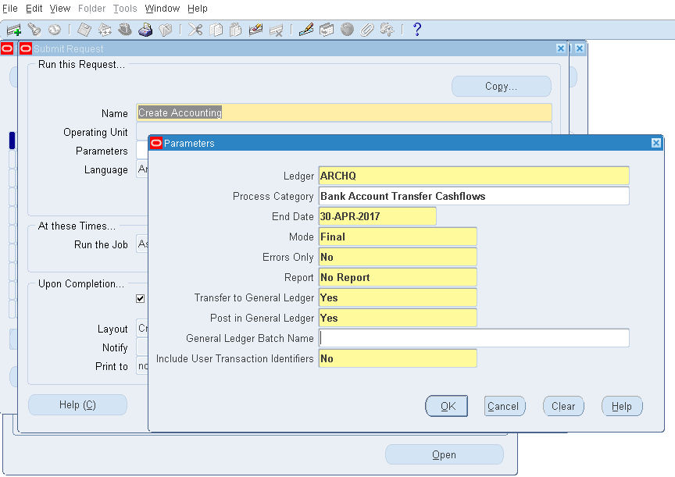

1. **Enter** the Parameters and **Click** OK

## **Budget Loading Manual**

**Responsibility:** General Ledger

**Navigation:** Journals > Launch Budget Wizard

1. Launch Journal Wizard

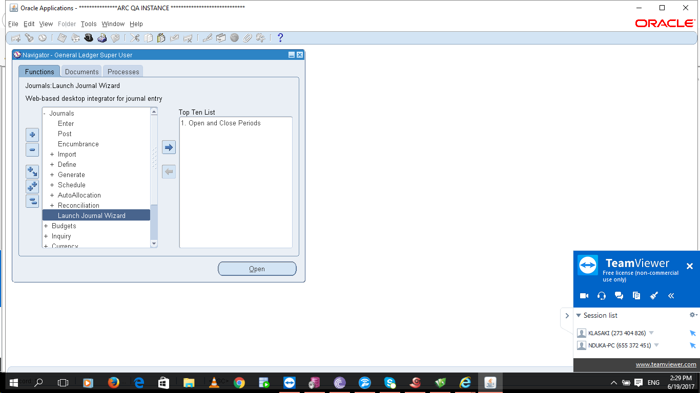

This is a tool used to create the Budget Revision with an Excel Template

**Layout**: Budget - Single

1. Create Document

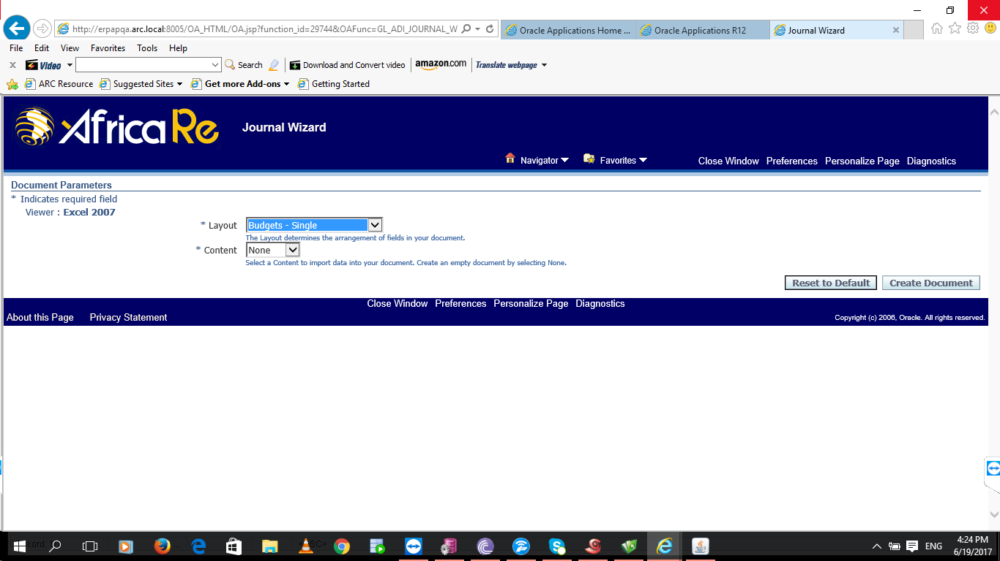

**Click** on Open when asked “Do you want to **open** or **save** WebADI?

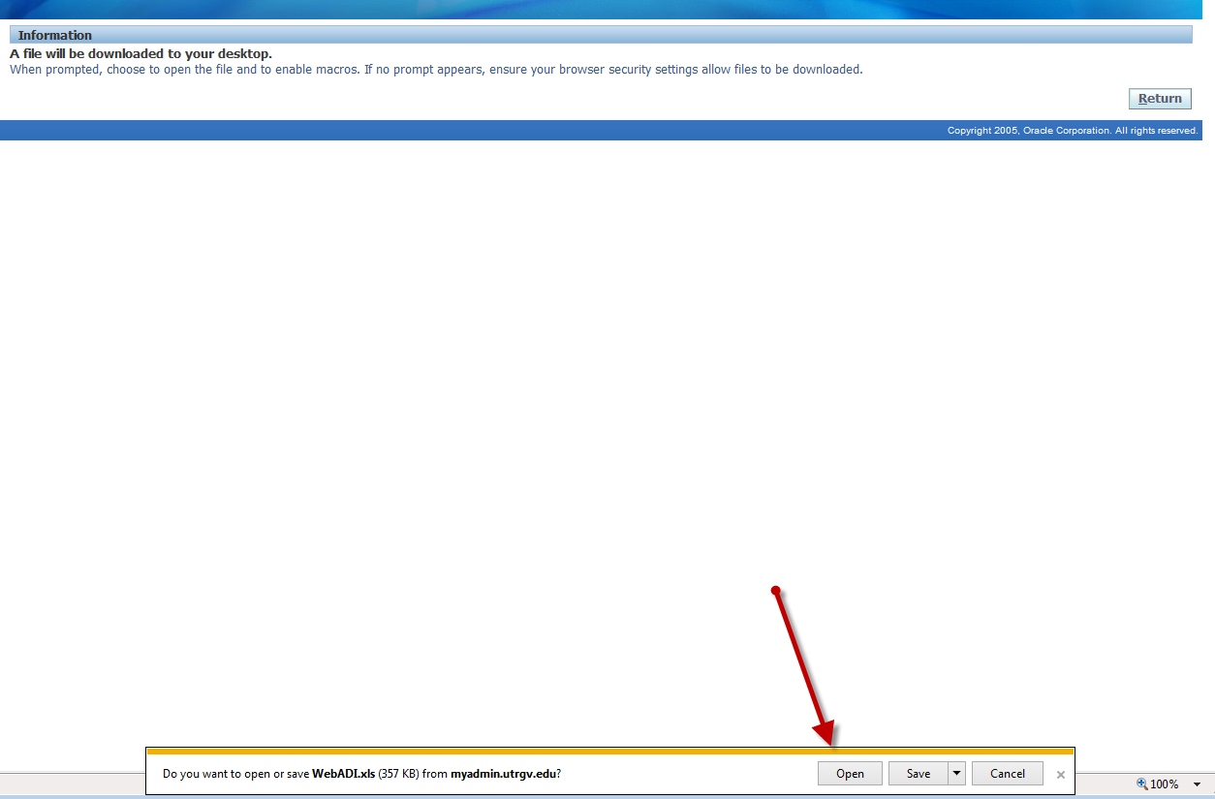

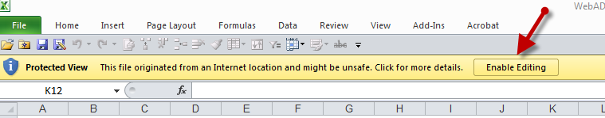

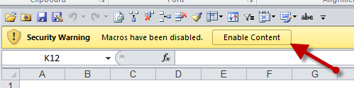

* **Enable** editing and **enable** content when prompted in excel.
* The Wizard will create a document on which to create Budget Revision.
* Do **NOT** Click **Cancel**, wait until it changes to the confirmation screen, then **select** Close.

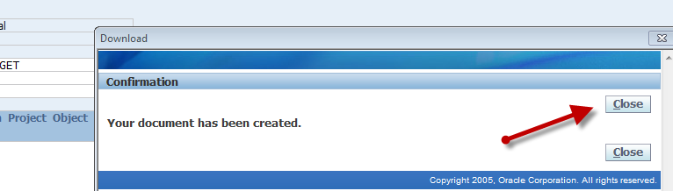

Journal Header fields to be entered and reviewed:

* **Budget:** Set to New Budget.
* **Batch Name**: Use your UserID. System will append Journal ID # when uploaded.

**Paste** the formatted excel sheet on the **Web** **ADI** **template** below

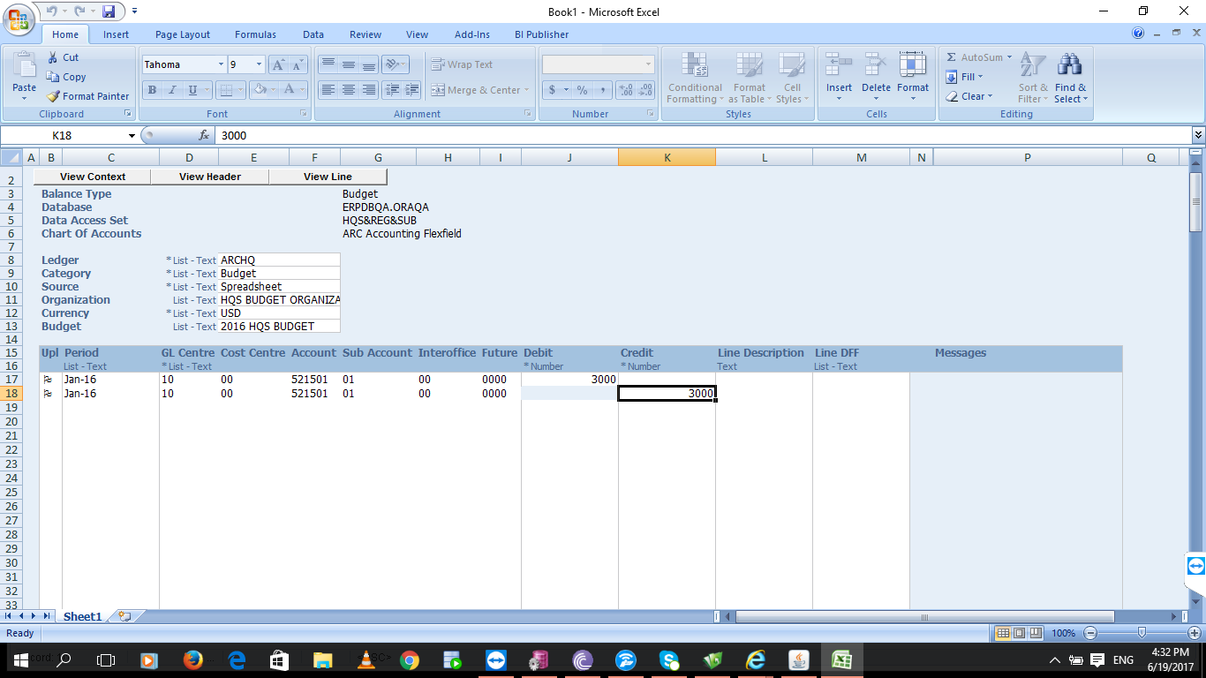

**Journal lines detail needed:**

* Period
* **GL** **String**: Account Combination
* Ledger, Cost Centre, Account, Sub-account, Interoffice, Future
* **Amount –** Debit and Credit (both numbers should be positive)

**Entering Period**:

* **Type** directly in the cell or
* **Right** **click** on cell and **select** “List of Values” or
* **Double** **Click** on cell

**Search** for and **Select** period and then **click** on Select button

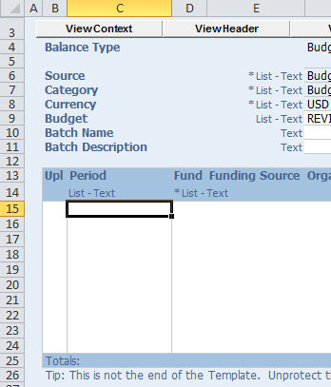

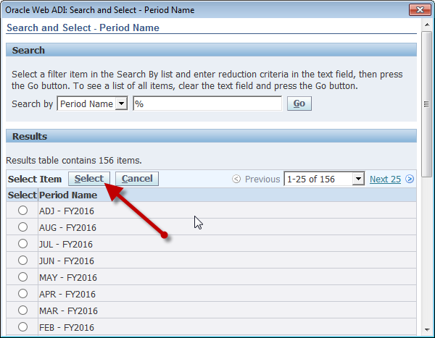

**Entering GL Accounting String**: You will now be able to setup new Objects.

* **Type** directly in the cells, **right** **click**, or **double** **click** on any field of the accounting string to get the following box.
* **Select** your values using the magnifying glass.
* Combinations will exist but does not mean they are valid, because if someone previously entered an invalid combination it will always show up. It’s better to check your GL string combination on the GL Inquiry screen.

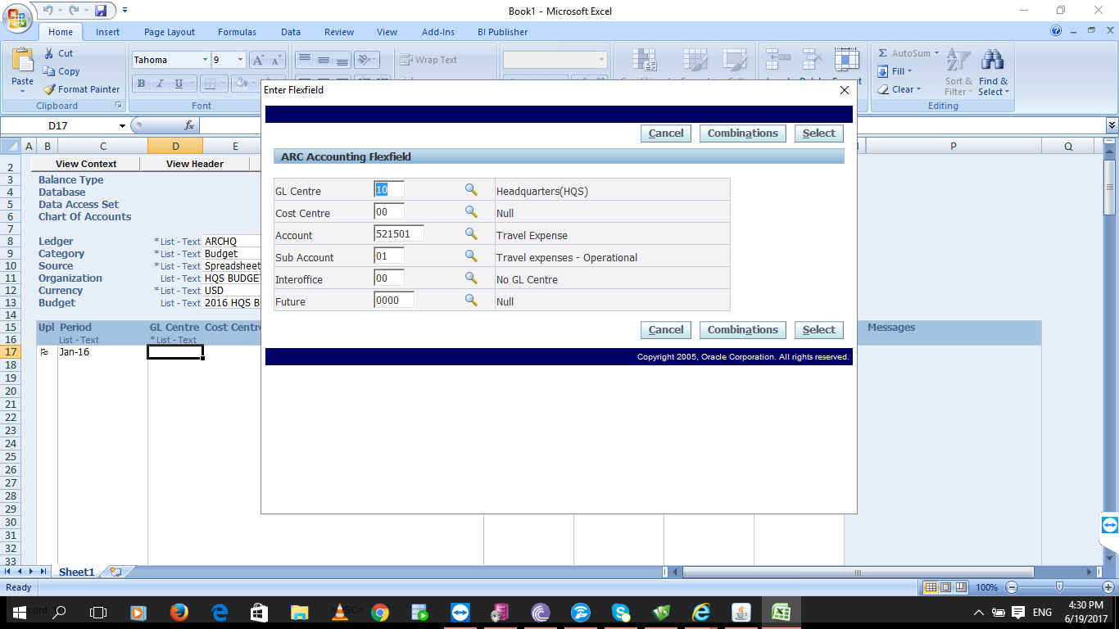

After Revision is completed, **upload** to Oracle.

* **Go** **to** “**Add-ins**” in tool bar
* **Select** Upload.



* **Verify** that same lines on screenshot below are selected.
* **Select Upload**. System will go through a series of screens and finally a confirmation or error message will be displayed.

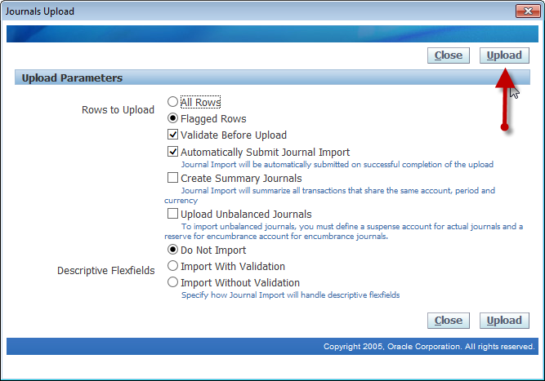

* Confirmation screen will show Group ID #, number of successfully upload rows, and Journal Import Request ID which can be used to identify your revision in Oracle. On your keyboard use Control and C keys to copy the ID.
* **Select Close**. Excel sheet can also be closed at this time, unless the revision has to be corrected. You will notice Happy Faces for error free revision and Sad Faces when error exist in the Message column.

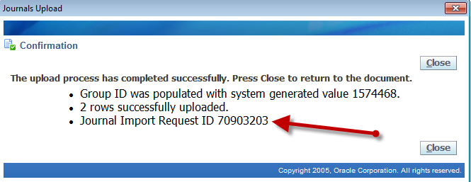

Now that you have created and uploaded the Budget Revision, funds need to be checked and revision needs to be sent through workflow for approvals.

In Oracle using your GL User Responsibility:

* **Navigation** **to**: Journals
  + **Select** Enter on either of the following screens.

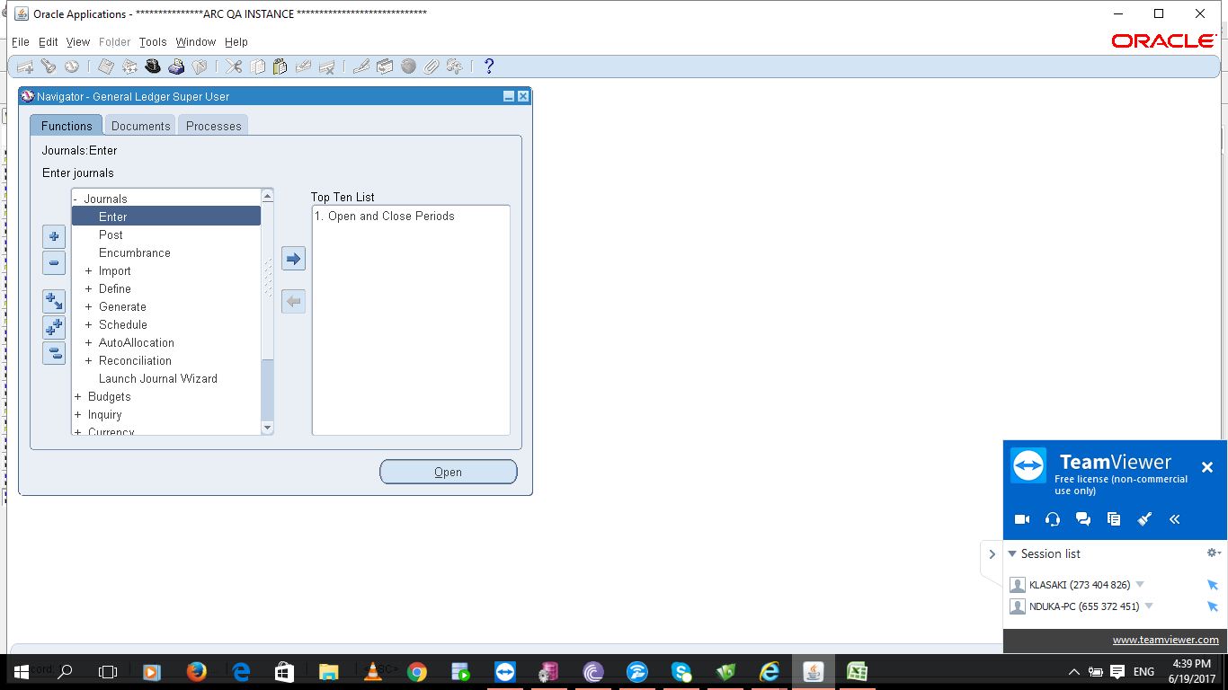

**Find** the Budget Revision by **querying** any of the following

(use % as wildcard):

▪ **Batch** **Name** with your **user** **name**: (i.e.%ARC%)

▪ **Journal** **ID**: (i.e %70903203)

▪ **Category**: Budget

▪ **Posting**: Unposted

▪ **Period**: (i.e. Sep-FY2016)

▪ **Click** Find

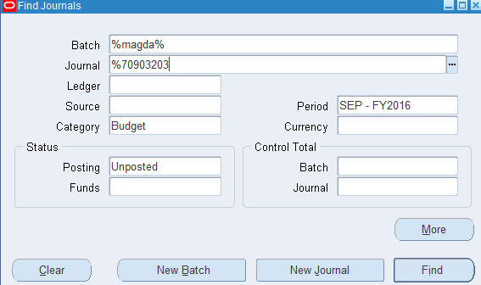

* On the Enter Journals screen **select** the Revision you wish to submit and **select** Review Journal.

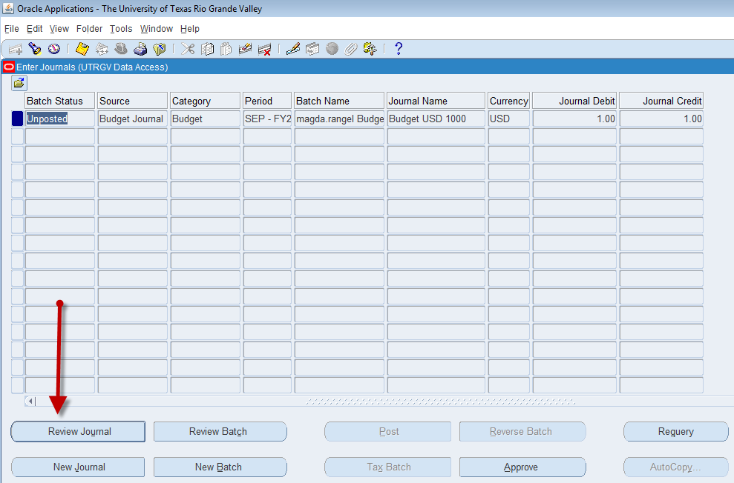

* **Enter** Justification and Comments. These fields are very important since they appear on the notification sent to approver. There is a 150 character limit on each including spaces
* **State** what you are trying to do so the approver can double check your work.
  + (e.g. N3,000.00 from operating to wages to cover student worker for Fall)
* If budget journal should be made permanent type “**PERMANENT”** in the justification or comment field.
* **Click** **Ok** when done.

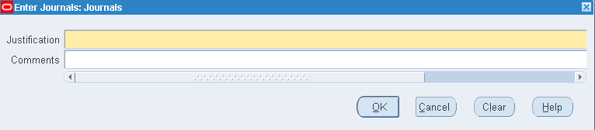

**Attaching Support to your Budget Revision**

* Attachments can be added at this point by **selecting** the paper clip on the toolbar.

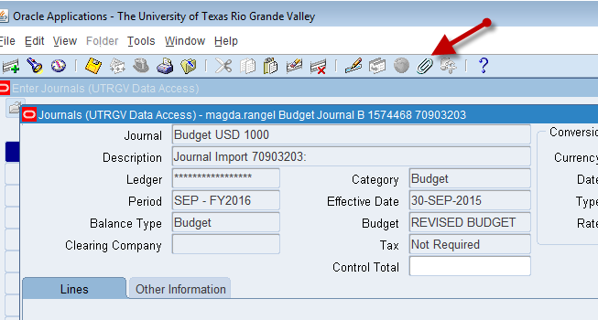

* **To attach support documentation**

After you click on the paper clip icon, the system will bring up the following screen to be filled out.

**Enter** other in the **category** field.

**Enter** the title of your attachment in the **Title** field.

Under description **specify** if your attachment is a **file** or an **e-mail**.

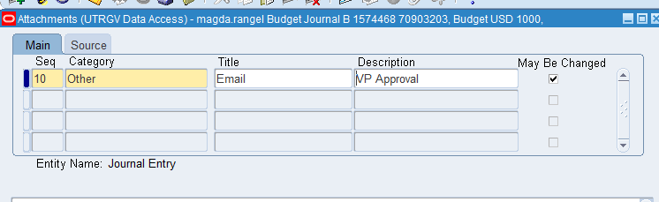

* + Under Data type you need to **select** file for excel or word documents or Short or Long text for e-mails.
* When you select file as the data type, Oracle will open a new window in explorer where you can search for and select the document you want to attach.

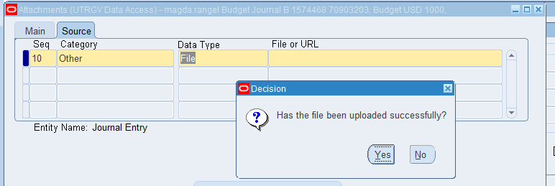

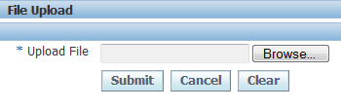

**Submitting Budget Revision**

* **Save** Revision using Disc icon in toolbar or **select** File and then **save**.
* **Click** on “**Check Funds**” and system will provide the results. If you want to see more detail, **click** on View Results.
* If passes check funds then **“Approve**”. This will start the workflow process.
* After message confirming that revision has been sent to approver is displayed you may close this screen.

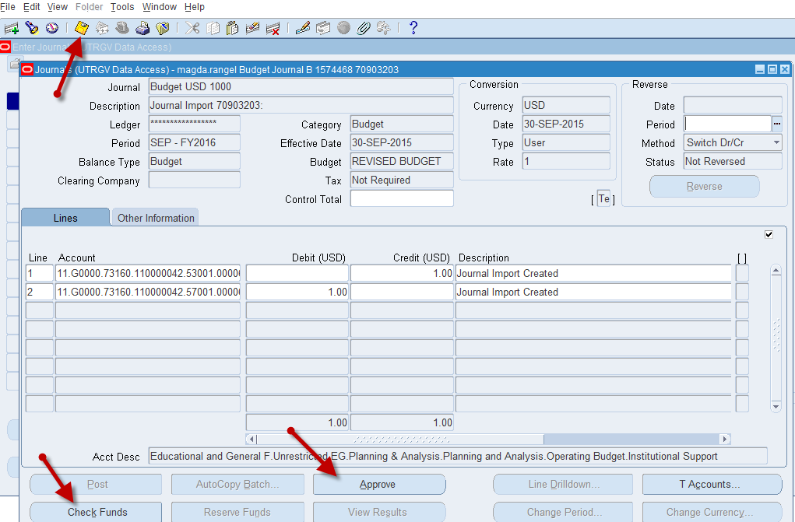

**NB**: Budget Journal goes for approval from where it is approved and the posted after the approval.

## **How to run a GL analysis with GLWand (on ERP)**

1. **Login** into ERP using the GLWand credentials

**Username**: WANDHQ

**Password**: lagos678 (this may change, so ask your colleagues to avoid getting the account locked).

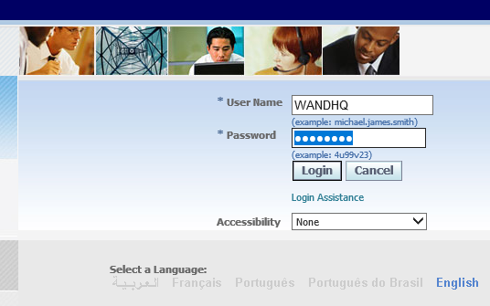

1. **Open** Excel (GLWand is an Excel addon, so it will need it to run).
2. In the menu section, **launch** GLWand by **clicking** on “**Excel4apps** **Wands**”

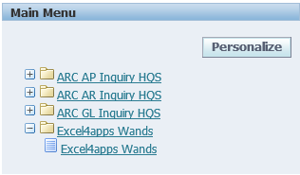

1. GLWand opens as extra tabs in an Excel worksheet (**check** your Excel file)

You should see 3 new tabs “**Excel4apps**”, “**GL** **Wand**” and “**Reports** **Wand**”

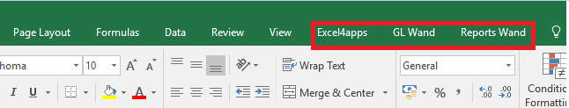

1. The GL analysis report exist as a “**template”, click** on **the “Reports Wand”** tab**,** thenon **“Shared Templates”**

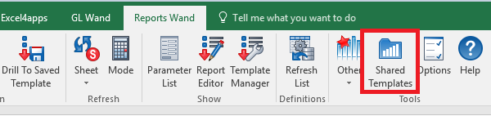

1. You will get this new window, there are 2 things to be done:
   1. **Red** **box**: In the “**Display templates**”, make sure you had “**All Types**”
   2. **Green** **box**: In the search filed, key in **“HQ”** (this is to limit the scrolling)
   3. **Yellow** **box**: the GL analysis report is named **“Account Analysis HQ”** (**open** it by **double**-**click**).

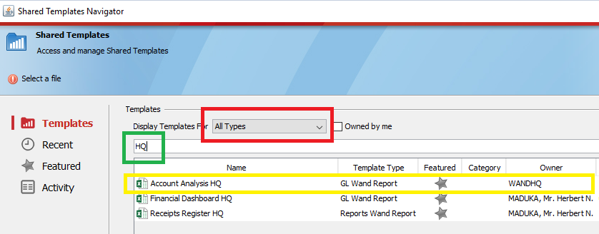

1. The report launches as a separate Excel file.

The file has three sheets:

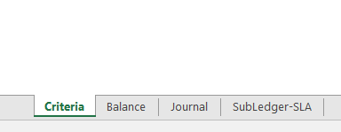

* **“criteria**”: for you to set your report parameters (period, account code, sub-account code, etc.)
* **“balance**”: to see the individual accounts/sub-account balances
* **“journal”**, and
* **“subledger-SLA**”: showing various levels of account details/drilldowns

To be sure of the account code details, **look** at the first column “**Account** **combination**”

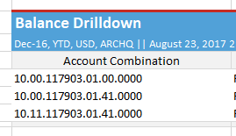

1. How to select the parameters:
   1. **click** on the “**criteria**” sheet
   2. **select** the values you need from the appropriate drop-down menus
   3. **double-click** on “**Execute** **Drilldown**”
   4. your report output will be displayed on the other sheets (“**balance**”, “**journal**”, “**subledger**-**SLA**”).

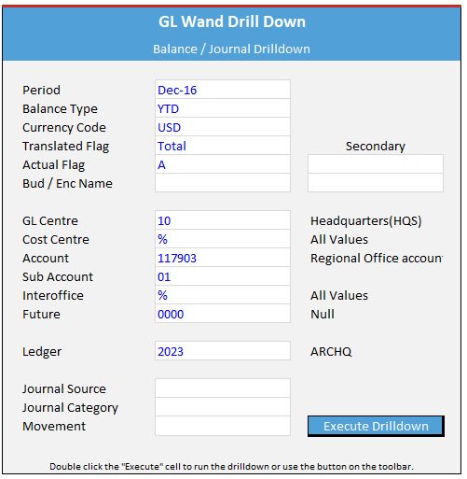

1. To close GL Wand: **click** on Excel4apps, then “**Exit**”

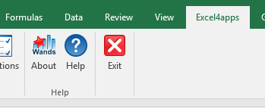

# **ACCOUNTS RECEIVABLE**

## **How to Open Accounts Receivable Period**

**Responsibility**: ARC Receivables Super User <<region>>

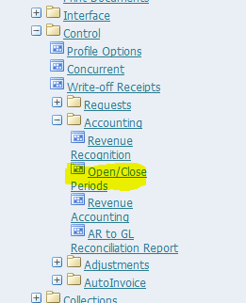

**Select** highlighted form: **Open**/**Close** **Periods**

If the next period to be opened is next to the latest open period (For instance, in the screen below, latest open period is Nov-16 and Dec-16 needs to be opened) **click** on the highlighted button, ‘**Open** **Next** **Period’**.

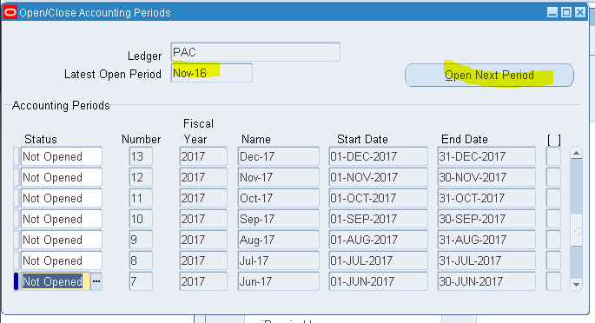

If it is Not Opened, **scroll** **down** to the period you want to open and **click** in the Status field.

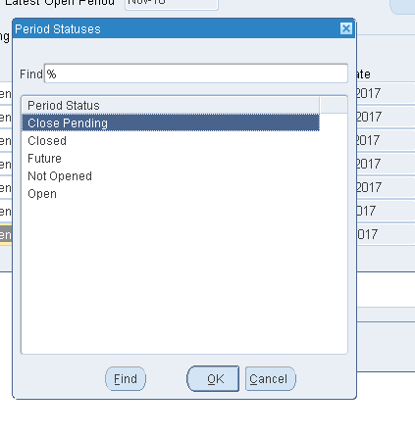

**Select** the **option**, Open from the **list** and **save** record.

### **Write**-**Back**/ **Allocation** **of** **Receipts**

### **Claims** **Settlement**

**Brief description**

A claim settlement consist in two steps; the creation of invoice, the settlement of the invoice. Each step can be broken down as follows:

1. **Creation of an invoice**

Invoices are created at the **Receivables** module level (this is the only module linked to the RMS application). After creation, the invoice is “**pushed**” to the Payables module (the module handles all outflows/payments).

* 1. Find the specific claim (search by Cedant/broker name, company number…)
  2. Offset the claim against any outstanding premium
  3. **Apply** “**refund**” to any balance amount (this will be the invoice amount)

1. **Settlement of the invoice**

All outflows/payments (either technical or not) are handled by the Payables module. The claim invoice create in the receivables module has to be found then settled (as any other invoice)

* 1. **Find** the claim invoice (search by “**trading** **partner**” and **refine** research by choosing “**payment** **request**” in the “**type** **of** **payment**” field)
  2. **Follow** standard payment procedures (initiate approval and pay)

Detailed description (with screenshots) – typical example: disbursement voucher P01707 Aug. ‘16

1. Invoice creation in the receivables module

In the receivables module open “**transactions**”

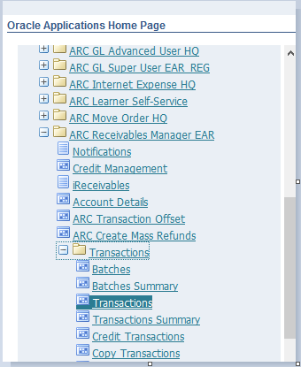

* 1. **Find the specific claim to settle**

The “**transactions**” function helps to query all technical transactions.

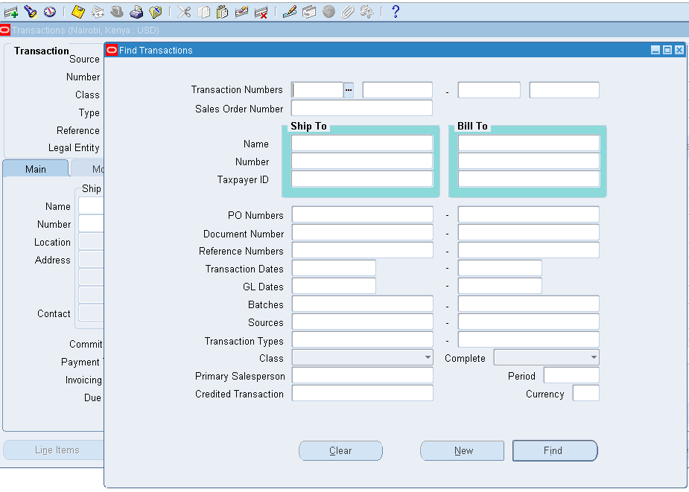

To find a specific claim, multiple keys (or filters) can be used. For example, “**policy** **sequence** **numbers**” (from RMS/IRMS reports) can be used in the “**transaction** **numbers**” field. Or, the “**COY** **CODE**” can be used at the “**Ship** **to**, **Number**” field. This will bring out the specific company (broker/Cedant). Another possibility is to use the company (broker/Cedant) name at the “**Ship** **to**, **Name**” field. To narrow the search to claims only, use the “**Sources**” field and **select** claims inward (see below).

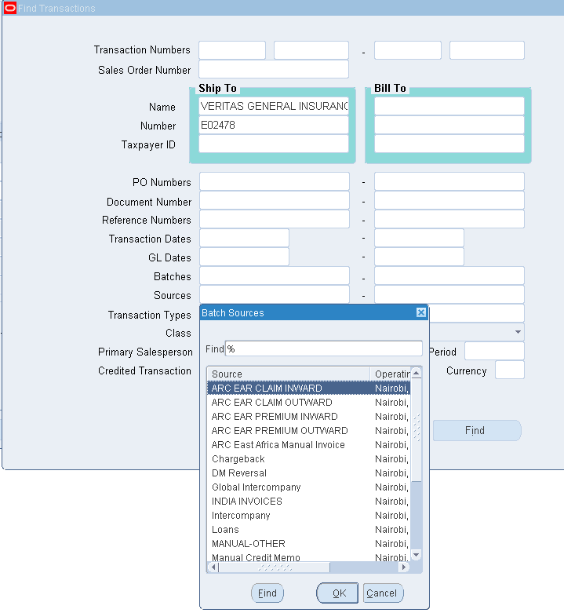

The search result gives a list of claims:

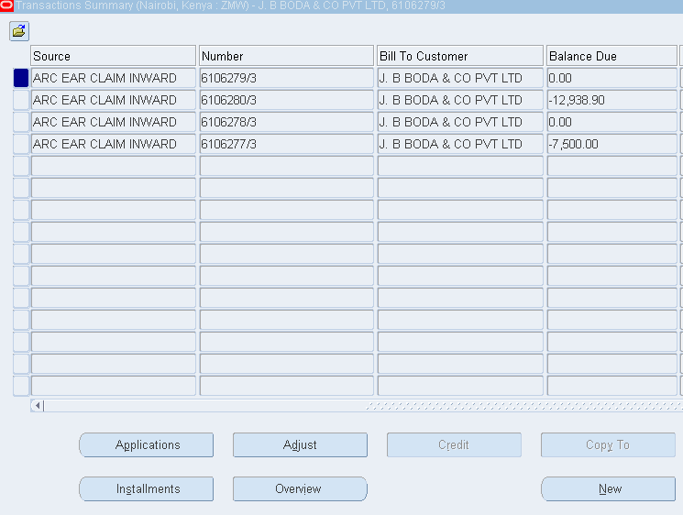

**Select** the specific claim you want to settle and **click** on “**Applications**”.

* 1. **Offset the claim against outstanding premium**

In case you do not want to pay the full claim amount, **select** a premium to offset against. Possible offset candidates are listed after “**Refund**”:

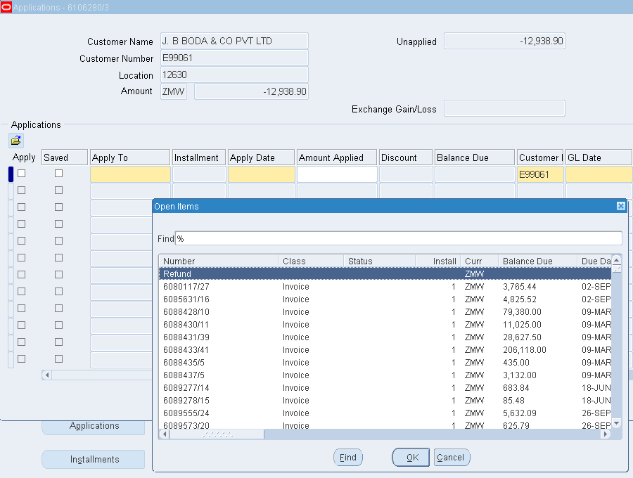

It is possible to filter the offset candidates by using the policy sequence number (RMS/IRMS report) in the “**find**” field (example below).

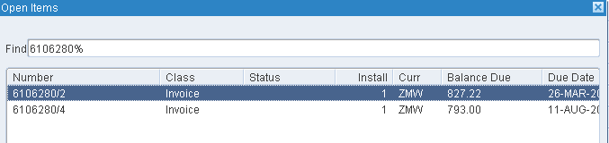

**Select** the premium you want to offset, then **update** the “**Apply**” and “**GL**” dates

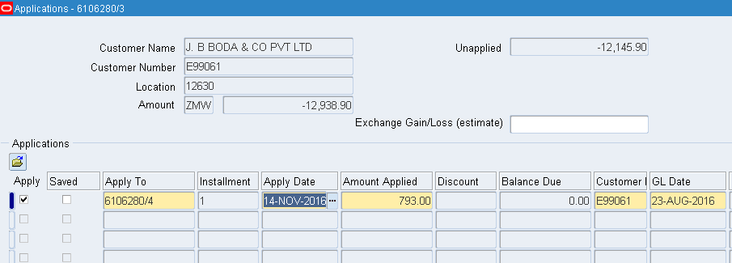

Notice that the net claim amount (“**unapplied**” field) reduces as you pick offsets.

* 1. **Create a “refund” invoice**

In case the claim amount is not fully offset, the balance amount will be paid. **Click** on the following blank row to create a new “**apply**” line.

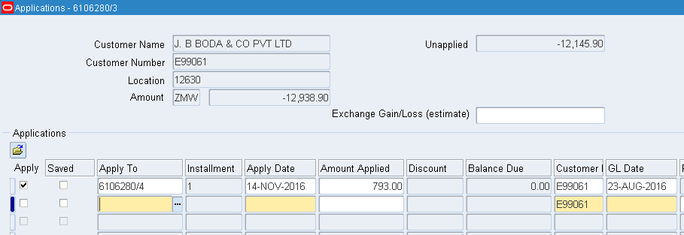

To create a settlement invoice, choose “**Refund**”, then **update** the “**apply**” and “**GL**” date. By default, this line will take as “**amount** **applied**” the full net claim amount (the unapplied amount becomes nil).

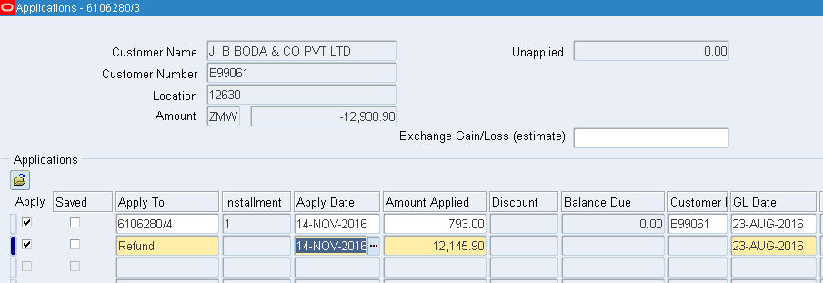

**Click** on the “**Refund attributes**” button. This allows to specify how you will settle the invoice (cash, check, bank transfer, etc.)

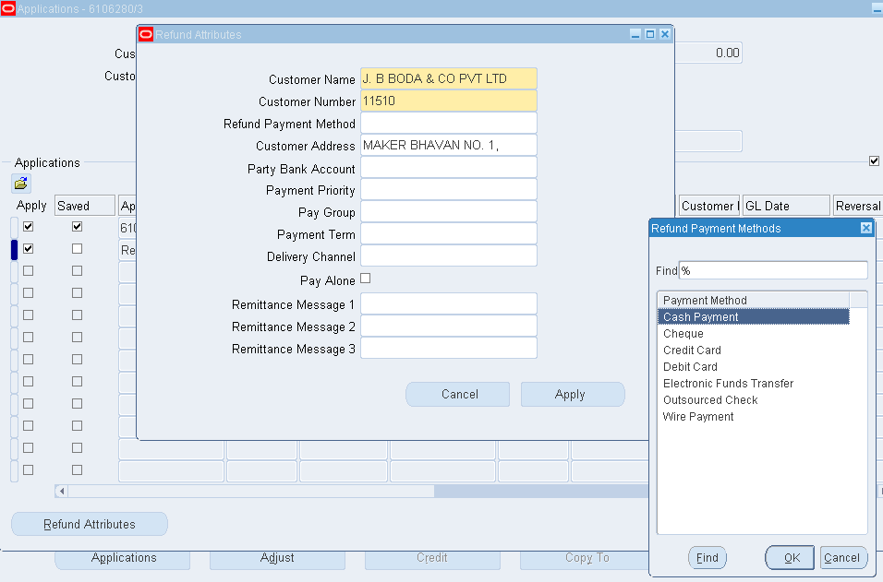

Once you have select the payment method, **click** on apply, then **save**. You should have a new “**Refund** **status**” button!

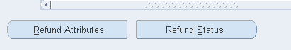

You need to **click** on “**Refund status**” to see two useful information:

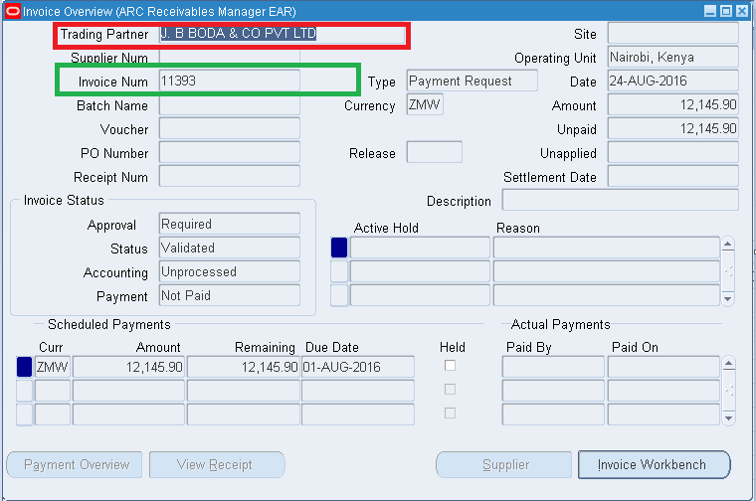

In **red**, you have the “**trading** **partner**” (the payee’s name). And the **new** **invoice** **number** (in **green**). The invoice number will help you find this specific invoice in the payables modules (tip: note it).

At this point, you are done with the Receivables module! The invoice has been created, you need to **switch** responsibilities (or ask whoever is in charge or payables to take over).

1. **Invoice settlement in the payables module**

In payables, **go** **to** invoices

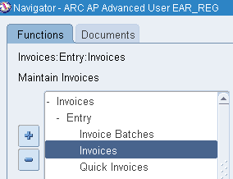

* 1. **Find the new invoice (created from the receivables module)**

The fastest approach to find an invoice is to use the **invoice** **number** (this brings out only one invoice).

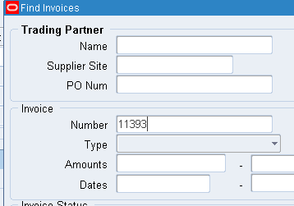

Otherwise, it is possible to search by trading partner (broker/Cedant). To narrow the search to invoices only created from receivables, in the “**Type**” field chose “**payment** **request**”.

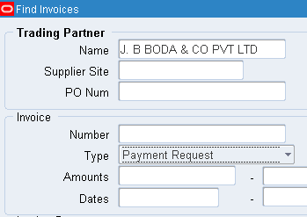

You should have your invoice in search result

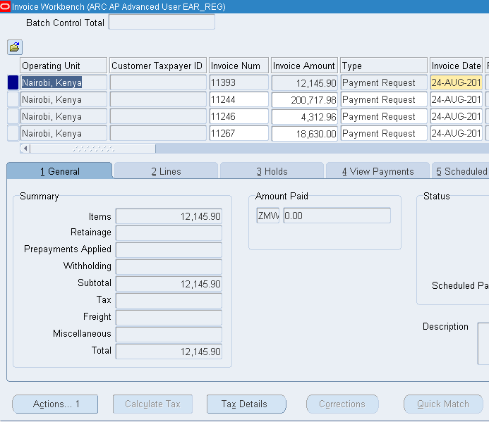

* 1. **follow payment standard payment procedures**

These steps are similar to all invoices irrespective their origin (technical payments from receivables, invoices created generate from procurement module, etc.)

* + 1. **review the payment and GL dates**

Double-check if the GL dates are accurate.

* + 1. **initiate approval**

**Click** on “**Actions**”

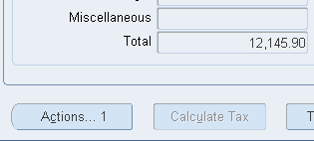

Then, **initiate** approval

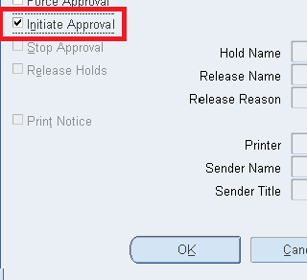

The invoice will follow the normal approval process. When approved, the “**pay** **in** **full**” field becomes active.

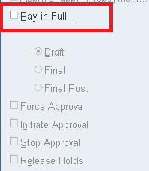

* + 1. pay in full

When you choose “**pay in full**”, you need to **double-check** and **update** these fields:

* payment date
* bank account (the actual cashbook account you want to settle the claim from)
* payment method
* payment process profile (choose: “**Africa Re Payment Profile**”)

**Pay** **attention** **to**:

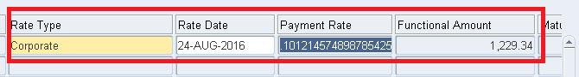

* rate type
* rate date
* payment rate (this field is updated automatically depending on the rate date)

**Tip**: to clear backlogs, choose **“corporate rate**”, then key in the specific voucher date, the payment rate should be the inverse (1/x) of the exchange rate found on the voucher. For example, voucher P01707 has an USD/ZMW of 9.88. The inverse of this figure is 0.10121 (the rate in the above screenshot). It is important to cross-check to avoid reconciliation issues.

**Save**.

If you query for the invoice, it should be marked as paid!

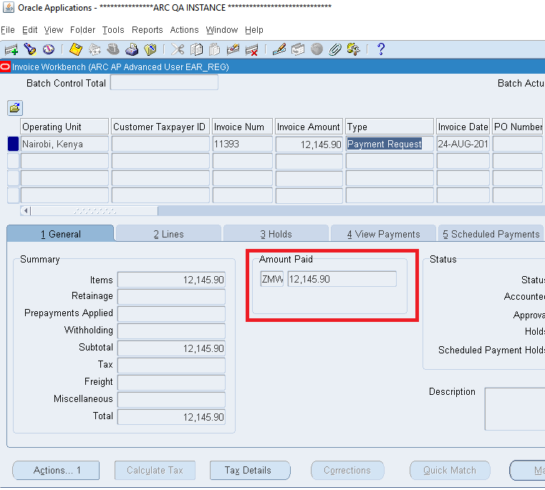

## **D. Defining receivables Activities**

Receivable Activities are used when inputting miscellaneous receipts. They provide accounting information for monies received that don’t relate to invoices or to account customers.

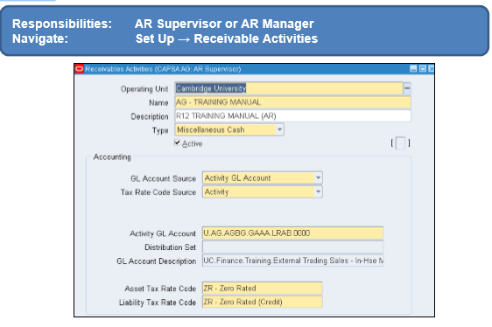

Populate the following fields:

* **Operating** **Unit:** Cambridge University (defaults in).
* **Name:** Prefix with your two letter department code followed by hyphen and name of the activity you are creating.
* **Description:** Free text field, enter details of the activity you are creating.
* **Type:** **Click** on the arrow and select Miscellaneous Cash.
* **GL** **Account** **Source:** Activity GL Account defaults in. However, if you require the income to be split to more than one distribution code refer to guidance on Distribution set.
* **Activity** **GL** **Account:** Populate the Distribution code you wish the income to go to by clicking on the list of values.
* **Asset** **Tax** **Rate** **Code:** Select the appropriate tax code for the activity from the list of values.
* **Liability Tax Rate** **Code:** Select the same code as the asset tax rate but it will appear as a credit.

Once all the details have been populated save your work and the activity is ready to be used with your miscellaneous receipts.

Responsibilities

# **ACCOUNTS PAYABLE**

## **How to Open Accounts Payable Period**

**Responsibility**: ARC AP Super User >>Accounting >>Control Payables Periods.

**Select** LOV and **change** to Open and then close.

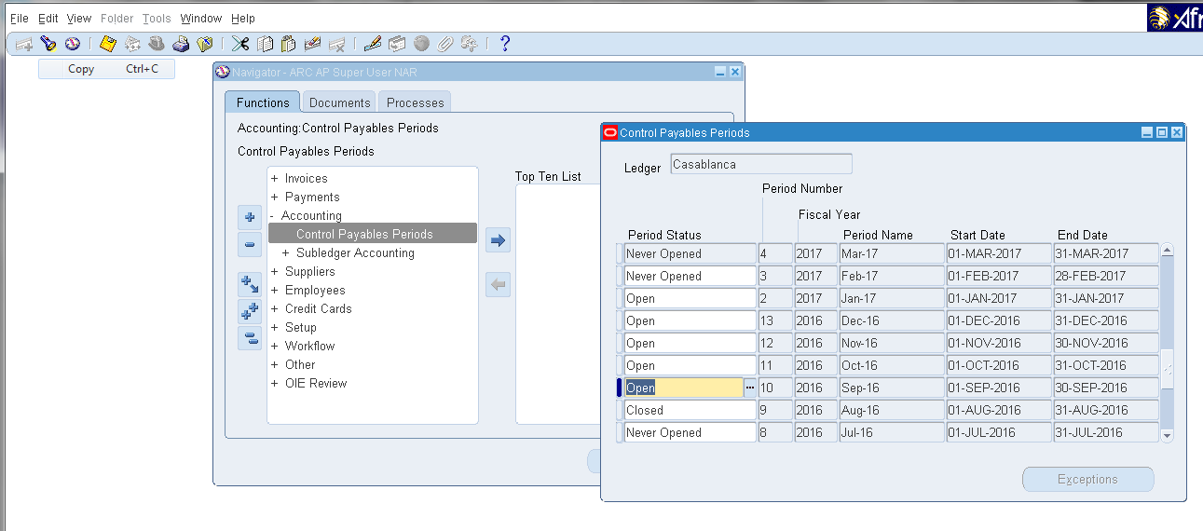

## **Auto Prepayment Application**

**Responsibility**: payables manger >> setup >> option >> payables option.

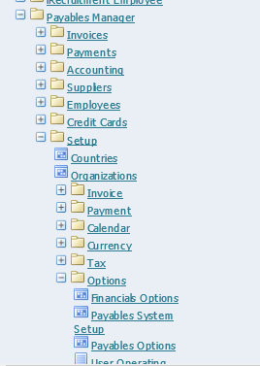

**Click** on Expense Report

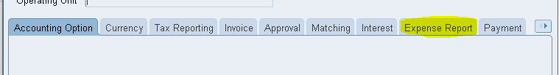

**Uncheck** box (Apply Advances) and **Save**.

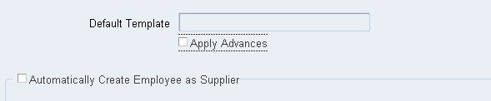

## **Un-applying prepayments**

If you mistakenly apply a prepayment to an invoice, you can un-apply it. Payables automatically creates a reversal distribution and a new scheduled payment for the prepayment in the amount that you un-apply. Payables also increases the Amount Available for the prepayment by the unapplied amount. Payables updates the status of the invoice to unpaid or partially paid. You can review in the Payments window of the Invoice Workbench all payment information for the prepayment and the invoice(s) to which it was applied.

**To un-apply a prepayment:**

1. In the Invoices window query either the prepayment or the invoice to which you matched it.

2. **Choose** Actions and **select** the **Apply**/**Un**-**apply** Prepayments check box. **Choose** OK.

* If you initially queried an invoice, Payables displays in the Existing Applications region of the Apply Prepayments window all existing prepayments that have been applied to it. **Select** each prepayment you want to **un-apply**. You cannot modify the Amount because you must **un-apply** the complete amount which you previously applied.
* If you want to limit available prepayment choices, **enter** a query or **use** the “**Find** **Prepayments** **to** **Apply**” window by choosing Find from the Query window. If you want to see more information on a prepayment, **select** it and **choose** Invoice Overview.
* If you initially queried a prepayment, Payables displays in the Existing Applications region of the Apply Prepayments window all invoices that have had the prepayment applied. **Select** each invoice from which you want to **un-apply** the prepayment. You cannot modify the Amount because you must **un-apply** the complete amount which you previously applied.
* If you want to limit available invoice choices, **enter** a query or **use** the “**Find Invoices to Apply**” window by choosing Find from the Query window. If you want to see more information on an invoice, **select** it and **choose** Invoice Overview.
* If you want to approve the new prepayment distributions that the application will create and the Allow Online Approval Payables option is enabled, **select** Approve. If the Allow Online Approval Payables option is not enabled, you can submit Approval from the Submit Request window.
* If you want to print a Prepayment Remittance Advice for the supplier, select **Print.**

1. **Choose** the Apply/Un-apply button to **un-apply** the prepayment amount(s) to the invoice(s), and to save your work.

## **Creating a bank, branch and account**

**Navigation:** ARCAR Super User HQS <<location>> 🡺 Setup 🡺 Receipts 🡺Banks

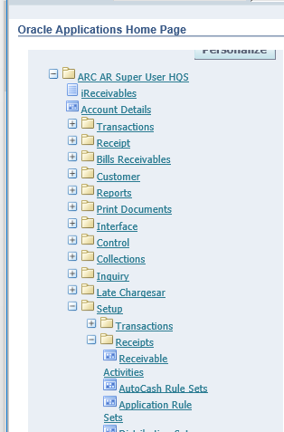

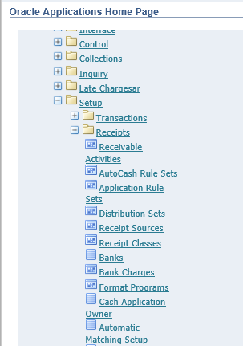

**To create A Bank**

**Click** on **Banks**

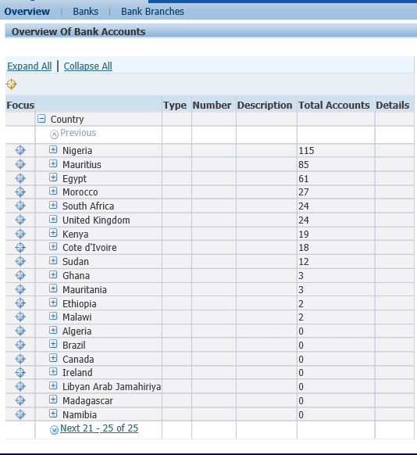

On the **Banks** form **click** on the **Create** button.

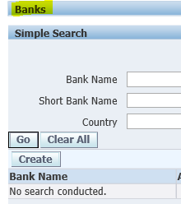

On the BankInformation form, **select** the ‘**country**’ for the bank, fill the ‘**Bank Name’**, and the ‘**Alternate Bank Name’**. then **click** SaveandNext button.

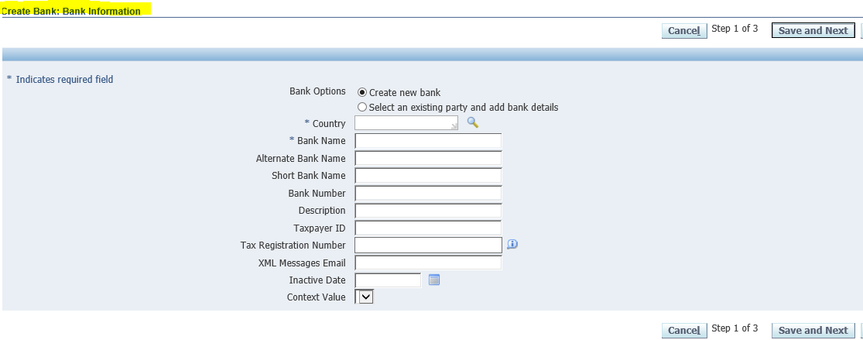

On the BankAddress form, **click** on the ‘**Create’** button to add the bank address.

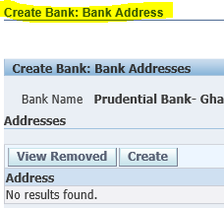

**Fill** in the necessary information. Then **click** the **Apply** button, which would then take you back to the previous page, then **click** on the **Save and Next** button.

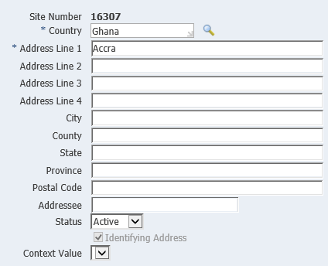

On the BankContact form, **click** on **Create** **Contact** to add the necessary contact information.

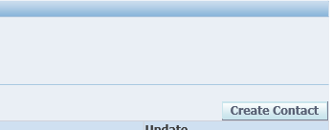

**Fill in** the necessary information, **click** the **Apply** button which would take you back to the previous page. Then **click** on the **Finish** button.

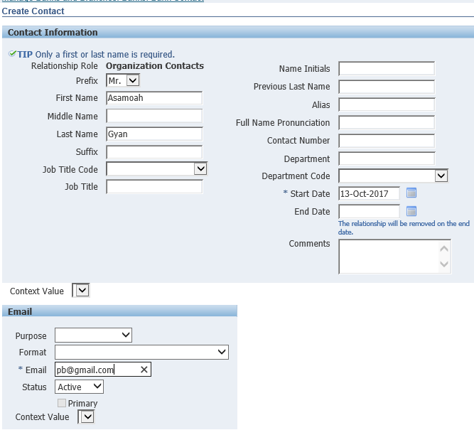

You would get a **Confirmation** **message**.

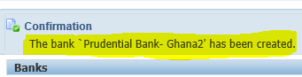

**To create a Branch**

**Click** on BankBranches then **click** on **Create** button.

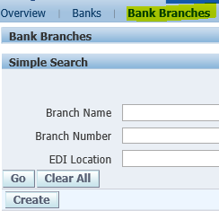

**Select** the **Country** and the **Bank Name**, then **click** on the **Continue** button.

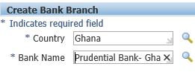

**Fill in** the required fields, then **click** on the **Save and Next** button.

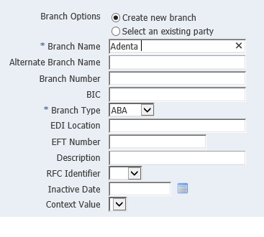

On the **Branch Address** form **click** on the **Create** button to add an address for the branch.

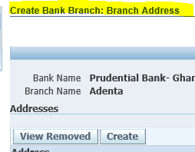

**Fill in** the required fields, and **click** on the **Apply** button, which would take you back to the previous page. Then **click** on the **Save and Next** button.

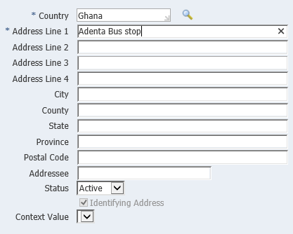

On the **Branch Contact** form **click** on the **Create** button to add the neccesary contact information for the branch.

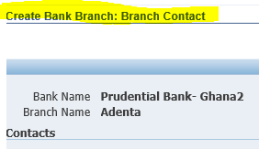

**Fill in** the necessary information and **click** the **Apply** button, which wouldn take you back to the previous page then **click** the **Finish** button.

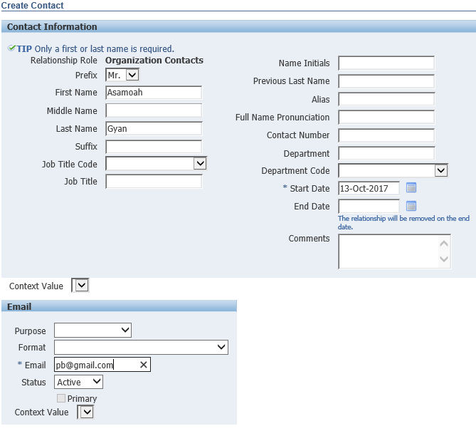

You would get a **Confirmation Message**.

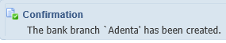

**To create an Account.**

On the **Overview** form, **select** the **location of the bank**.



**Select** the **Bank**.

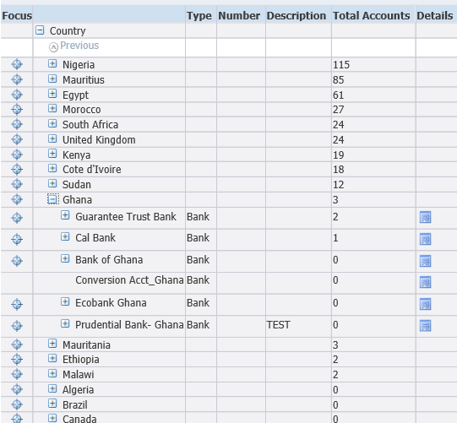

**Click** on **Details.**

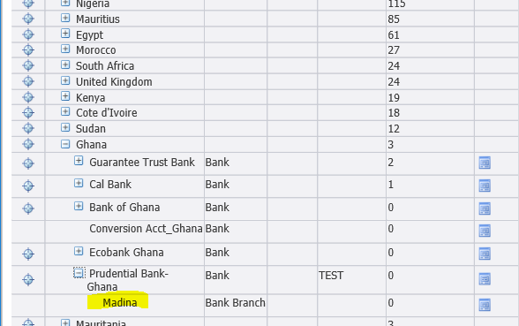

On the **Bank Branches** form **click** on **Create Account** button**.**

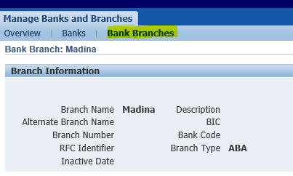

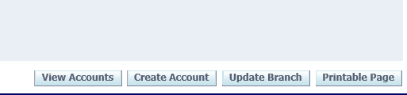

On the **Account Owner and Use** form, **Fill in** the **Bank Account owner** and **tick Payables** and

**Receivables (**depending on the type of account you want to open) under **Account Use**. Then **click** the **Next** button.

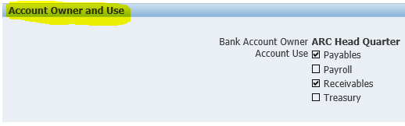

On the **Account Information** form, **fill in** the **Account Name, Alternate Account Name**, and **Account Number** and **select** the **Currency** for the account. Then **click** the **Next** button.

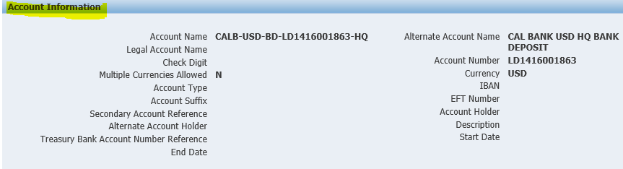

On the **Account Control** form, **fill in** the **Cash** field. Then **click** the **Next** button.

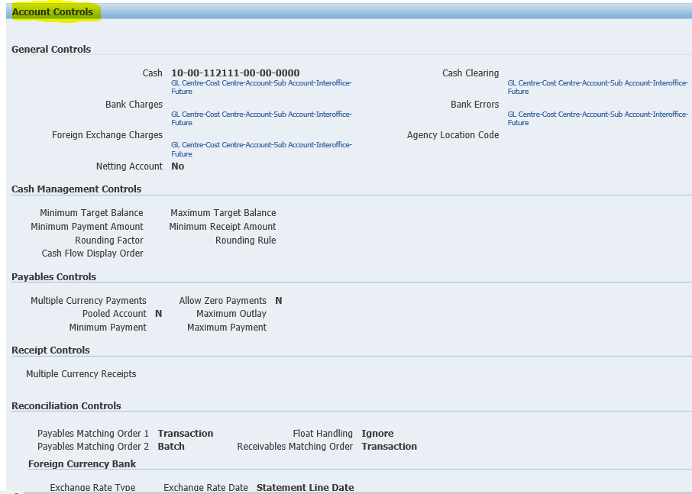

On the **Account Access** form, **fill in** the organization and **tick Payables** and **Receivables**. Then **click** the **Next** button**.**

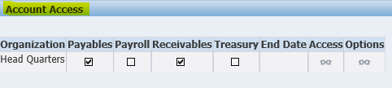

On the **Account Contact** form, **fill in** the necessary information and then **click** the **Save** button. 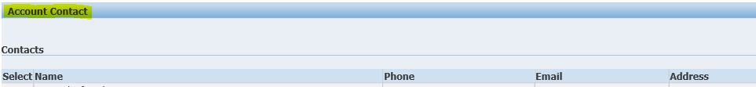

## **Voiding Payments and Cancelling invoices**

To Void a Payment, you **go to** the Following under **AP**: Payments -🡪 Entry --🡪 Payments: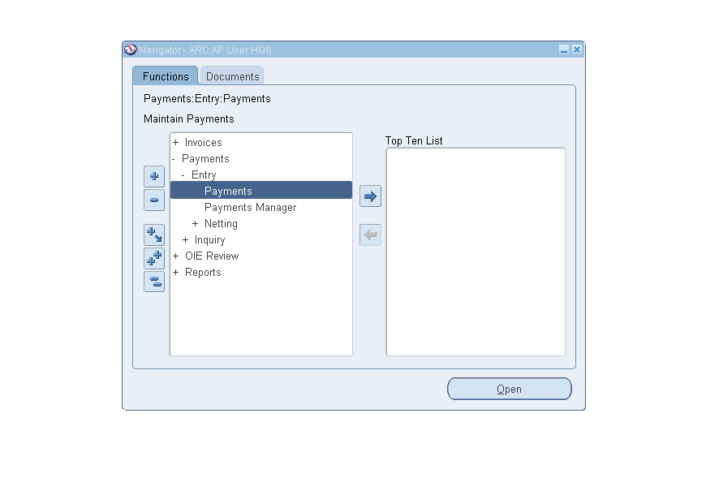**Use** the findbutton, under “**Edit**” to lookfor the payment:

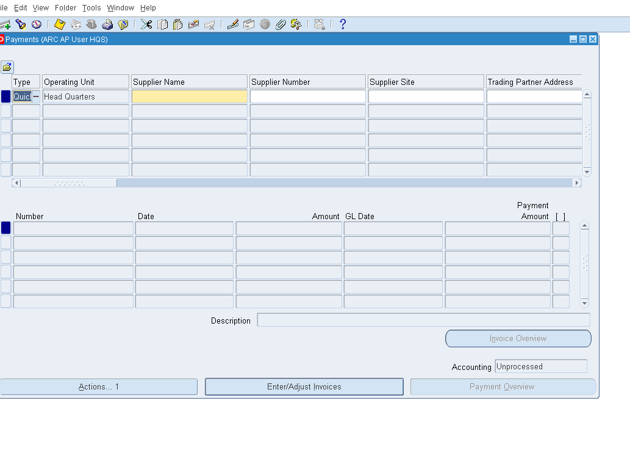

**Enter** the ‘**Payment Number’** or ‘**amount’** and the ‘**currency’** in the ‘**Find Payment Menu’** and **click** on Find:

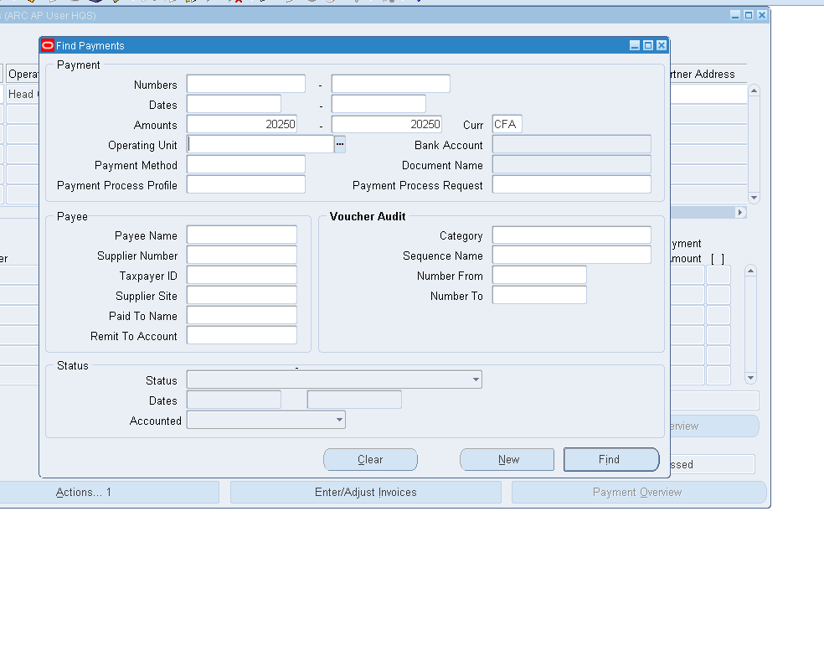“**Click** on **Action**… 1”

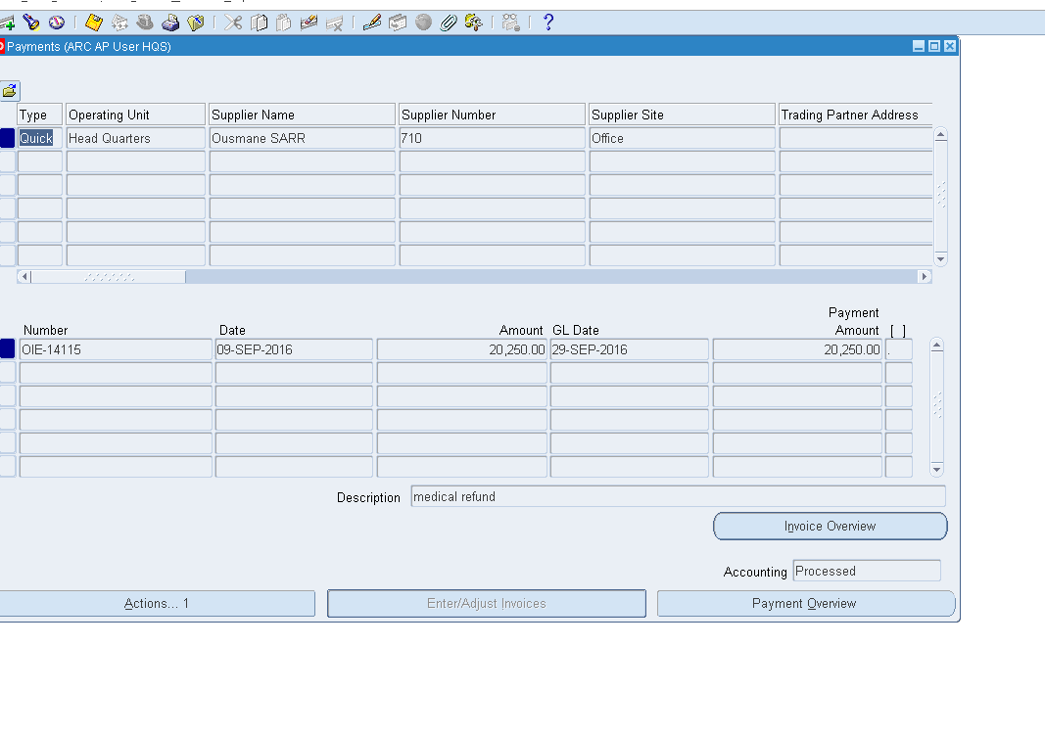**Tick** the boxVoid, **enter** the date for which the payment is to be voided

**Date**: Should normally be the same **‘Date Payment was issued’** in case of processing error. In case of return cheque, it should be the **‘date the cheque was returned’** by the bank. Date: This date has no impact on Accounting.

**GL Date:** Should normally be the same **‘Date Payment was issued’** in case of processing error, so the reversal is accounted in the same GL Period. In case of return cheque, it should be the ‘**date** **the** **cheque was returned’** by the bank. **GL Date:**  This date has impacts the GLAccounting.

The ‘**Invoice Action’** should be used properly depending on the reason **Cheque** is being voided:

**Note:** This should be the default option. If the Invoice was process properly and only the payment contain error, the Invoice does not need to be cancel. Selecting none will cancel only the payment and account the reversal with the GL Date selected.

**Cancel: Should be used wisely**. This option is only selected if **’both the payment and the Invoice’** contain errors and need to be reversed. The invoice will be cancelled, pending accounting (Partially Accounted). Both Invoice and Payment will be cancelled using the **GL Date entered**.

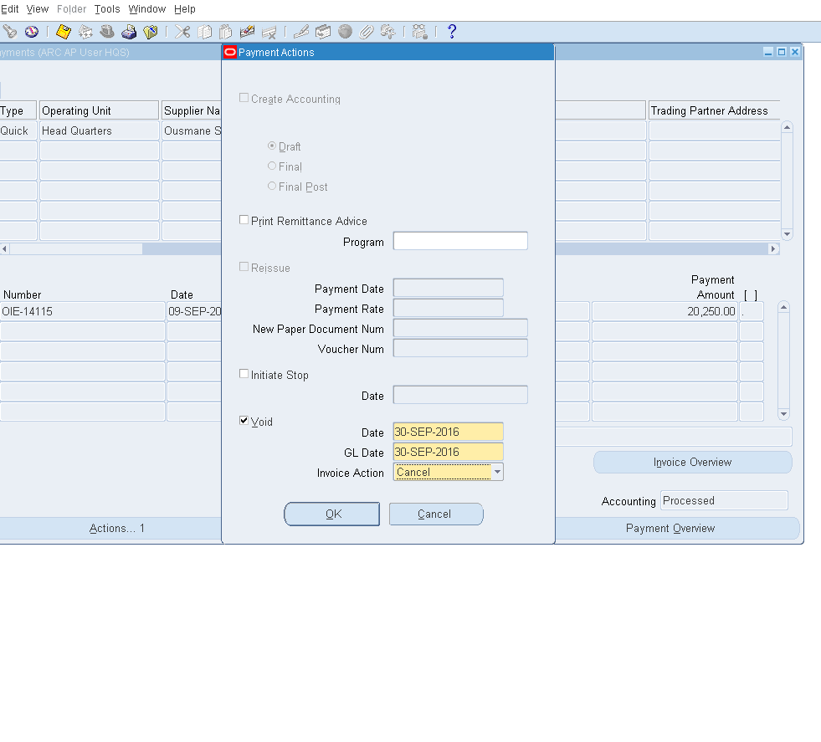

A **warning** prompt will come up, **click** “ok”

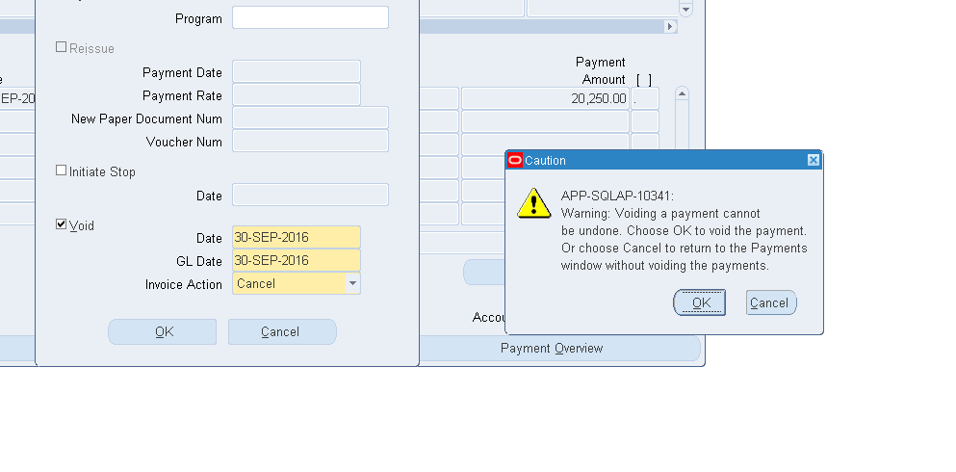

**Click** on **‘Create** **Accounting’** and final **post** and then “**ok**”:

In case option **selected** was ‘**Cancel**’, both Payment and Invoice should be **accounted** to have the **net effect** expected in the GL. See explanation above.

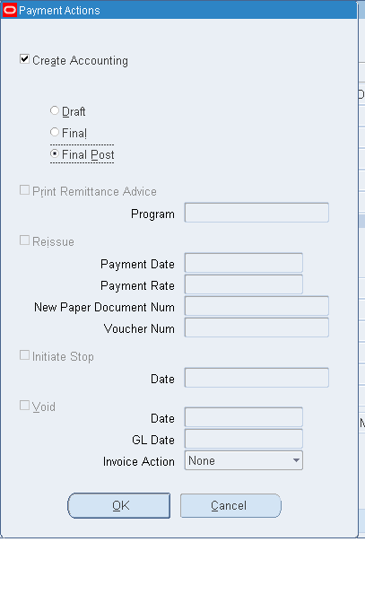

This completes the process of **voiding** a payment and canceling an Invoice.

## **Treatment of Cash Calls and Payments in Foreign Currencies**

* 1. **Treatment of Cash Calls:** SuggestedSolution1

**Use** prepayment functionality in Payables Application (AP). This allows asset of the advance payment to cedants to be captured and written off when claims payable are subsequently processed.

* + 1. **Tasks**
* Before Claims are processed

1. **Raise** a prepayment invoice for cash calls in Payables Application (AP) and **pay** the cedants.

* When Claims are processed

When Claims payable are processed from RMS, they are created as a credit memo in AR. They have to be written down to zero because they cannot be applied to the prepayment invoice earlier created in **task** **1.**

1. **Call** **up** the claims in AR
2. **Create** an invoice with the same amount in AR.
3. **Offset** the credit memo against the invoice in **task** **3**
4. **Create** a standard invoice in AP and **apply** to the prepayment invoice in **task** **1** above.

**Pre-requisites**

Cedants must be created as suppliers in AP.

Shortcomings of This Solution

1. Writing back these claims to RMS when payments are made may be difficult
2. The process is long
   1. **Treatment of Cash Calls:** SuggestedSolution2

Process cash calls as partial claims before claims are processed and the balance as additional claim when claims are finally processed.

* + 1. **Tasks**

Before Claims are processed

1. **Process** the cash call (amount payable) as partial claim via RMS before the claim processing is completed.
2. **Call** **up** the claim in **task** **1** and **apply** to Refund in AR.

When Claims are processed

1. **Process** the balance via **RMS**, if any, as additional claim when claim Processing is finally processed.
2. **Call** **up** the claim in **task** **3** and **apply** to Refund in AR.

Ease of Processing

1. This is straight forward and writing back to RMS is easy.
2. Tasks 1, 3, 4 and 5 of suggested solution 1, which is long and time consuming, are eliminated.
   1. **Payment of Claims and Other Payables in Foreign Currencies**

Every Office, except in countries with embargo on payments from USD bank account, can pay their claims, premiums and other bills in any currency directly from their USD bank account.

* + 1. **Countries with Embargo on Payments from USD Bank Account**

**Problems**

1. These offices cannot pay claims, premiums and any bills in foreign currencies from their local currency bank account. This is because this bank account currency is not the functional (i.e. ledger) currency for African Re and, therefore, cannot be used for multicurrency payments in Oracle Application.
2. They also cannot make payments from their USD bank account because their national laws do not allow it.
   * 1. **Suggested** **Solution** 1

Pay in local currency. This means claims, premiums and other bills in foreign currency would be settled in local currency equivalents.

**Treatment in Oracle Application**

All Claims and Premiums payable in foreign currencies are currently processed from RMS and created as credit memos in Oracle Receivables (AR). They should be written down to zero and recreated in AR in local currencies. This is because they cannot be paid in foreign currencies.

**Tasks**:

1. **Call** **up** the claims in AR to view details
2. **Create** invoices with the same amount, currency and other details
3. **Offset** the invoices in **task** **2** against the claims (credit memo) in task 1. This brings down the value of these credit memos to zero.
4. **Create** another credit memo in local currency with equivalent amount
5. **Apply** the credit memo in **task** **4** to Refund to create a payment request in Oracle Payables (AP)

**Shortcomings**

1. Writing back these claims to RMS may be difficult.
2. The process is too long
   * 1. **Suggested Solution 2**

Process all claims and other payables in local currency directly from sources (RMS).

**Tasks**

**Call** **up** the claims in AR and **apply** to Refund

**Ease of Processing**

1. This is straight-forward and makes writing back to RMS easy
2. Tasks 2 to 4 in suggested solution 1 are eliminated

## **Creating Suppliers**

**A) Search existing suppliers**

**Note**: Before creating a new supplier, **search** and **ensure** the supplier does not exist in the system. Below is how to search for a supplier.

**Navigate** **to**: Purchasing >> Supply Base >> Suppliers

**Enter** the name of the supplier or the initial of the supplier followed by (%) or the full name of the supplier

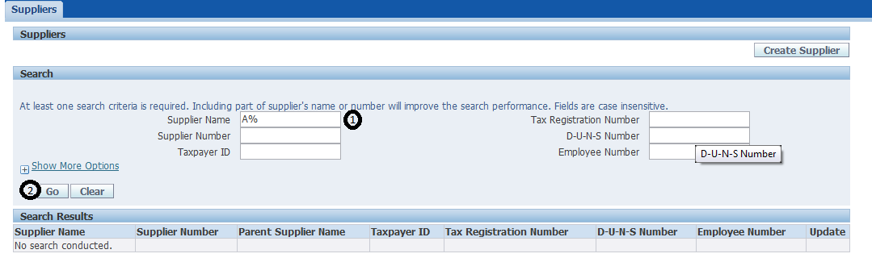

**Click** Go, in the case of Initials you will get a list of suppliers starting with the first letter entered

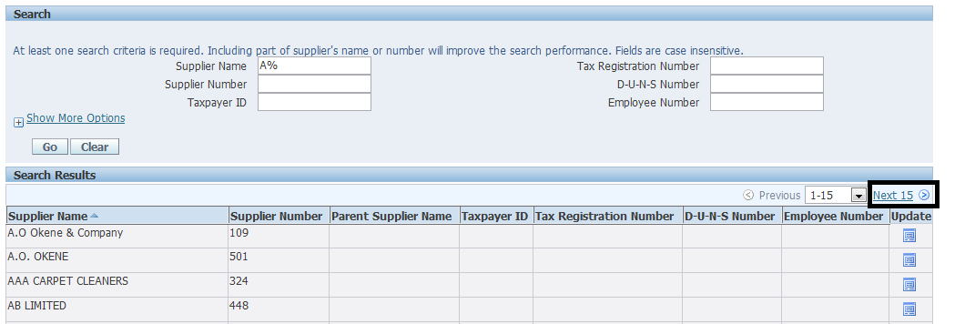

**Note**: if the name of the supplier is not on the first search result **click** on “**Next**” until you find the supplier, if at the end of the search the supplier is not available this means the supplier does not exist.

**B) Creating New Supplier**

This process is for creating a new supplier in the system

**Navigate** **to**: Purchasing>> Supply Base>> Suppliers

**Click** “**Create** **Supplier**” at the top right corner of the form

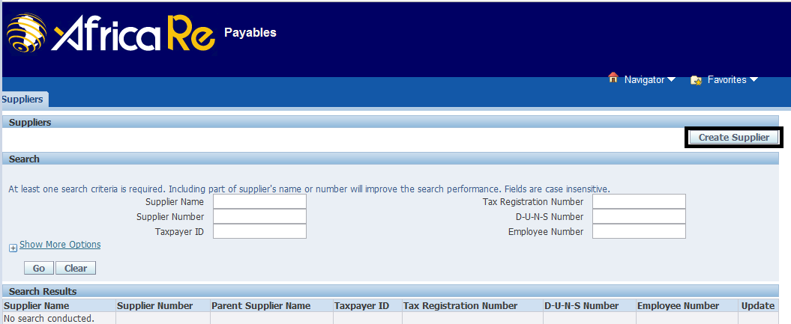

This opens the **“Create Supplier form**”

1. **Enter** the Supplier name in proper cap (Example: Mattsong Limited)

2. **Alias**: **Enter** Alias for the supplier (Optional)

3. **Enter** the Tax Country and Tax Registration Number if applicable

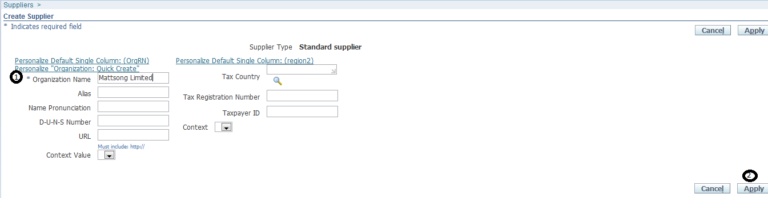

**Click** Apply.

**1. Entering Supplier Specialization**

**Click** on the “**Organization**” tab and under the Type field **select** the supplier specialization by clicking on the search icon

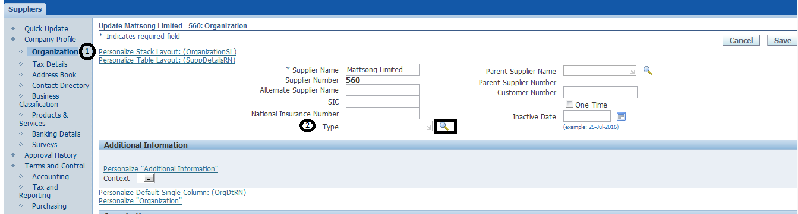

The search form will open, **click** on “**Go**” a list of specialization will be dispalyed. **Click** on the quick select icon on the appropriate specialization

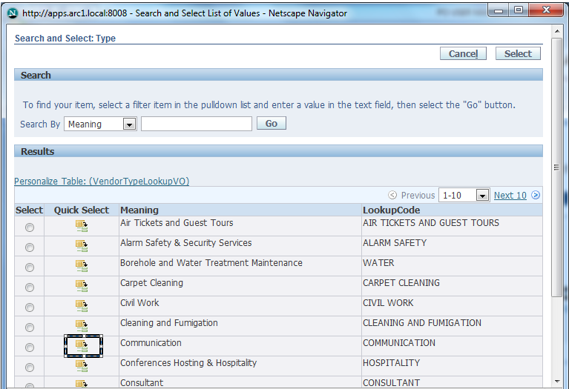

This will populate the selected specialization on the “**Type**” field, **enter** as much information available and **click** save.

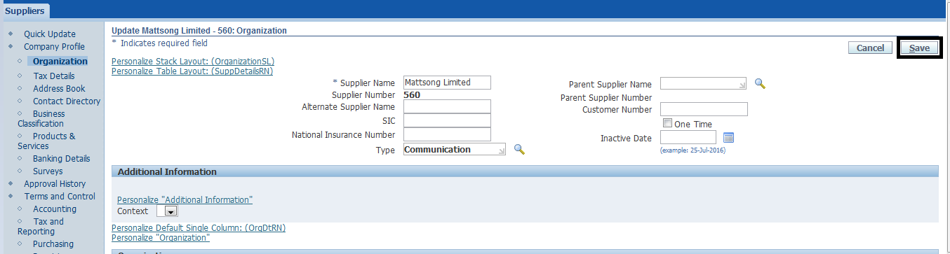

**2. Entering Tax Details**

**Note**: This is for region using tax

**Click** open the “**Tax** **Details**” form

1. **Check** the Allow Witholding Tax

2. **Check** the either Federal or State under ‘**Reportable’**

3. **Check** the ‘**Set Invoice Values as Tax Inclusive’** box

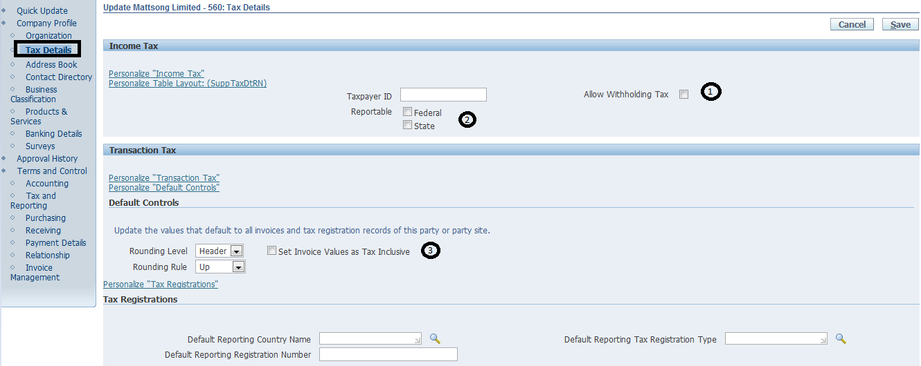

**Enter** as much information available on the supplier tax details on this form then **click** Save.

**3. Address Book**

1. **Click** on the Address Book Tab

2. **Click** ‘**Create’**

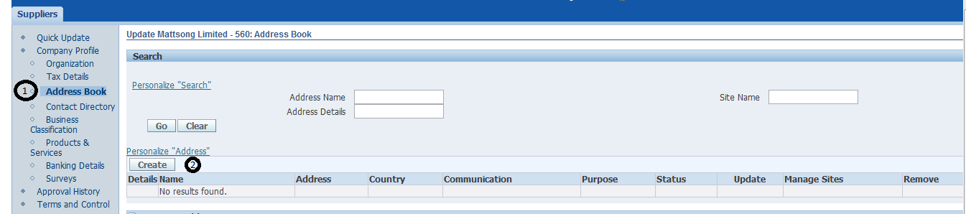

The Create Address form opens

**Enter** the following

1. Address Line 1

2. City

3. Address Name (This is for proper documentation, for suppliers with two different address, the address name should also differ for easy identification)

4. ‘**Optionally’** **enter** the supplier Phone Number

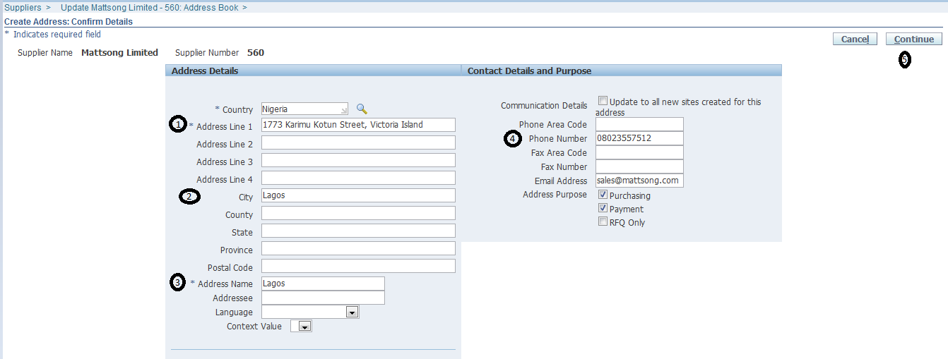

5. **Click** ‘**Continue’**

The Site creation form opens

1. **Check** the box beside the Site Name

2. **Click** Apply

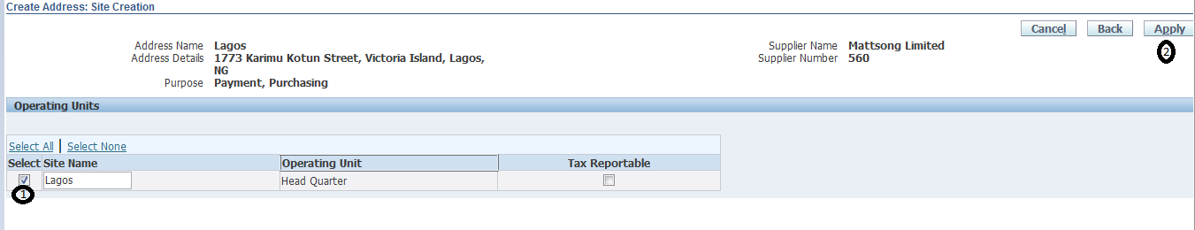

You get a confirmation about the Address Book creation

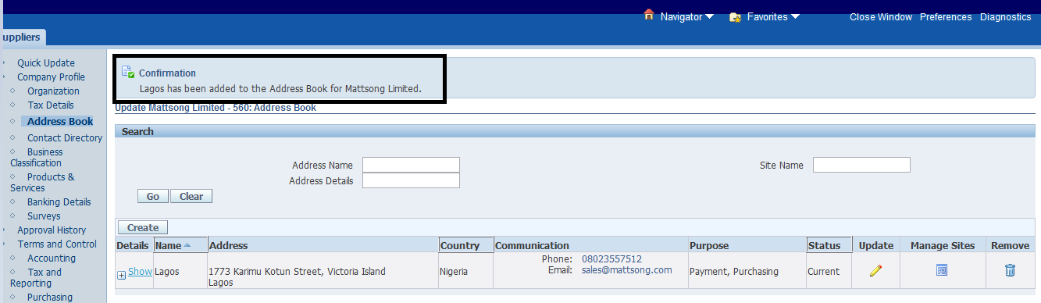

**4. Contact Directory (Optional)**

1. **Click** on ‘**Contact** **Directory’**

2. **Click** on ‘**Create’**

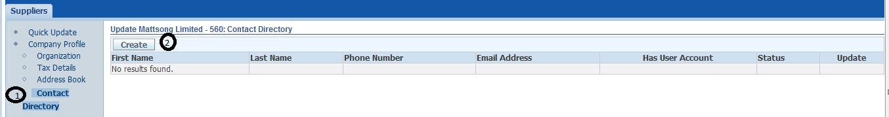

When you click on Create, the Create Contact form opens

1. ‘**Optionally’** **enter** the Contact Title

2. **Enter** the Last Name

**Enter** any other information available for the supplier contact directory

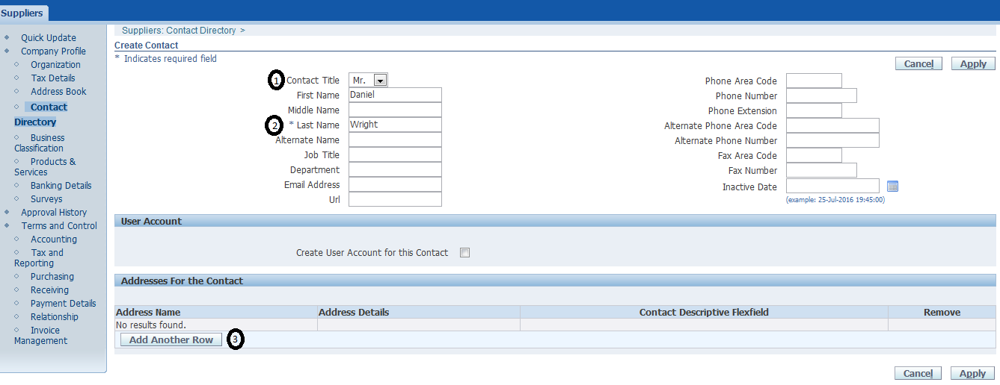

3. **Click** “**Add another Row**”

1. **Click** on the search Icon to enter the Address Name

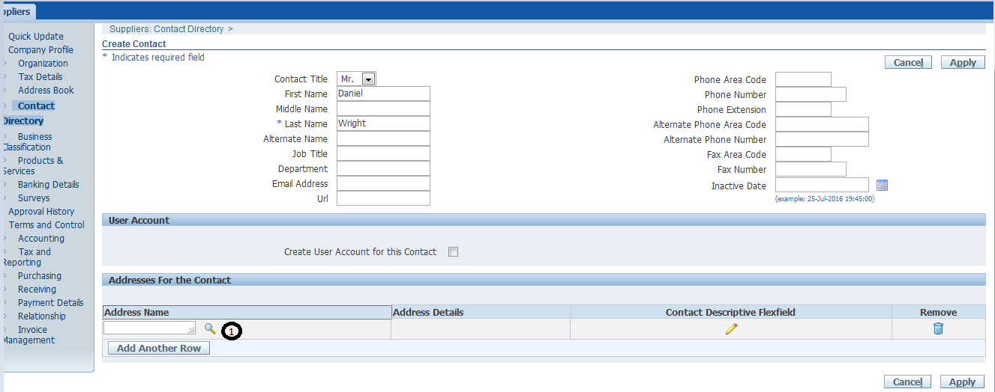

Once the Address populates

2. **Click** Apply

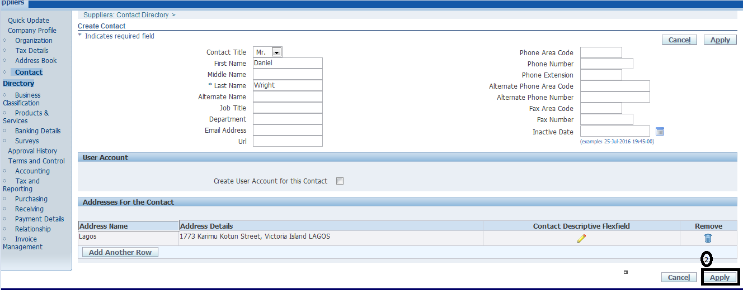

**5. Business Classification (Optional)**

1. **Click** on the Business Classification tab

2. **Select** the appropriate business classification for the supplier

3. ‘**Optionally’ select** the Status and **Click** Save

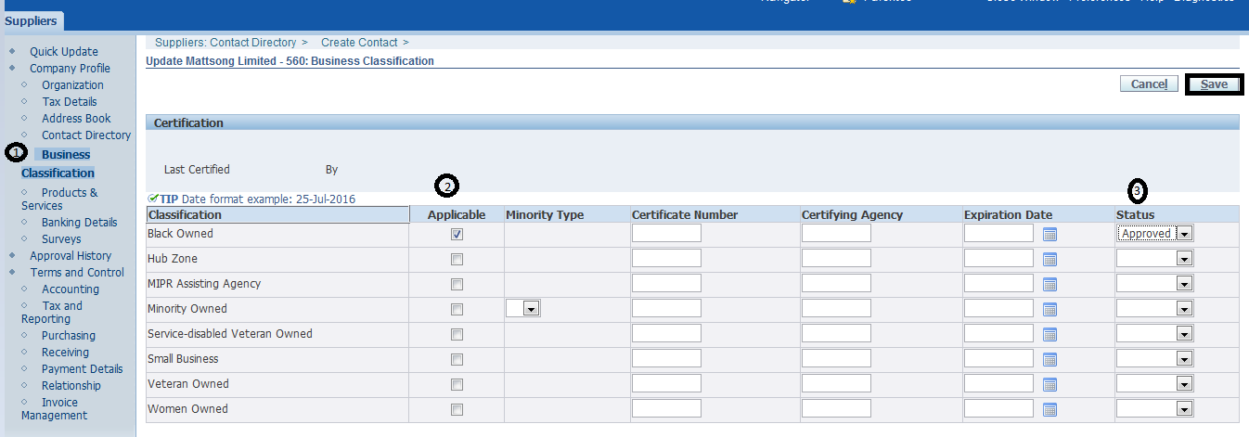

**6. Products and Services**

1. **Click** the Products and Services tab

2. **Click** ‘**Add’**

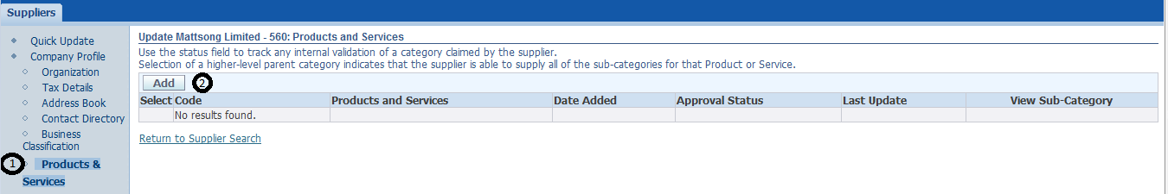

Add Products and Services form opens

1. **Select** the applicable code

2. **Click** Apply

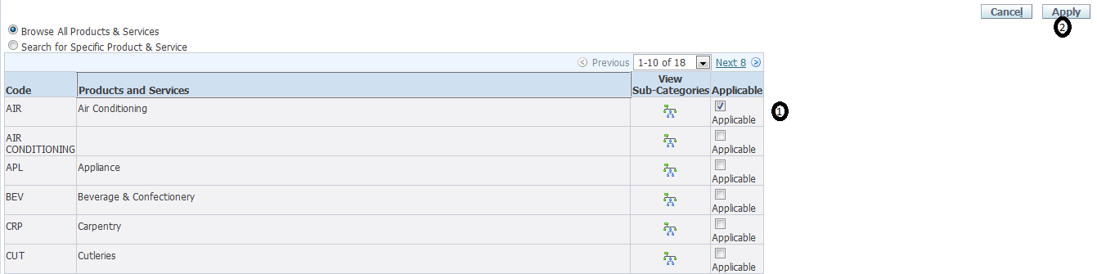

This takes you back to the Products and Services form,

1. **Check** the box of the products and services selected

2. **Click** Approve

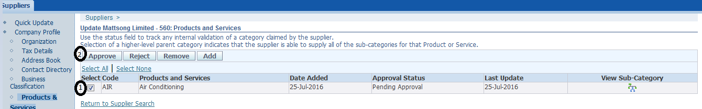

A confirmation is displayed for the Products and Services

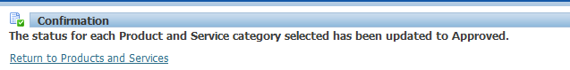

**7. Banking Details**

1. Open the Banking Details form

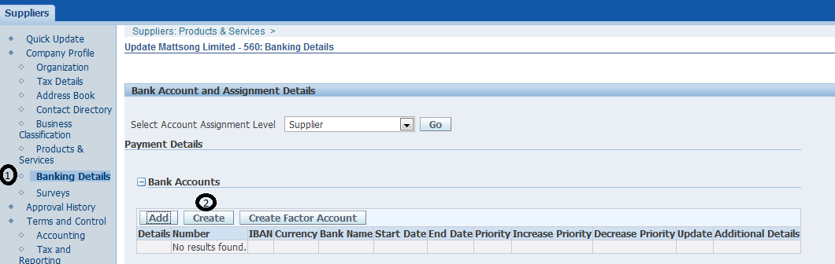

2. **Click** Create

For existing bank, **query** the bank and **enter** the bank account details. For new bank, **select** “**Create New Bank**”, **select** the appropriate country and **enter** the bank details including the account details.

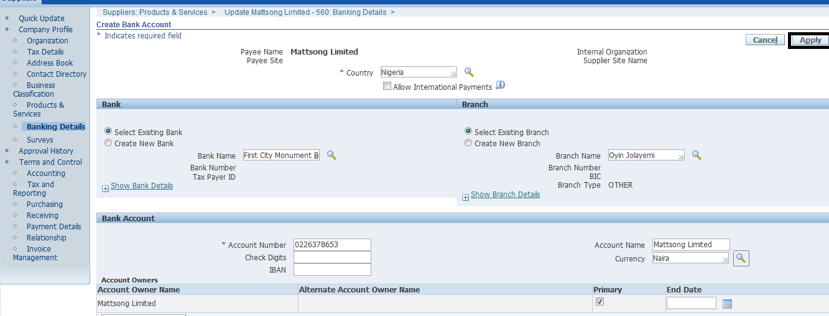

**Click** Apply and **Click** Save on the next form.

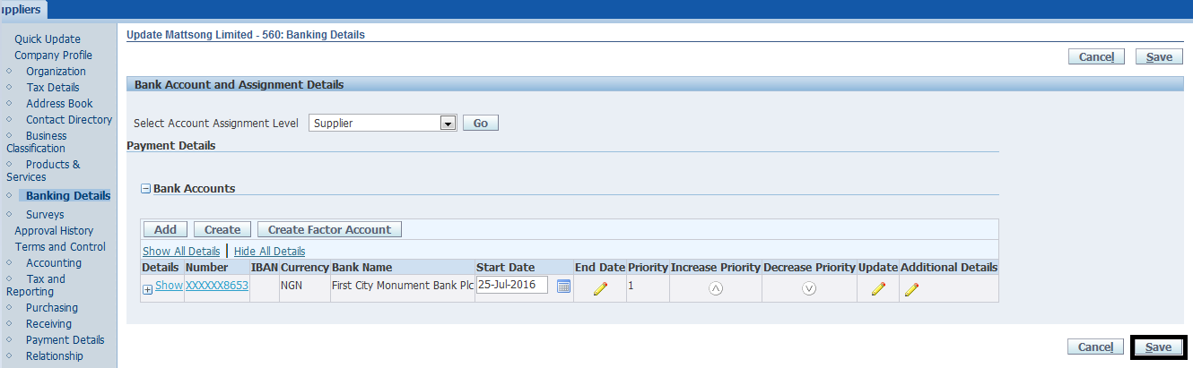

**7. Purchasing**

**Click** on Purchasing Tab

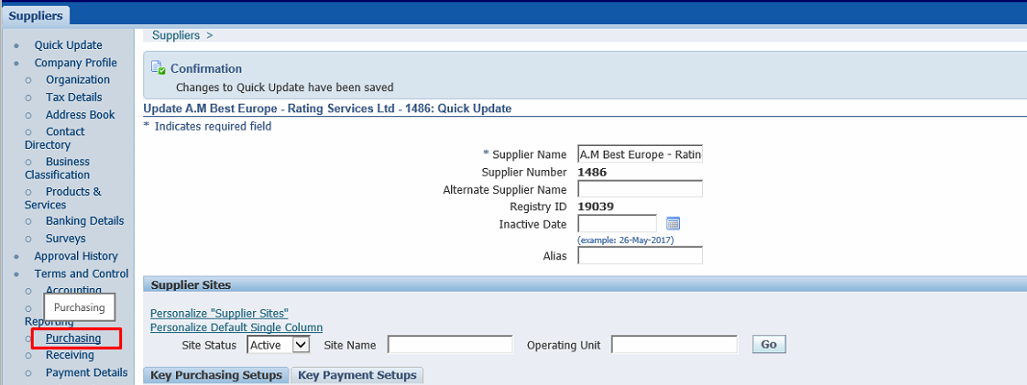

**Open** the “**Self Billing**” Form

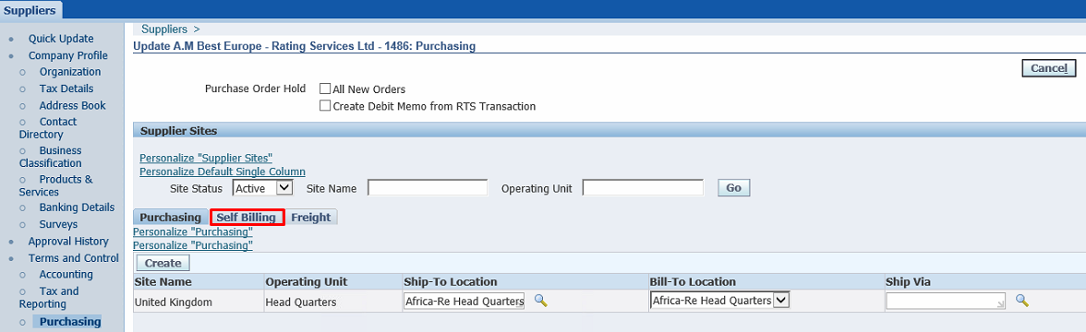

**Enable** **“Create Debit Memo from RTS Transactions**” and then **Save** the form.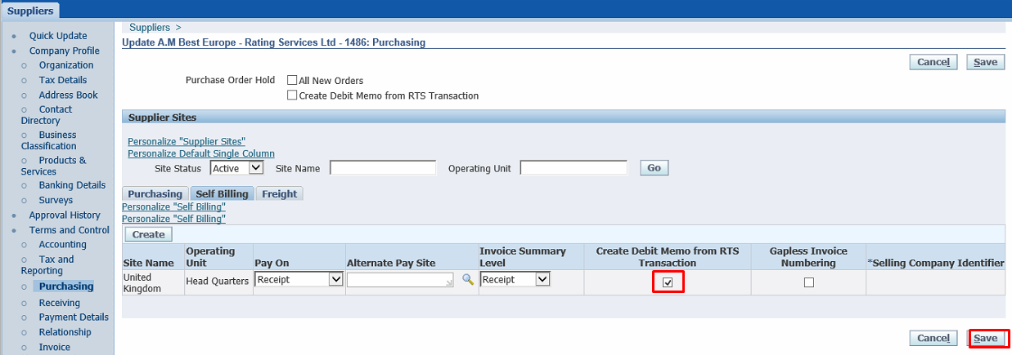

**8. Invoice Management**

**Select**

1. Invoice Currency

2. Payment Currency

Under the invoice tab, **select** the appropriate Invoice Currency

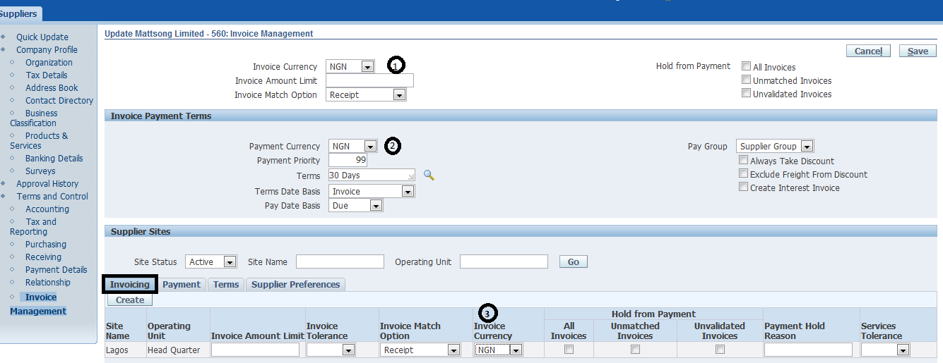

Under the Payment tab, **Select** the appropriate payment currency and **click** Save

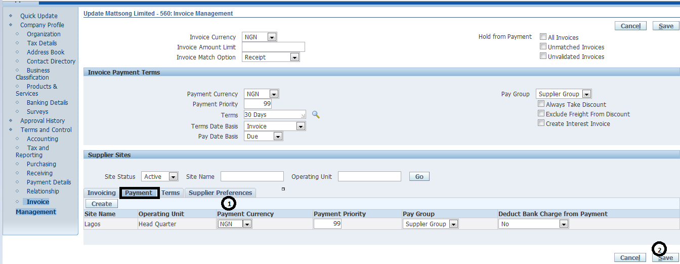

# **CASH MANAGEMENT**

## **Clearing Bank Statements Manually**

**Navigation**: Cash Management >> Bank Statements>> Manual Clearing

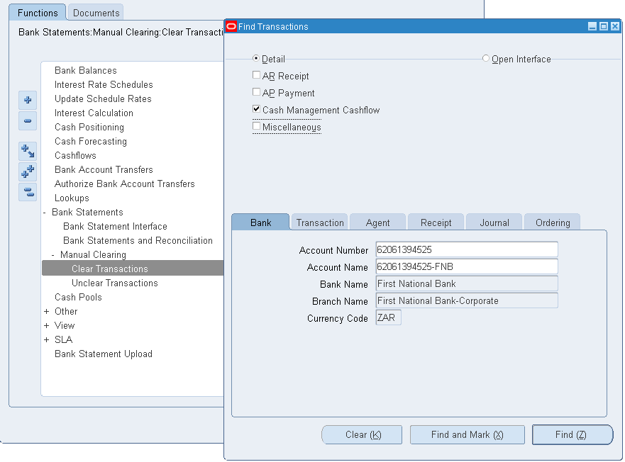

1. **Select** Bank
2. **Check only**: Cash Management Cash flow
3. **‘Optionally’** **Select** Date Range (Transaction Tab> Date)
4. **Click** on Find

**2. Clear Transactions**

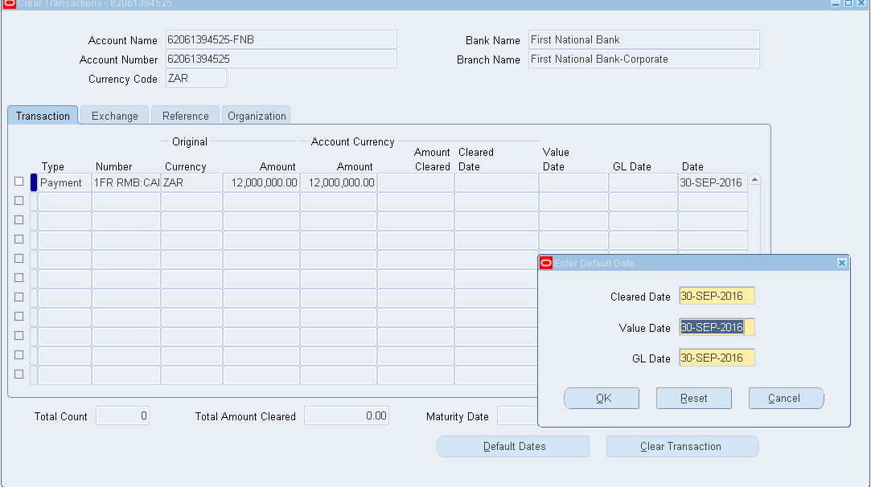

1. **Click** on ‘**Default Dates’** button
2. **Enter** the **Date** to **clear** the **transactions**. **Note**: Ensure GL Date is in the same period as the Transaction Date.
3. **Create** Accounting for Cash management
4. Submit Request>> Create Accounting

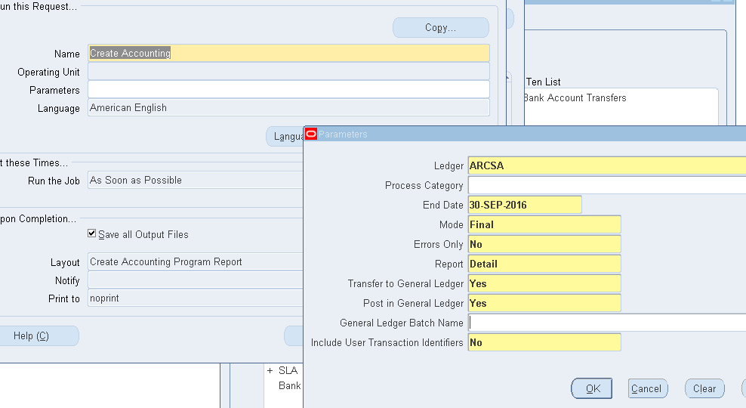

# **IEXPENSE**

## **IExpense Reimbursements – Proxy Application**

**Responsibility**: ARC Internet Expense HQ responsibility

**Navigation** **Path**: **Select** Expenses Home.



1. **Select** the **highlighted** tab ‘**Access Authorizations’**.

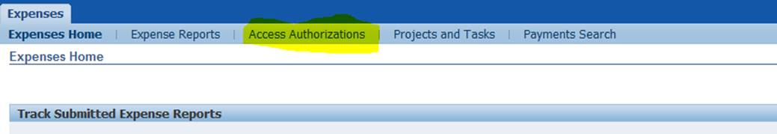

1. Once the page is opened, under the ‘**Expenses Entry Delegations’** tab, **click** the highlighted button to add a delegation.

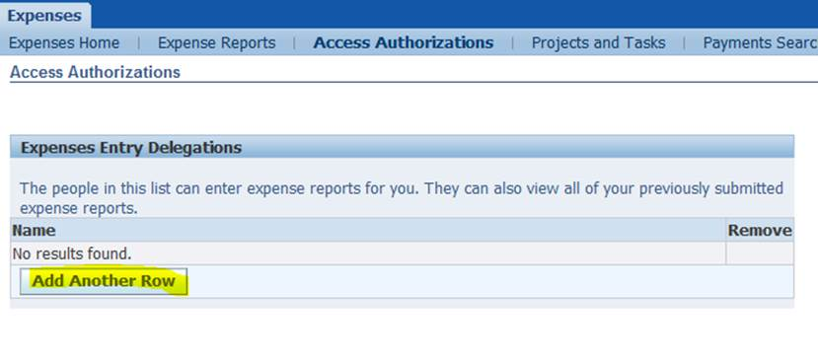

1. **Enter** name of proxy in the field provided as shown below:

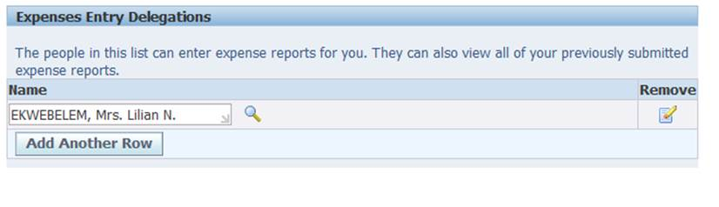

1. **Click** on the **save button** in the bottom right hand corner of the screen.

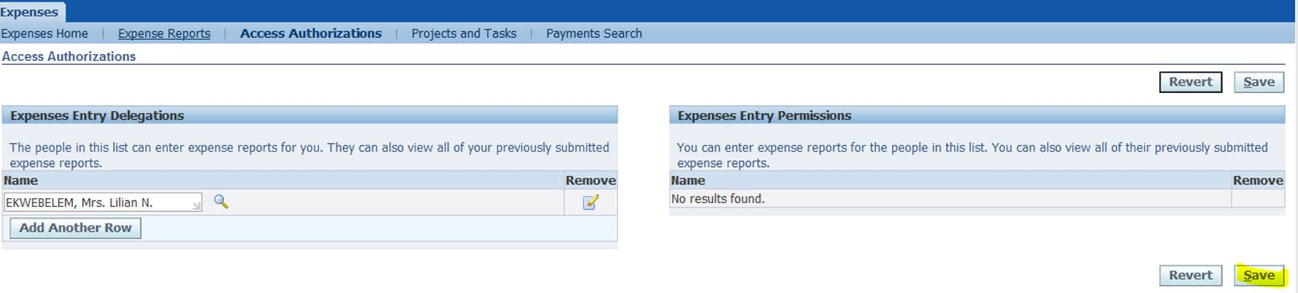

1. Setup is complete.

## **Applying for reimbursement in a currency other than USD or local currency**

**Navigation: ARC** Internet Expense <<location>> 🡺 Expenses home

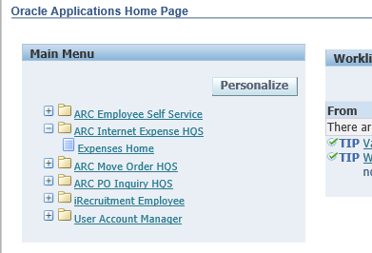

**Click** on the **Apply** forReimbursement button

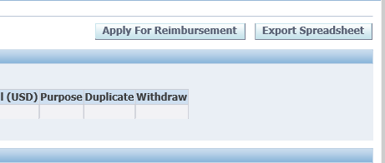

**Select** the ‘**Reimbursement currency’** (Currency other than what was spent on the transaction, this should be either USD or your local currency e.g. Naira for Nigeria unless prior approval has been received).

Then **state** the Purpose of the refund.

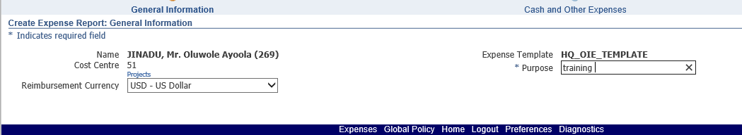

**Click** on Details

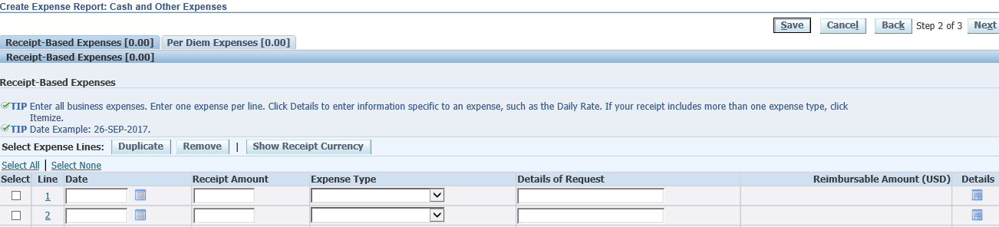

**Fill in** details and **Click** on **Add** button to attach necessary documents then **click** on Return button

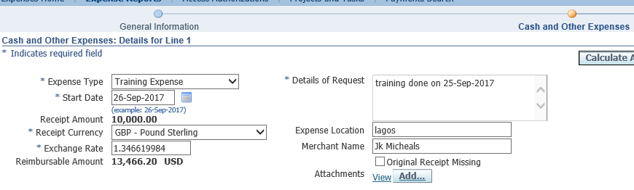

**Note**: **Specify** the receipt currency i.e. the actual currency spent on the transaction.

Then **click** on **Submit** button

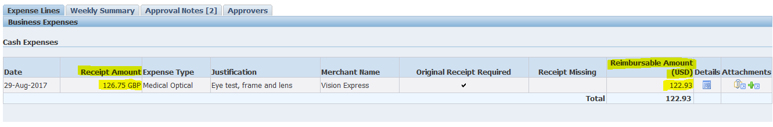

On the final page, the Receipt Amount and Reimbursement amount should be different currencies and different amounts as shown above.

## **Submit requests to payables module immediately**

**Responsibility**: Accounts Payable

**Navigation**: OIE Review>>Expenses Audit

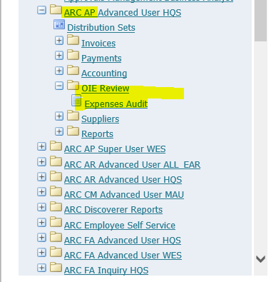

**Enter** the Expense report number you are auditing in the search box as shown below. **Click** on Go. Details of the request are shown. **Enter** Date received and saved.

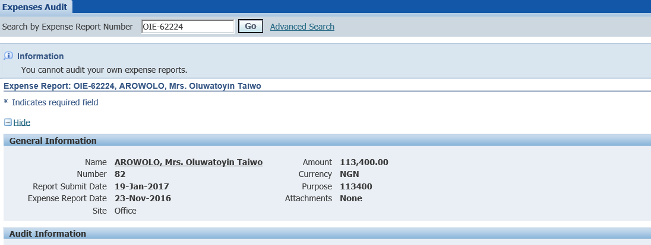

**Click** on the link ‘**Advanced** **Search’**

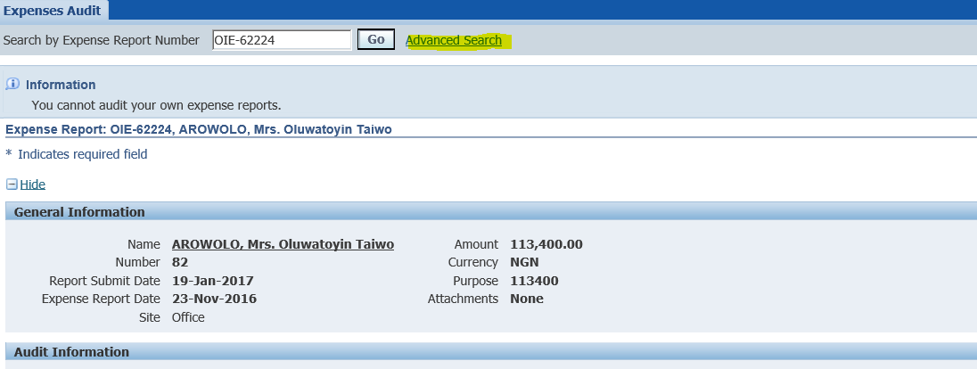

**Click** on Submit when the screen loads (See highlighted button below)

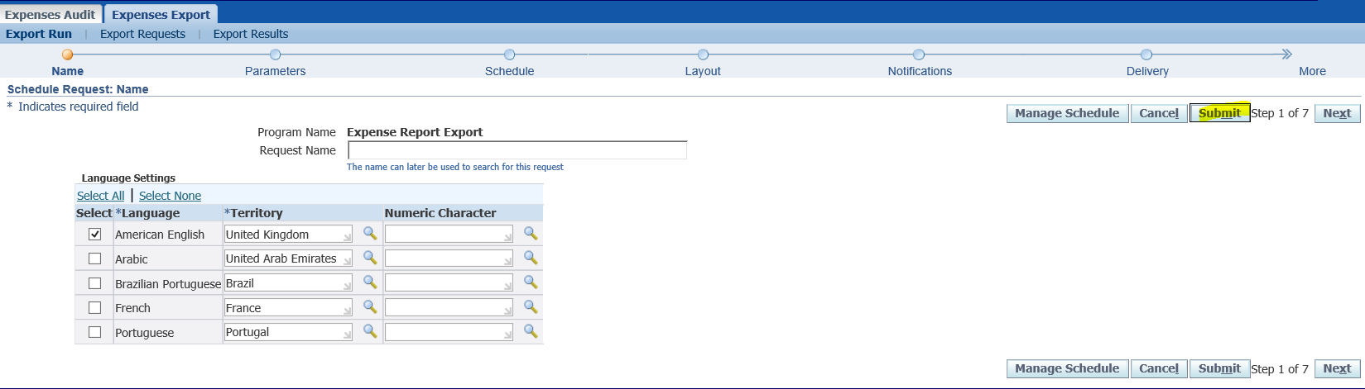

**Click** on the Submit button again.

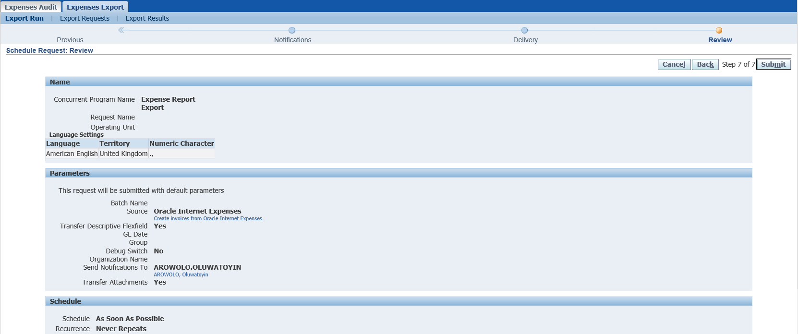

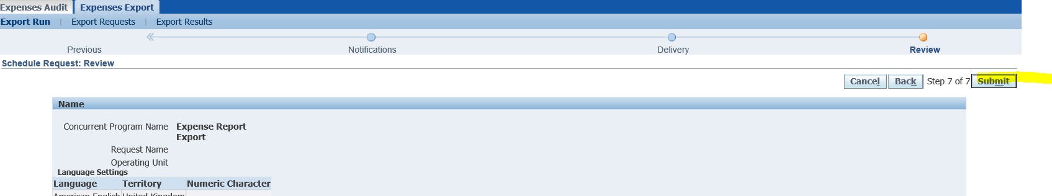

A screen shows the concurrent request has been submitted.

Proceed to the Payables module to complete the payment.

# **TREASURY**

## **How to roll over with full interest Accrued**

1. **Search** For the **Deal** to **roll over**

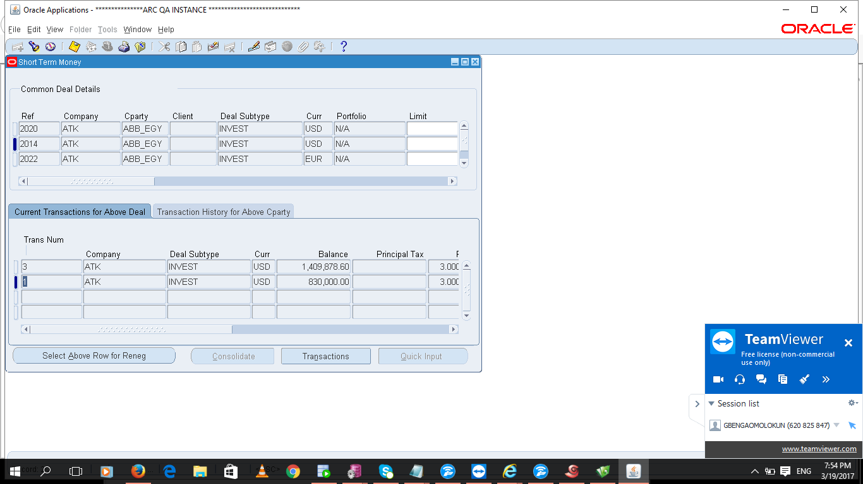

1. **Click** on “**Transactions**”

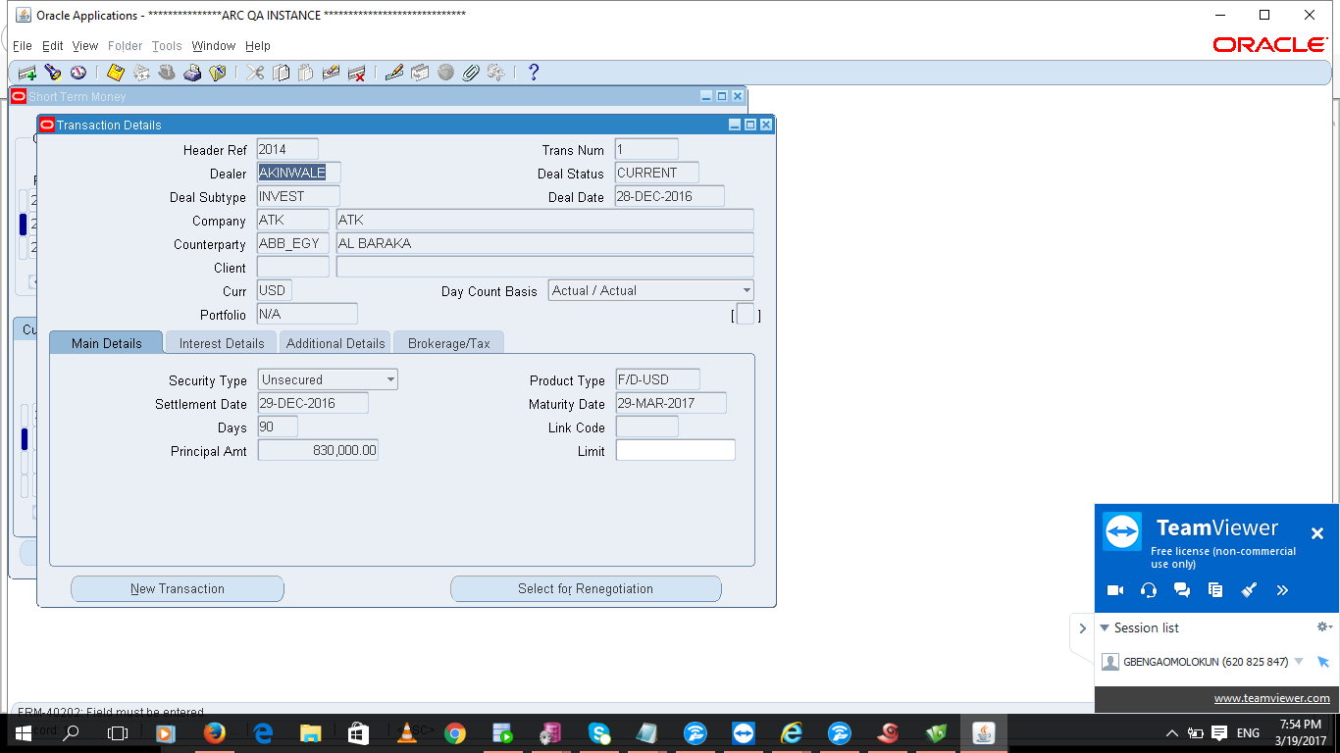

1. **Click** on “**Select for Renegotiation** and change the “**Reneg Date**” to the start date of the deal in this case 01-Feb-2017 as shown below:

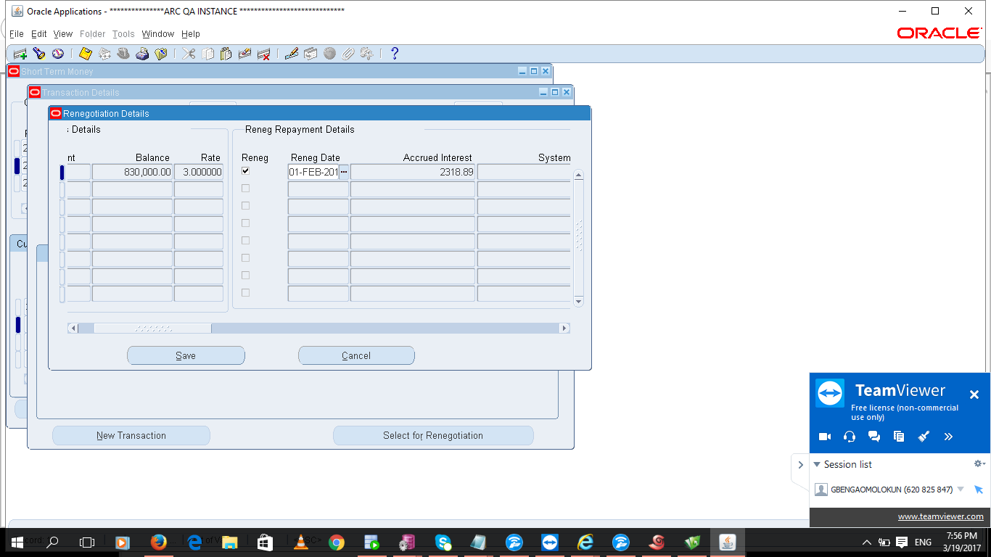

1. **Scroll** to the right until you get to **“Interest Action**” field

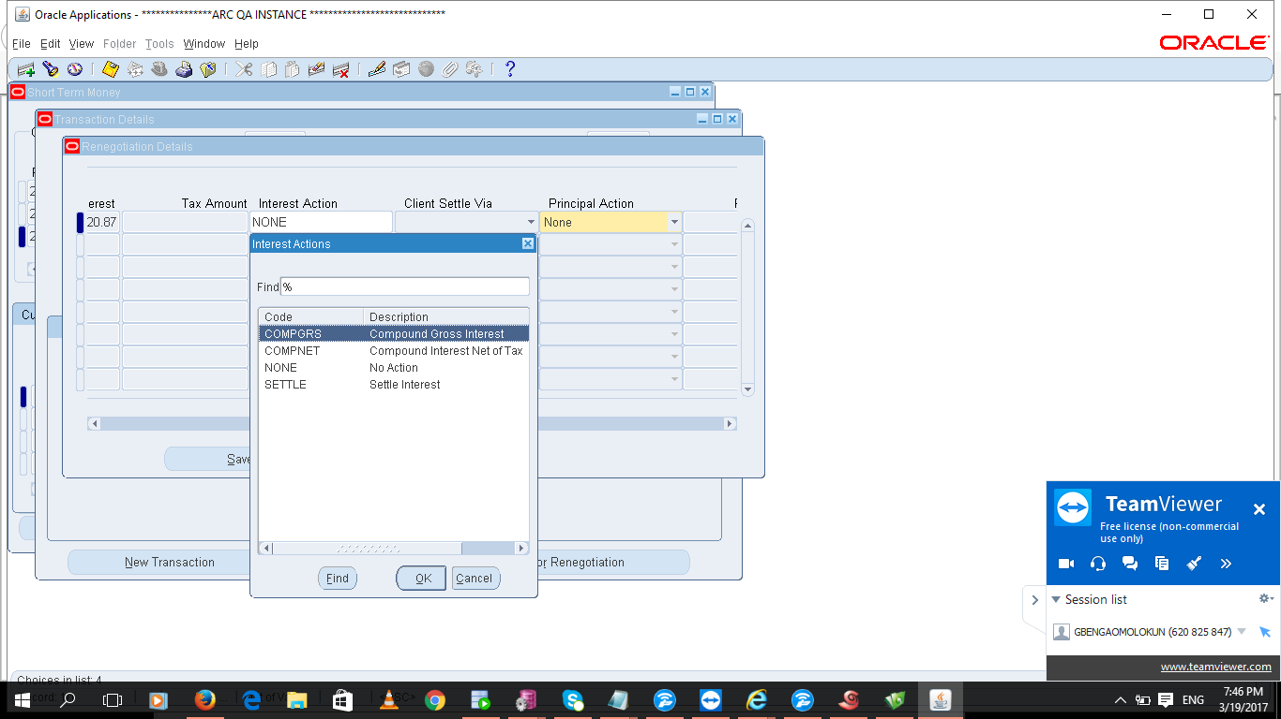

1. **Change** interest action from “**NONE**” to “**COMPGRS”**

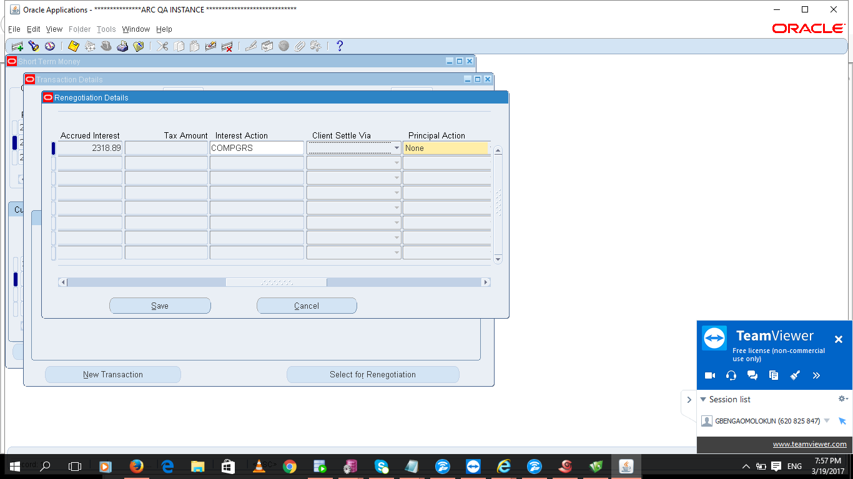

1. **Scroll** to the right until you get to **Maturity Date field**, and **change** the date to the new maturity in this 30-APR-2017 as shown below:

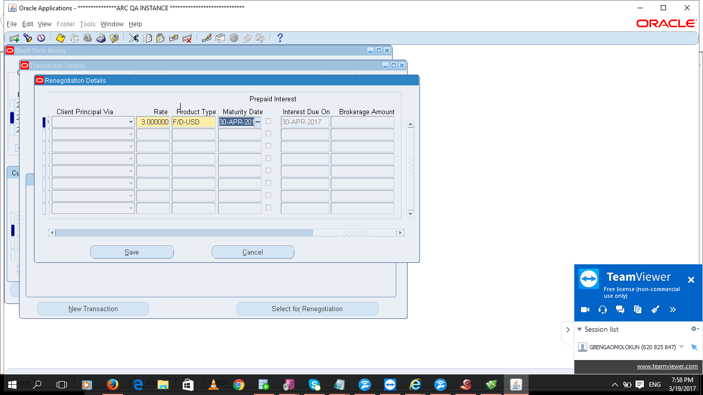

1. **Save** by **clicking** on the **Save button**. Once the transaction saves the system goes back to the transaction details form

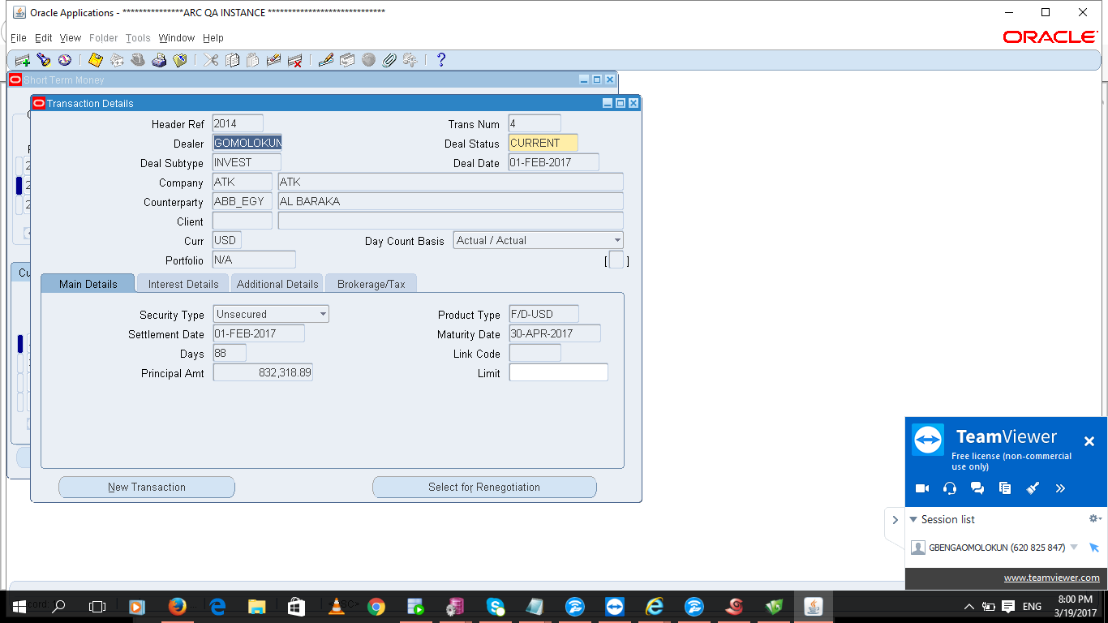

1. The new deal is created with the principal plus accrued interest and the maturity date. Please Save your work and close the form.

## **How to close a deal on Maturity**

1. **Search** for the **deal** to close **after maturity**

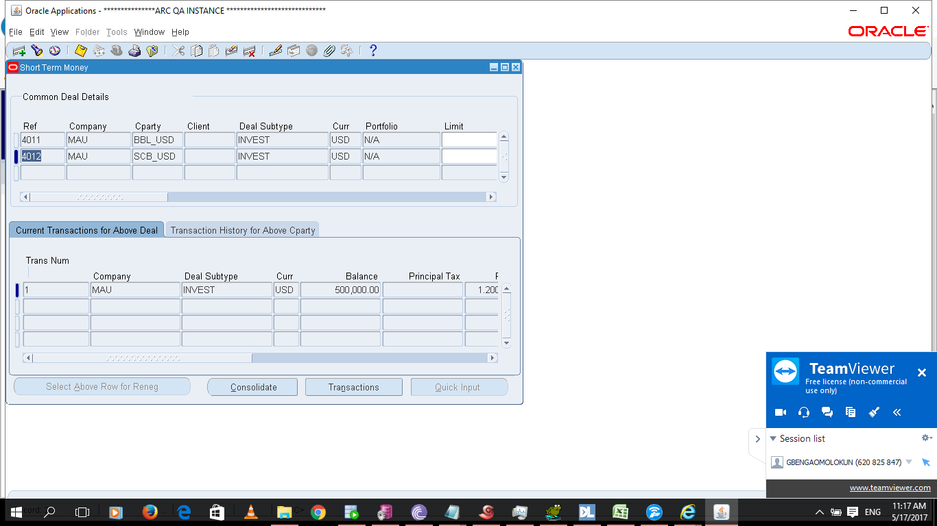

1. **Click** on “**Transactions”**

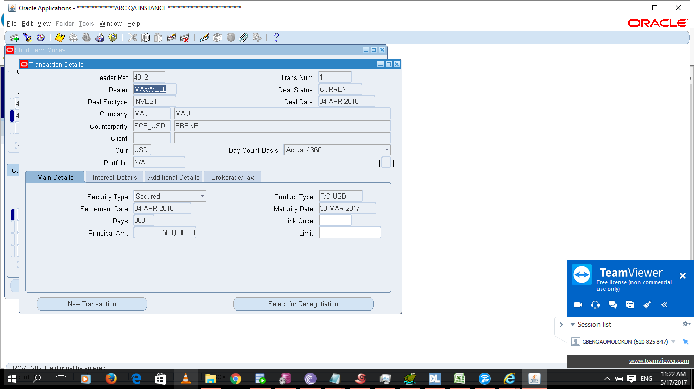

1. **Click** on “**Select** for Renegotiation and leave the **“Reneg Date”** as default

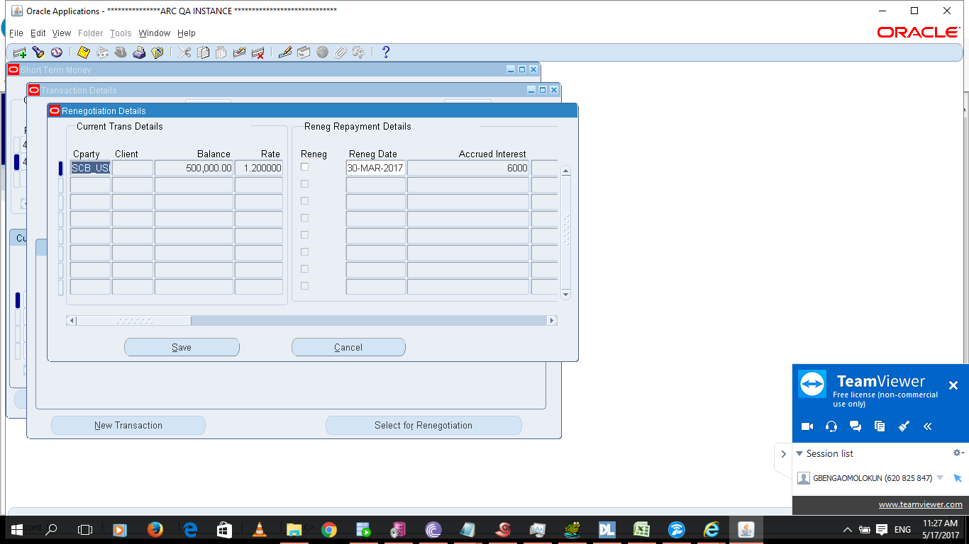

1. **Scroll** to the right until you get to **“Interest Action**” field



1. **Change** interest action from “**NONE**” to “**SETTLE”**

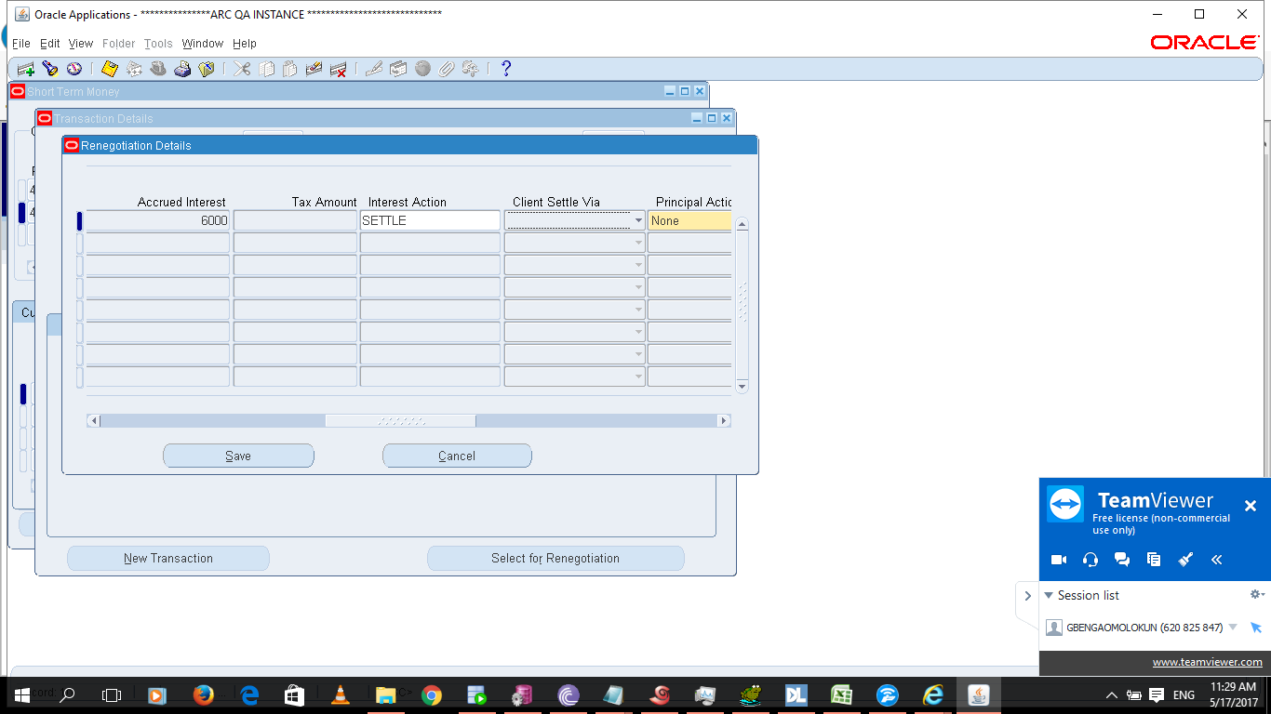

1. **Scroll** to the right until you get to Principal Action and Principal Adjustment and change both to “**Decreas**e” and the “**Principal amount**” respectively. You will observe that the Balance Carry Fwd becomes zero.

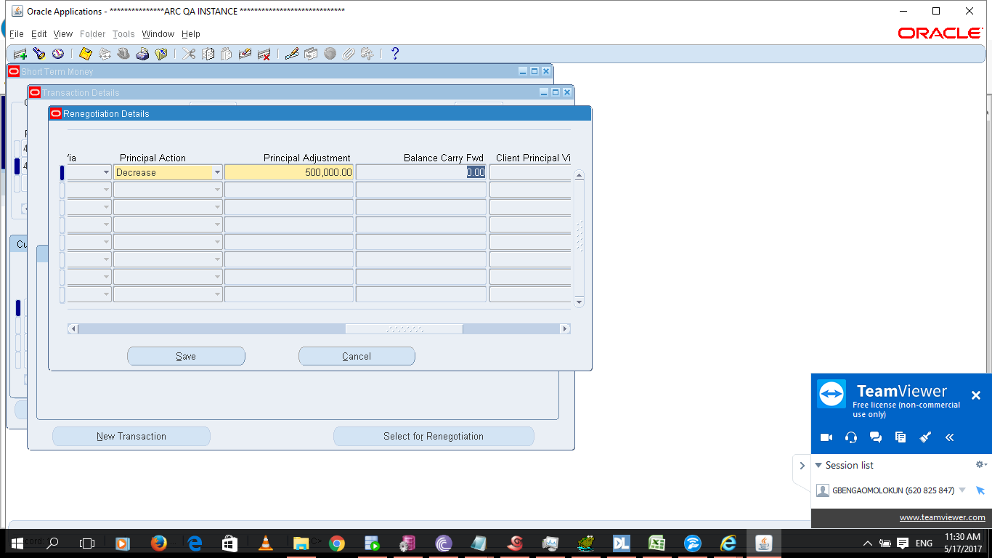

1. **Scroll** to the right until you get to the **Rate field** and **change** the **rate** to zero

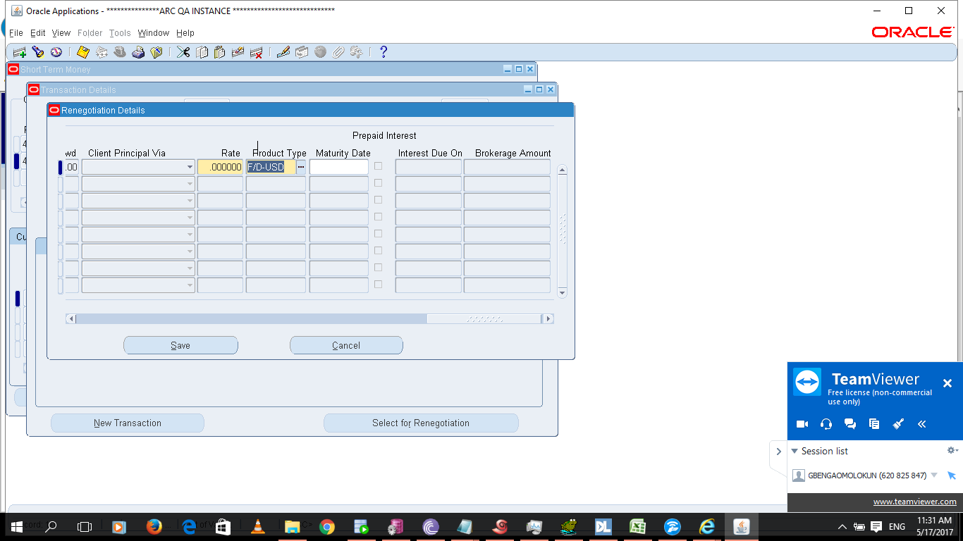

1. Save by **clicking** on the Save button. Once the transaction saves the system goes back to the transaction details form

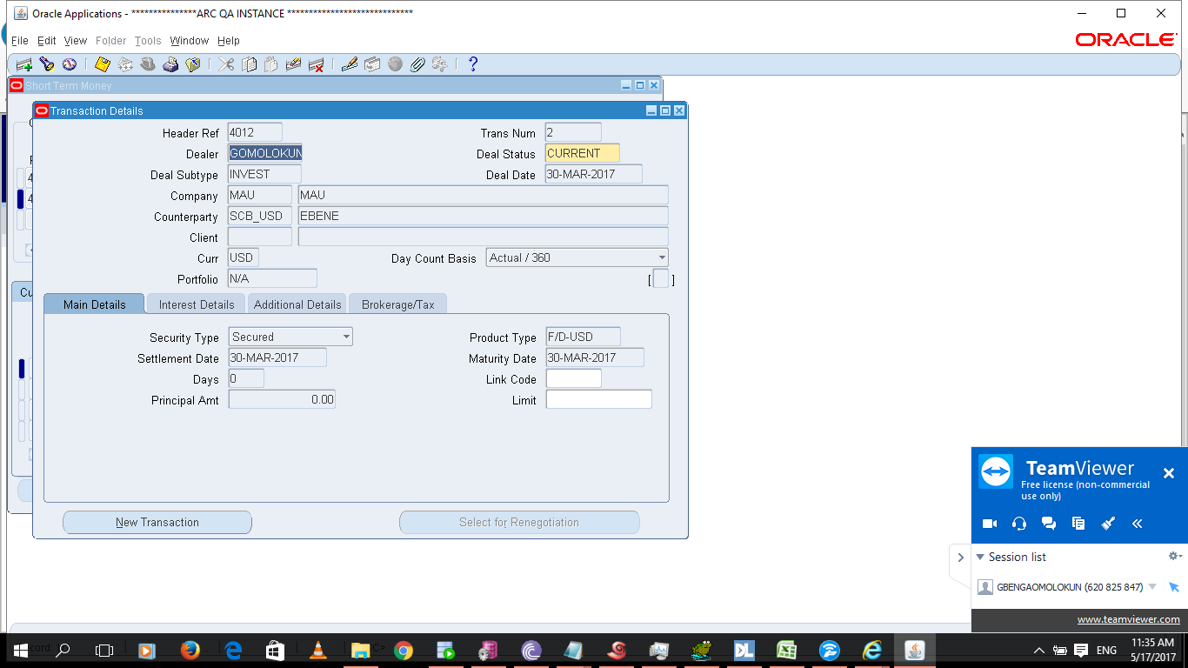

1. The new deal is created with zero principal amount while the old deal is closed.
2. Proceed to validate the transaction and create the accounting entries. The entries created will DR your bank account and CR your investment account.

## **How to handle interest on deposit on Maturity**

1. **Navigate** Receipts -> Receipts, using Account Receivable Responsibility

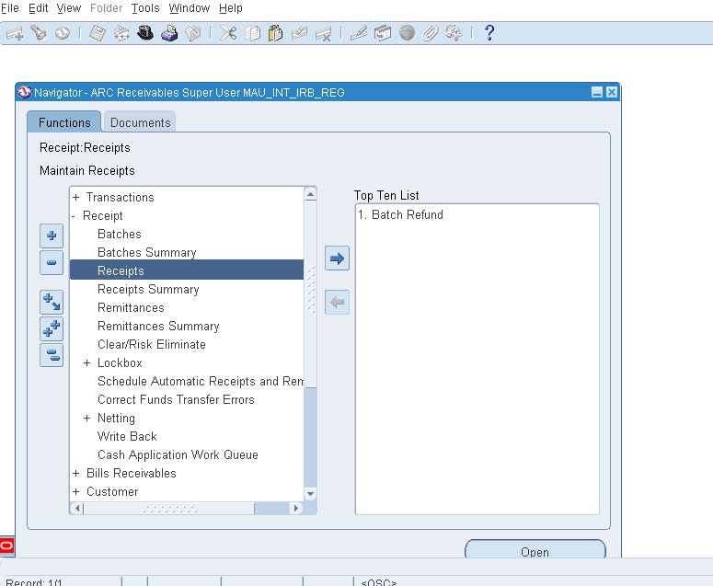

1. **Change** the Receipt Type – **‘Miscellaneous’**

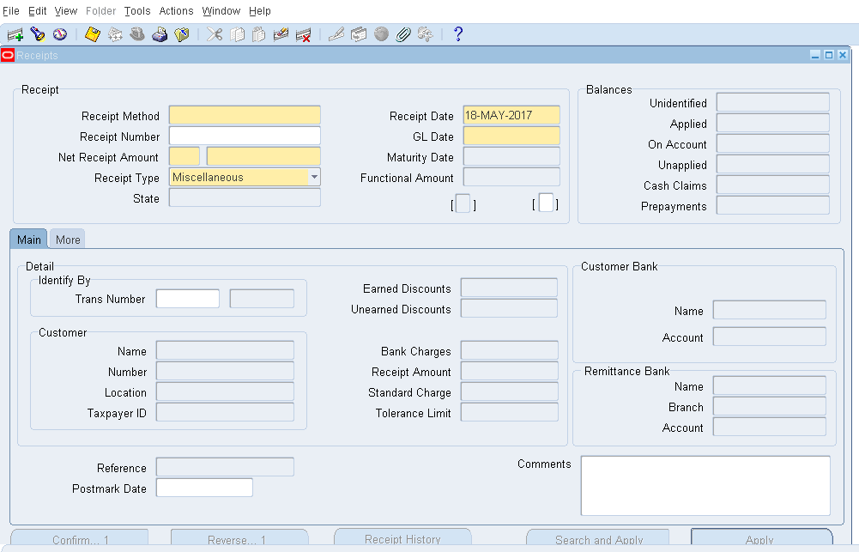

1. **Select** Bank Interest call/term deposit from Activity

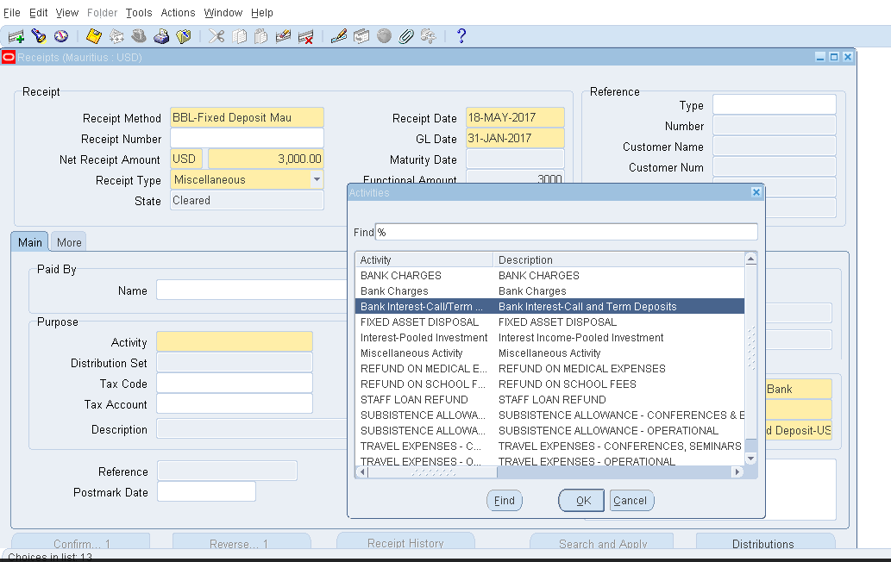

1. **Complete** other information

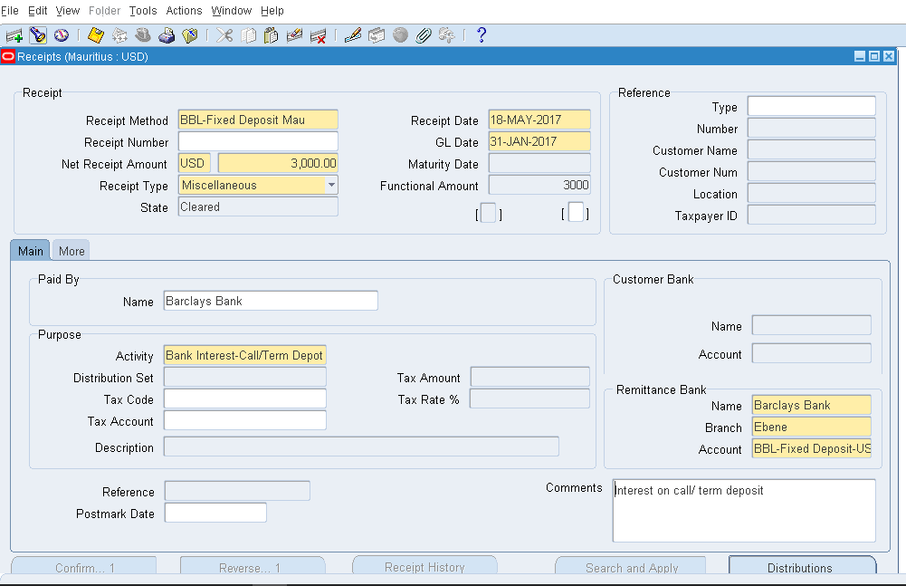

1. **Click** on Distribution

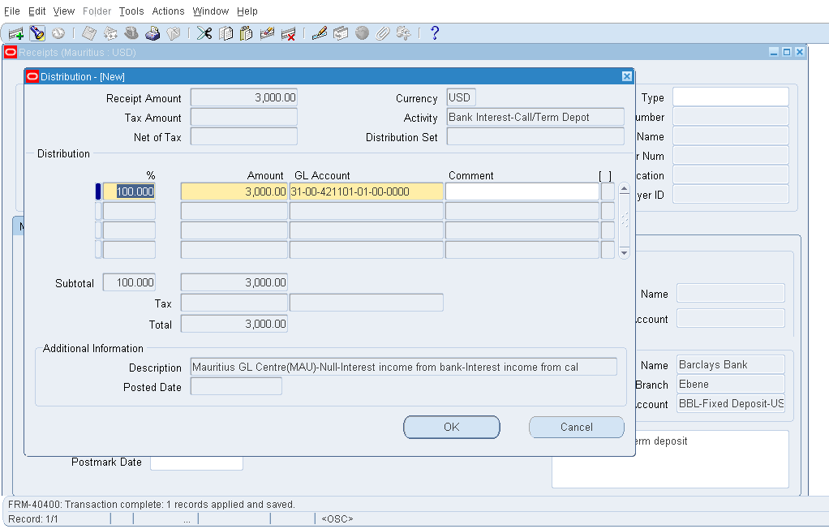

# **FIXED ASSET**

## **How to Create Physical Location Inventory**

There are two parts in this document.

**Part** **1**: how to set up Microsoft Excel to open the document which will be used to upload the items to the inventory.

**Part** **2**: creation of a physical inventory, and how to run the integrator and download the inventory “.xls” file which will be used for the upload.

**Part** **1**: Setting up Microsoft Excel to View WebADI file

**Step** **1**: Disable Excel4Apps in Microsoft Excel.

**Step** **2**: Go to file > options

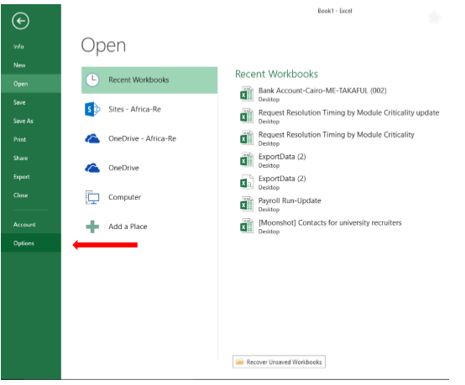

**Step** **3**: Go to Trust Center > Trust Center Settings

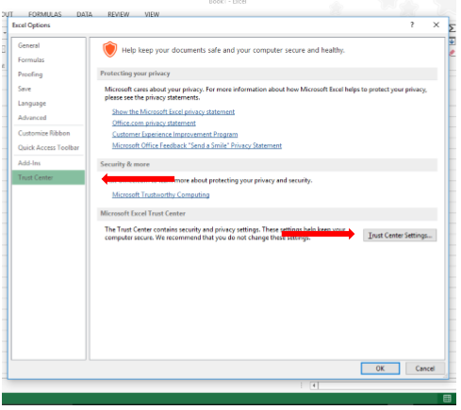

**Step** **4**: In trust center settings, go to the Macro Settings tab and ensure that the “**Enable** **all** **macros**” and “**Trust access to the VBA project object model**” are selected.

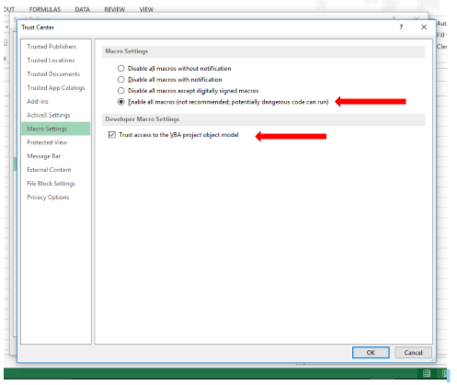

**Step** **5:** **Click** on the Protected View tab and ensure that all the options are unselected. **Click** **OK** and **close** the settings window.

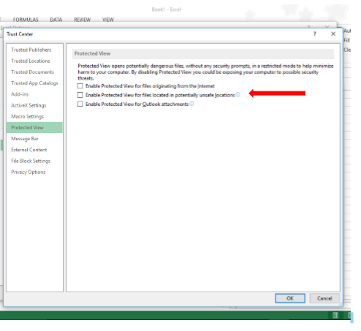

**Creating a Physical Inventory**

**Step** **1**: **Open** Internet Explorer > Settings (found in the top right corner of your browser window) > Internet Options

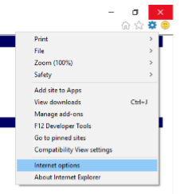

**Step** **2:** **Go** **to** the Security tab > **click** Custom Level

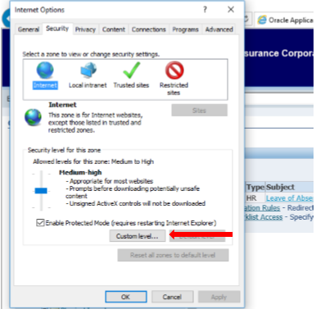

**Step** **3**: Ensure that the “**Allow status bar update via script**” option is enabled. **Click** **OK**

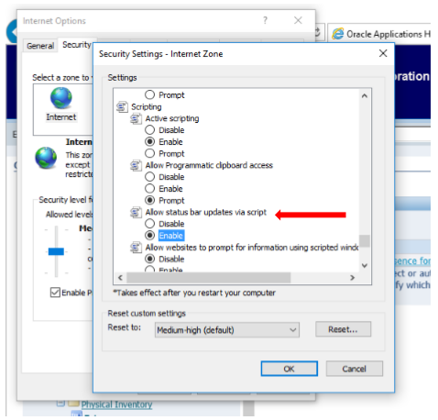

**Step** **4:** **Log** **in** to ERP using your username and password.

**Step 5**: With the ARC FA Super User HQS responsibility, **go** **to** Physical Inventory > Enter

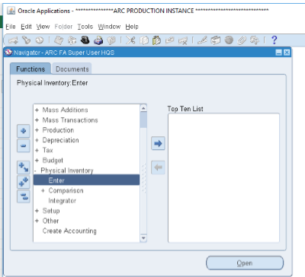

**Step** **6**: **Enter** in a name for your new inventory, as well as dates. **Click** Open and then **save** changes using the **yellow** **icon** in the toolbar.

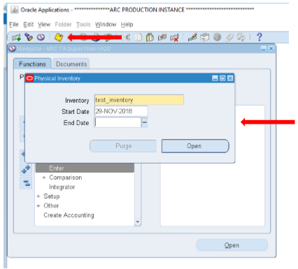

**Step** **7**: Go back to Physical Inventory and then **select** Integrator. Since it is not a java form, a new page will open in a new tab within your browser.

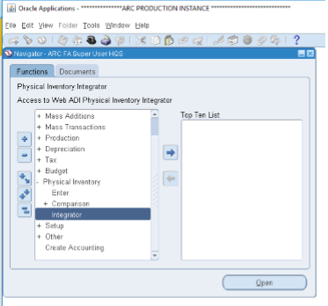

**Step 8**: **select** the inventory you created in step 6 above from the dropdown options and **click** continue.

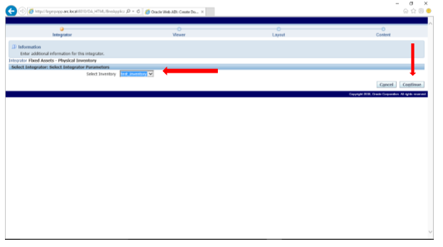

**Step 9:** **Select** the version of excel which you will be using to upload items to the inventory. **Click** next.

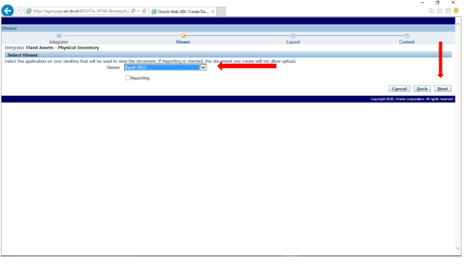

**Step** **10**: **Select** the layout you want the data upload table to show in. For this manual, “**Physical** **Inventory** – **Line** **Entry**” was selected. **Click** next.

The next screen will be a download screen. Once the download finishes, **click** return.

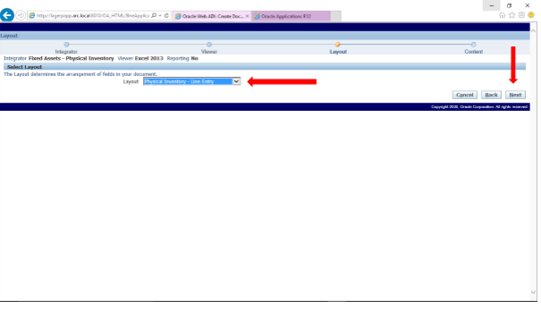

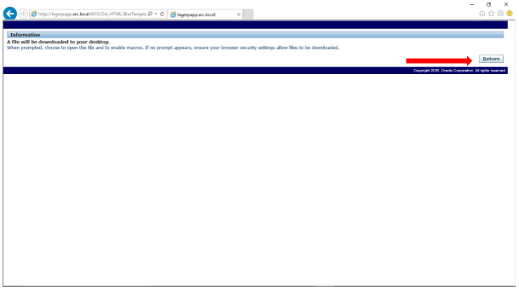

**Step** **11**: **open** the downloaded file in excel. It should open without issues if you have set everything correctly. You should see a window informing you that your document has been created successfully.

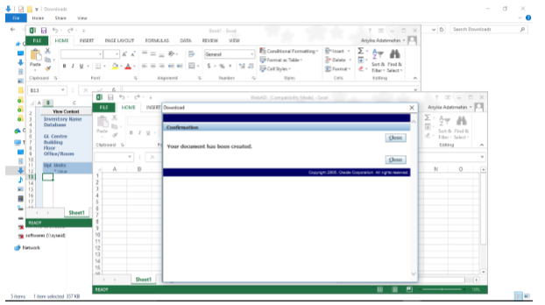

**Step** **12**: **Enter** the details of the items to be added to the inventory.

You can **double** **click** the cells to display an ERP pop up window and **select** correct items to add to the flex fields.

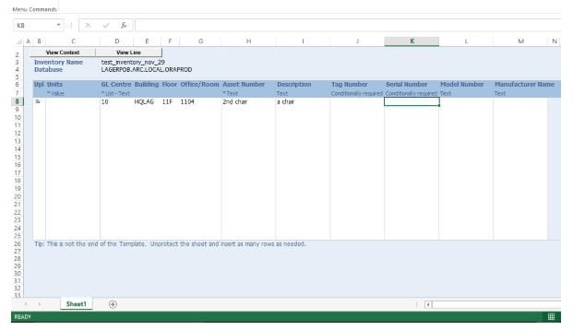

**Step** **13**: **Go** **to** the Add-Ins tab > **click** the Oracle dropdown option > **select** Upload.

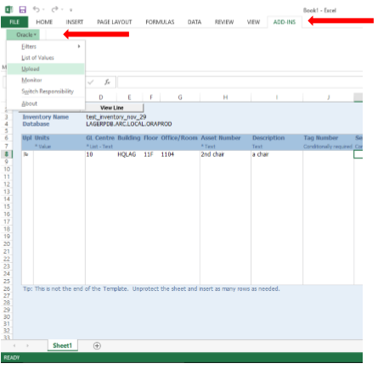

**Step** **14**: A new window will pop up. **Select** the necessary check boxes and **click** upload. Ensure that “**run** **comparison**” and “**view comparison results**” are selected.

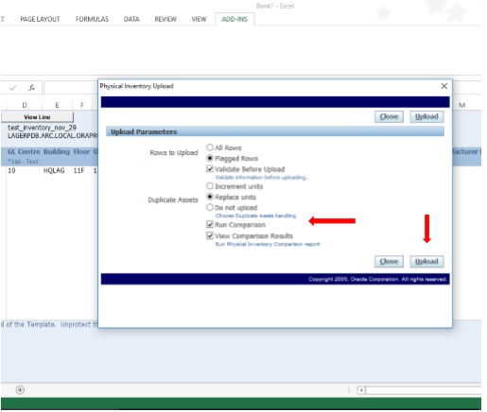

**Step** **15**: If your update was successful, the screen below will confirm your success.

You can now save the document. Make sure to **save** it as a “**macro** **enabled** **workbook**” which can be selected from the “**save** **as** **type**” dropdown menu in file explorer.

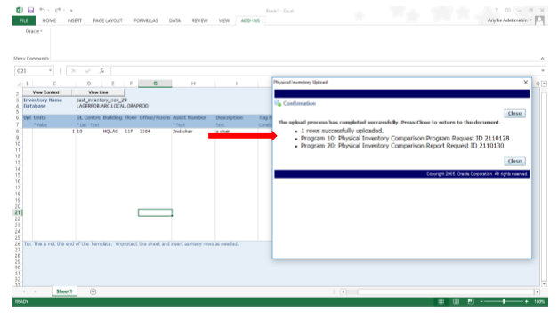

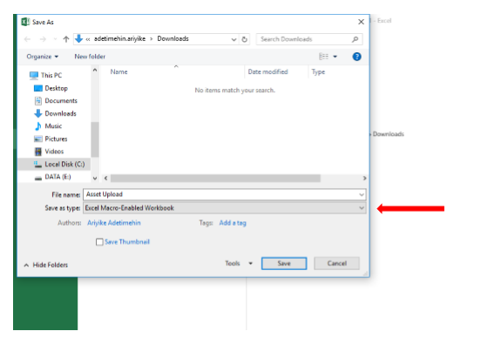

**Step** **16**: **Log** **in** to ERP and navigate to Physical Inventory > **Enter**. Search for the inventory you created in step 6. You should be able to see the item(s) you added.

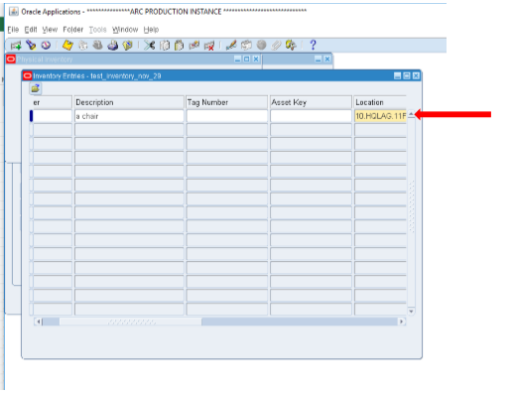

## **Bar Code Settings**

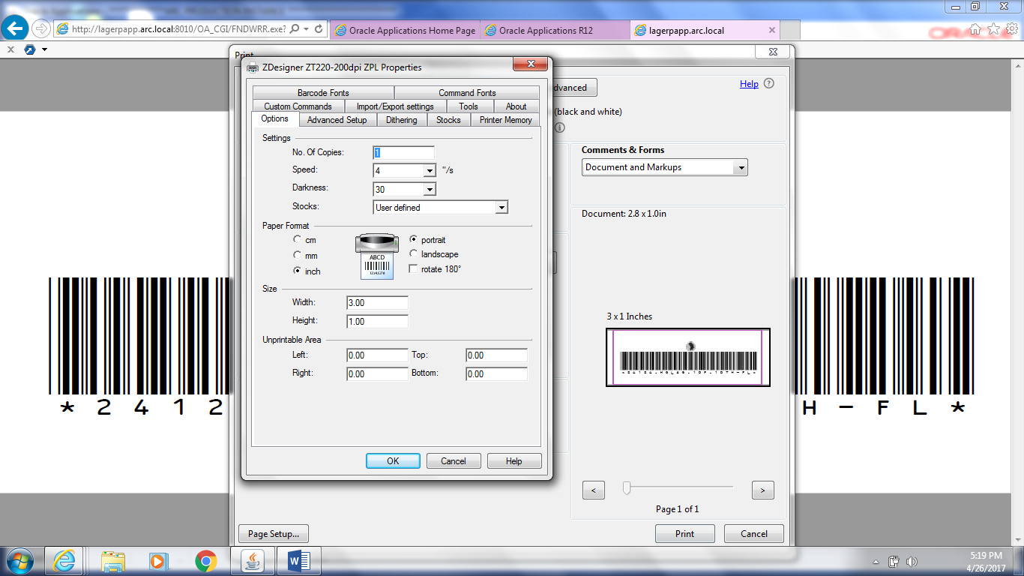

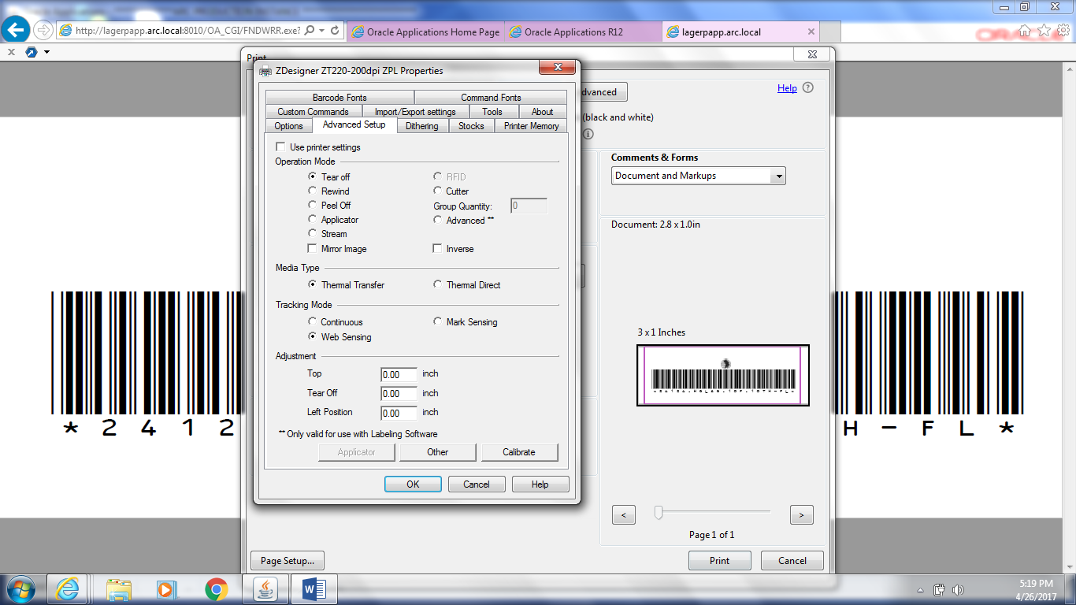

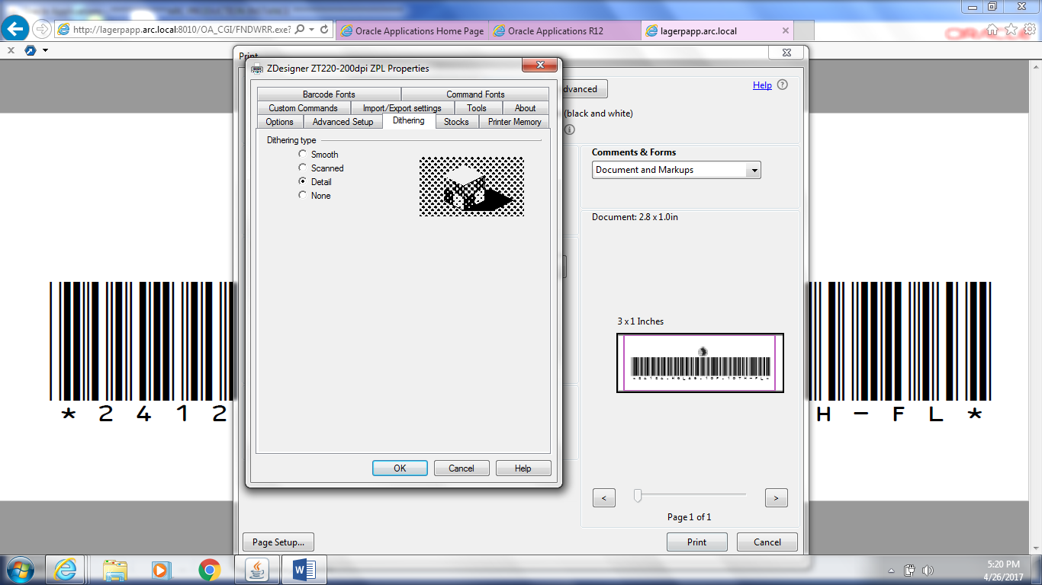

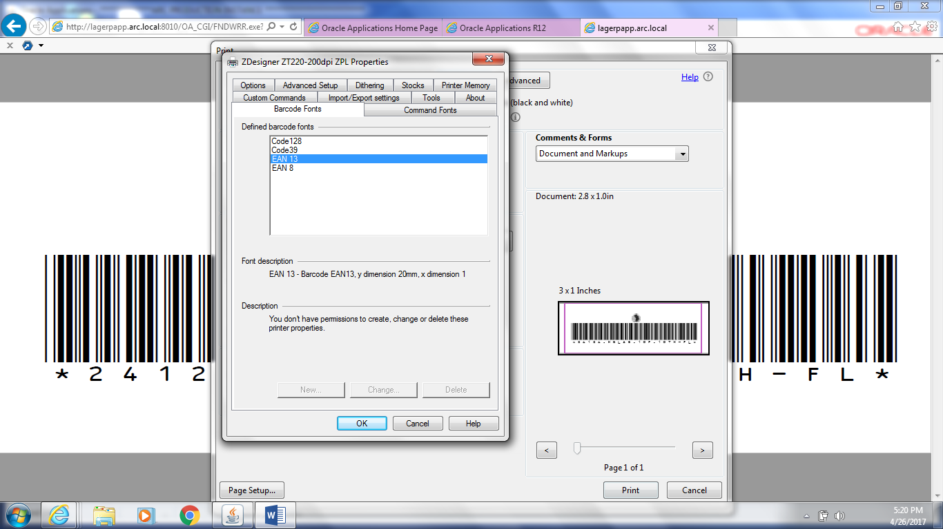

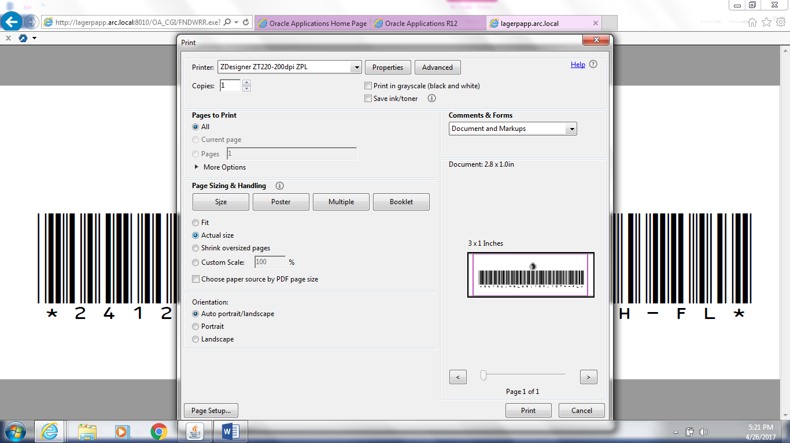

## **FA Mass Addition Process**

**Step** **1**: Create Payables Invoice

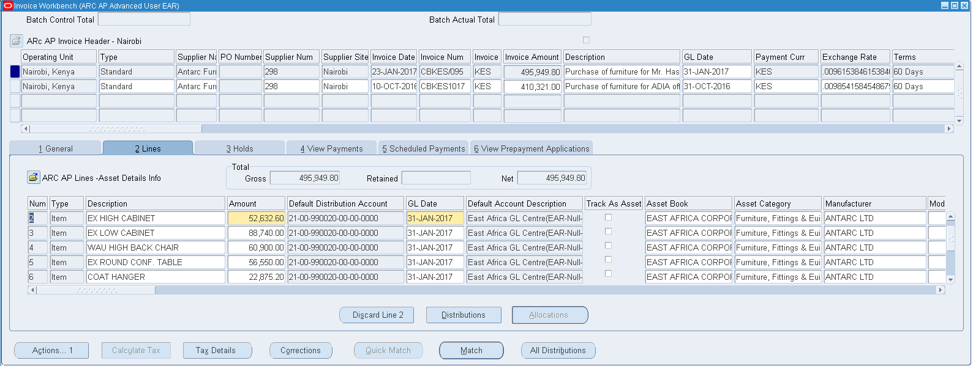

Ensure the Account Distribution uses the **‘Asset Clearing Account’** i.e 990020-00

Invoice Status should be: **Validated** and **Accounted**

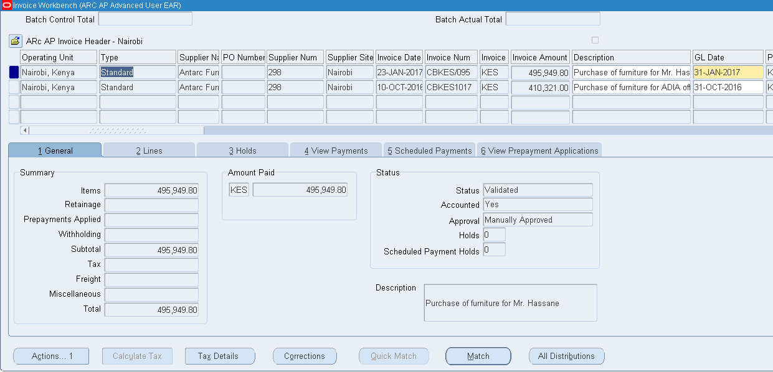

**Step** **2**: Ensure All Invoices are accounted

**Run**: **Create** Accounting Request from Payables

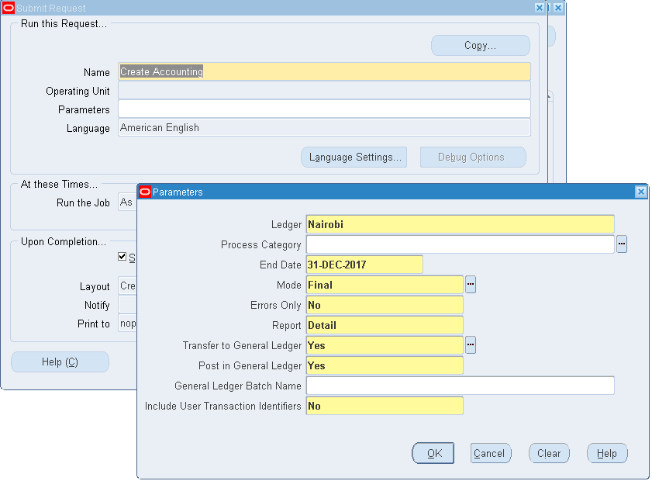

**Step** **3**: From Payables, Run ‘**Mass Additions Create’** Report

This will bring all the Addition lines to ‘**Mass Additions Form’** for asset creation details to be completed in Fixed Asset.

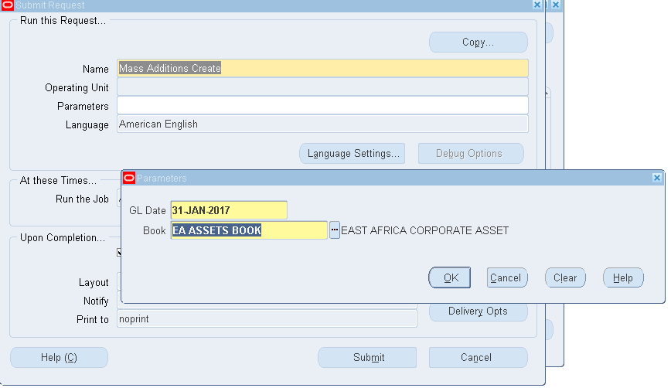

To view lines Created, Run **‘Mass Additions Create Report’**

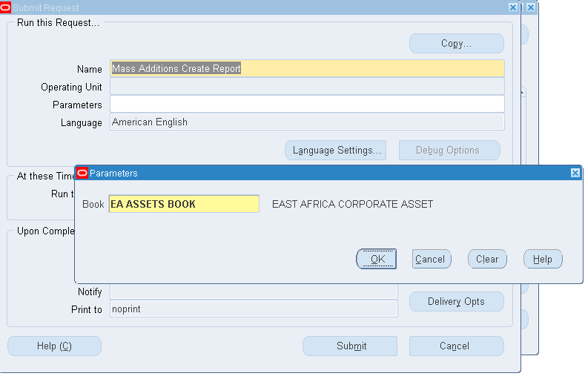

This is simply to get an output and Confirm all the Addition Lines have been moved to Fixed Asset Module, if not run through the previous steps again and check.

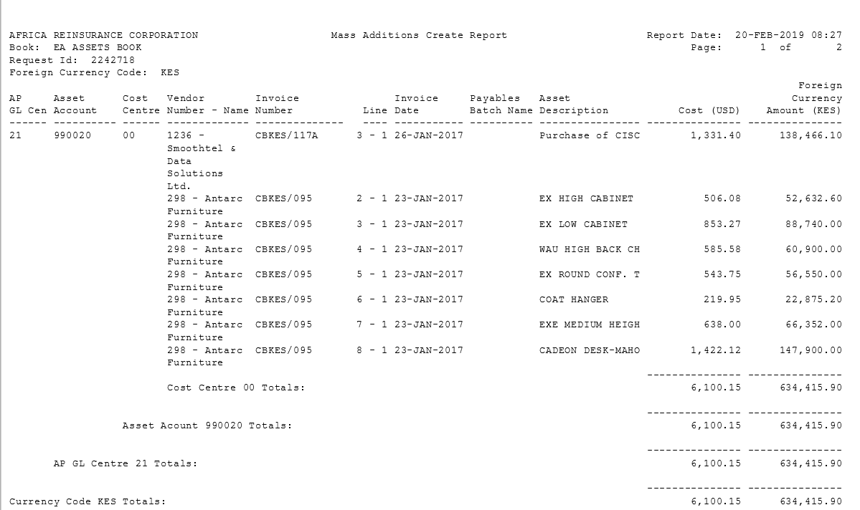

**Go to FA Module**

**Step 4: Prepare Mass Additions**

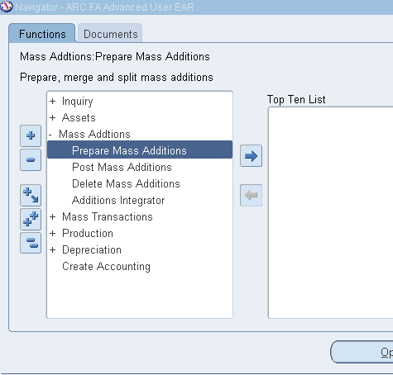

**Enter** Books and Status

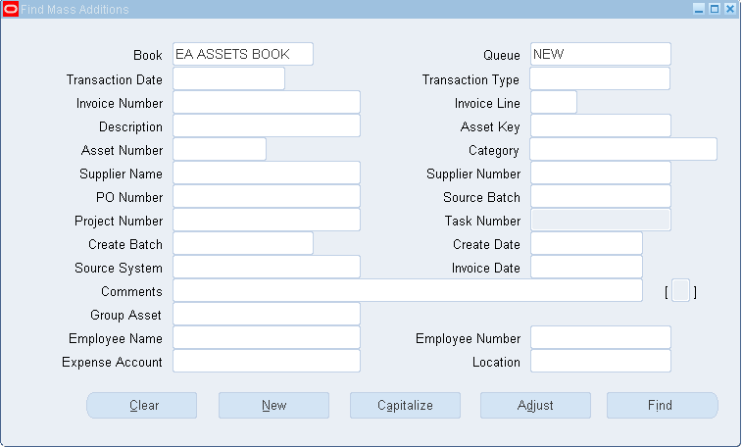

**Click** on Find> this will show all New Additions to be completed

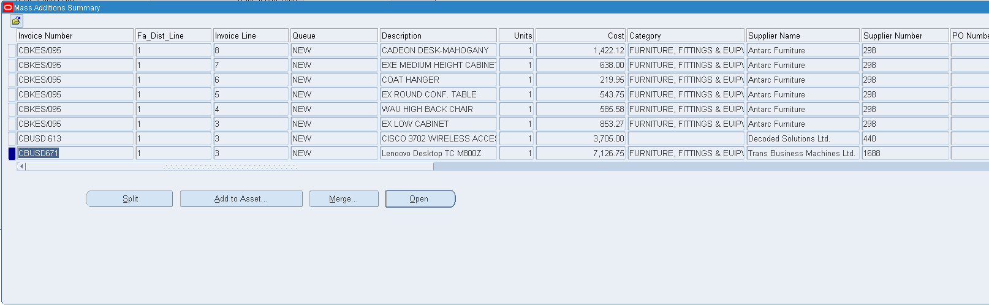

**Select** Lines > **Click** Open (Recommend doing the Additions by Invoice Number)

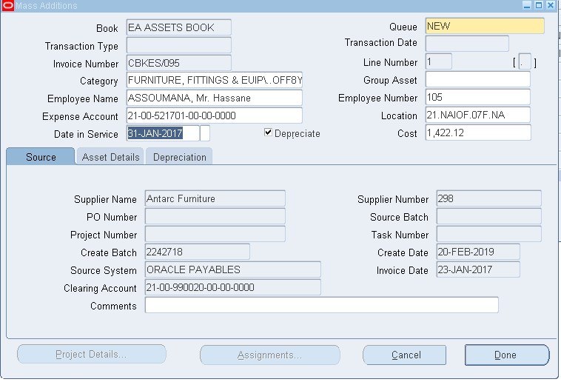

Complete Information (mandatory):

1. **Employee Name** (If asset assigned to a specific Employee)
2. **Expense Account**: Enter the Depreciation Account Combination. Note: The Account already defaults. Complete other segments
3. **Location**: Where the asset is located

Other Optional Information (especially in case of equipment’s) > Go to Asset Detailed Tab

1. Serial Number
2. Model
3. Manufacturer

Once all information have been filled > **Click** on Done button. This will put the Line in Status **‘On** **Hold’**

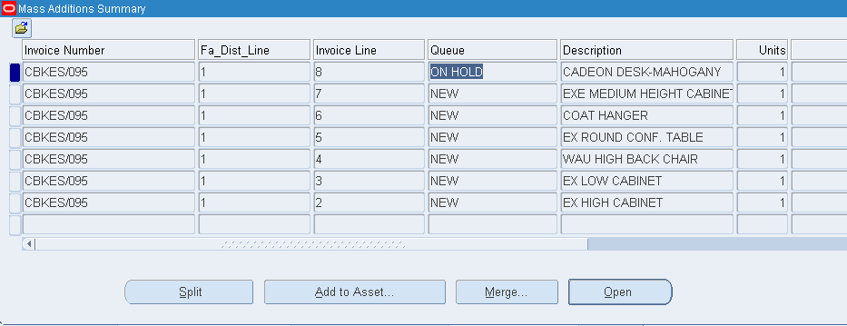

Complete all the other lines > move them to Status ‘**On Hold’**

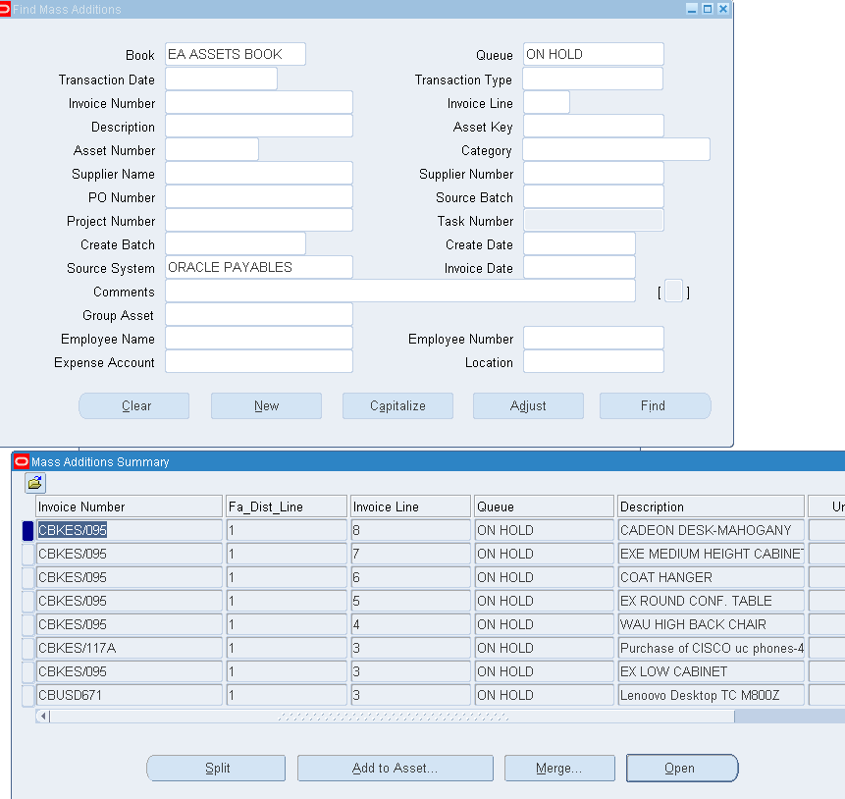

**Step** **6**: **Send** the Mass Additions to **‘Posting’** Status

From Mass Additions Screen > **Click** on Tools > Post All

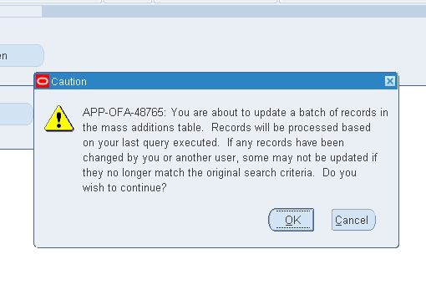

**Click** on OK

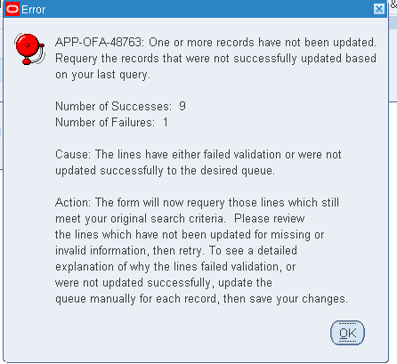

Ensure everything is Successful

**Step** **7:** Final Step. Post Mass Additions to create all the Assets

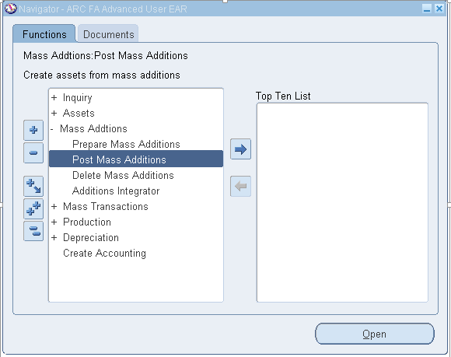

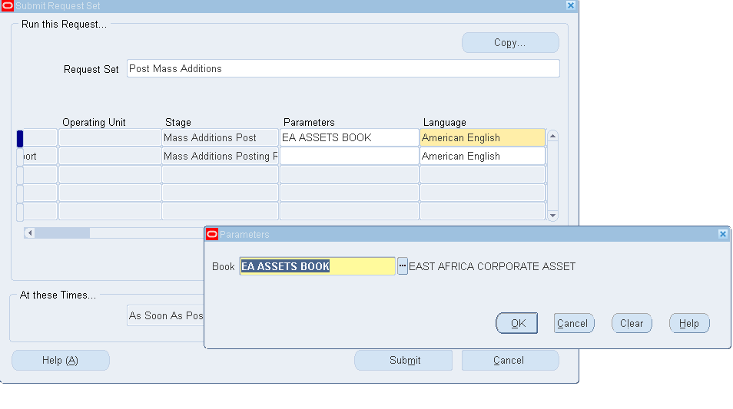

**Click** Ok then Submit

This will submit the Post Mass Additions Request

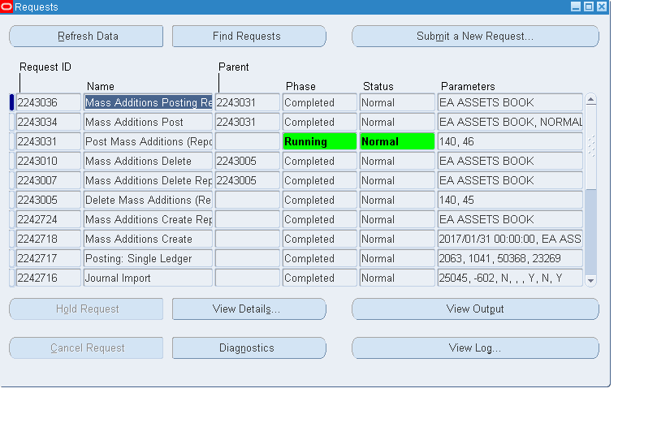

**View** Output ‘**Mass Additions Posting Report’**

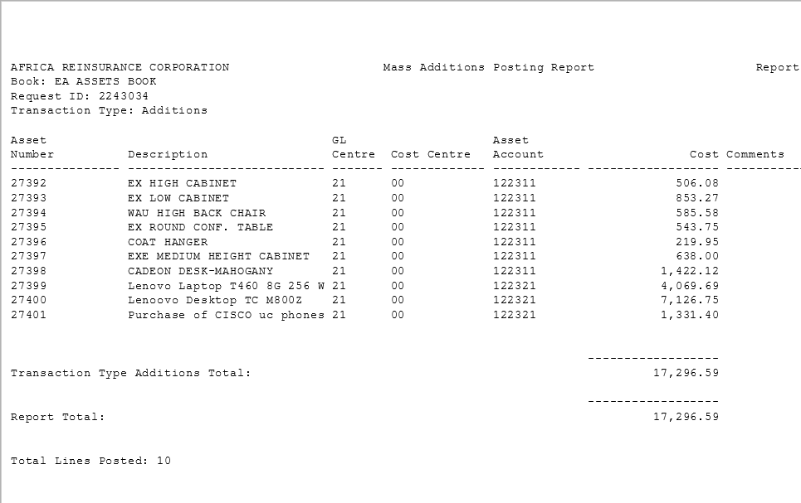

This complete the process

# **JOURNALS**

## **Auto Reversing Journals**

1. Period to be reversed into must be entered

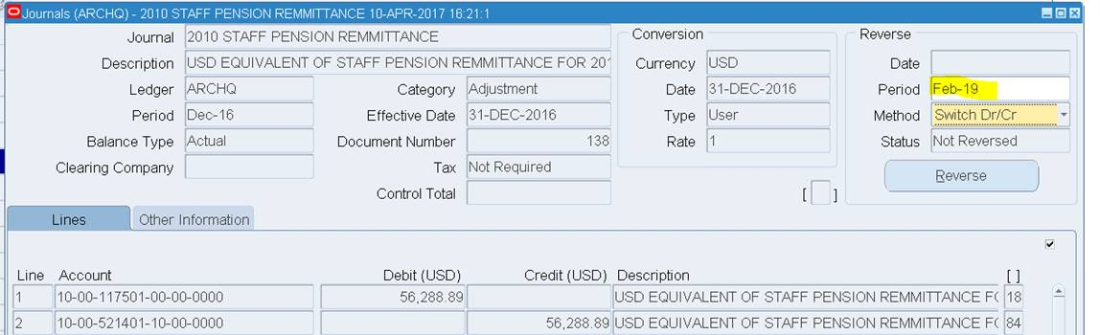

1. **Navigate** to ARC GL Super User >> Setup>>Journal >>Auto Reverse

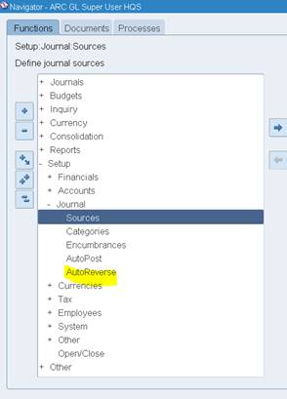

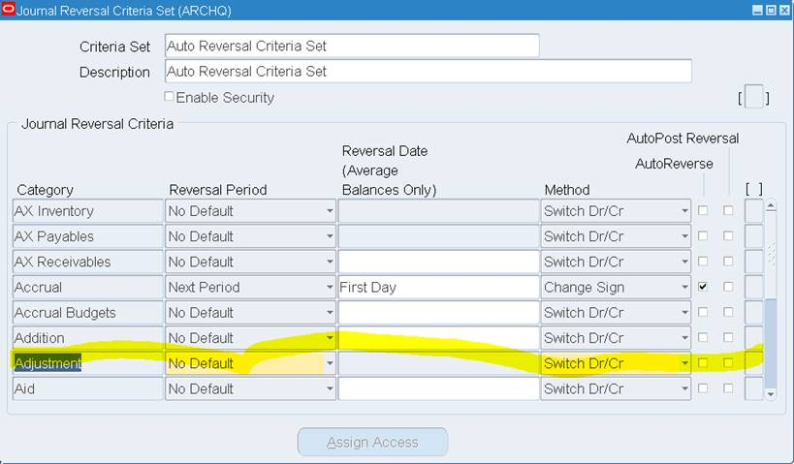

1. **Select** the type of journal category and ensure the Auto Reverse **check** **box** is selected and auto post reversal (if you want it to be automatically posted).
2. After creating your journal reversal criteria sets, **assign** them to ledgers. Journal reversal criteria set can be shared and assigned to multiple ledgers. Also secure journal reversal criteria set definitions using definition access set security to prevent unauthorized users from using, viewing, or modifying the journal reversal criteria.
3. **Note**: Journals posted by the **AutoReverse** process always bypass approval.
4. General Ledger automatically creates the **AutoReverse** Execution report when the **AutoReverse** process completes successfully. The report prints the journal name and reversal period for each journal that is successfully reversed and whether the reversal journal is submitted for posting. The **AutoPost** Execution report is created automatically when the **AutoPost** process finishes. These reports help you diagnose any problems and verify that all journals were processed properly.

## **How to delete a journal**

Journals that have been created in error or that are no longer required can be deleted from the system as long they have not been posted.

**Responsibility**: CAPSA XX: GL User or GL Dept Supervisor

**Navigate**: Journals → Enter

1. **Locate** your journal by either searching by **Journal** **name** or **Batch** **name** or any of the other fields available. After entering your search criteria **click** on Find 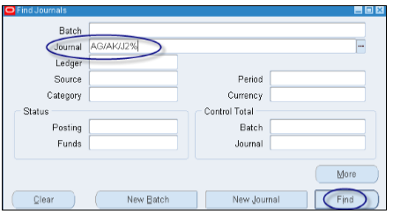

2. The Enter Journals screen, pops up. Here you will find the information about the journal in question. Ensure the ‘**Batch** **Status’** is Unposted and the details of the correct journal have been located. Upon locating the journal **click** on Review Journal. 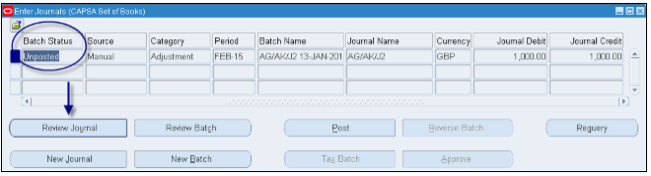

3. You will now be in the journal you wish to delete. To delete the journal you will need to follow the steps below:

a) **Go** **to** the Edit menu (top of the screen)

b) **Select** Delete from options

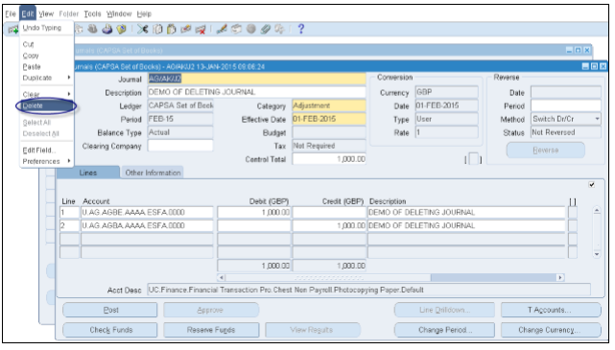

1. Upon selecting Delete, you will see a message on screen stating ‘**Are** **you** **sure you want to delete this** **journal** **entry**?’

**Select** Yes and then **click** the save icon 

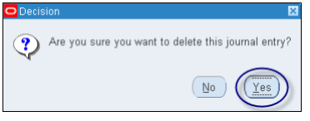

5. This will remove all lines from the journal and the journal will be deleted off the system. As well as the journal being deleted, the batch will be deleted on the basis that it was the only journal entry within that batch.